CASA
AASA Item Specifications  COMMON ITEM FORMATS | 

ELA
Code | Name | Description | Example
MCR | Multiple Choice | Requires the student to select one correct answer from 4 options. | 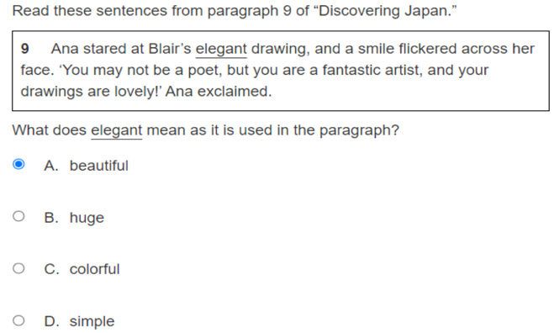
MSR | Multiple-Select | The student must select all the correct answers from several options. | 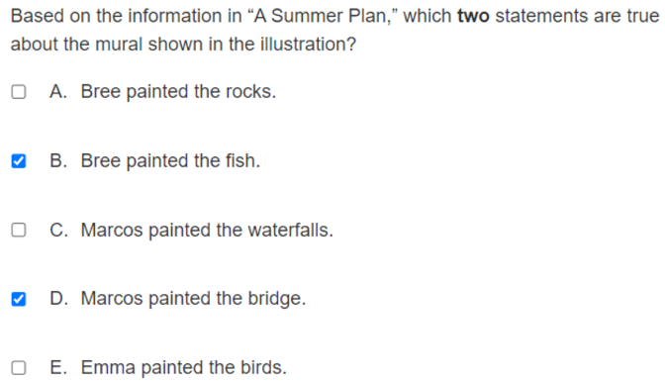
EBSR | Evidence- Based Selected Response | MC/MS format: The student is directed to answer a ‘Part A’ multiple-choice item based on a passage and is then asked to provide evidence in support of that answer by completing another ‘Part B’ multi-select item.  MC/TE format: The student is directed to answer a ‘Part A’ multiple-choice item based on a passage and is then asked to provide evidence in support of that answer by completing another ‘Part B’ TEI item. | 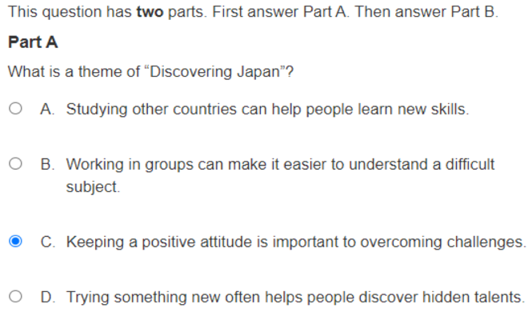  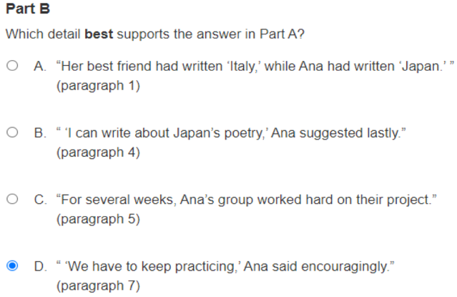
InC | Inline Choice | The student clicks a box which reveals a drop-down menu containing options. The student then selects the correct word or phrase from the drop-down menu. | 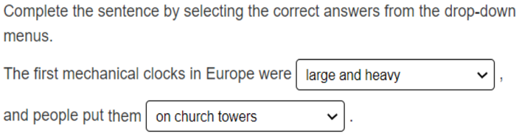
GM/GMT | Gap Match/ Gap Match Table | GM: Certain numbers, words, phrases, or sentences may be designated ‘draggable’ in this item type. The student can then click on the option, hold down the mouse button, and drag it to a graphic or other format. | 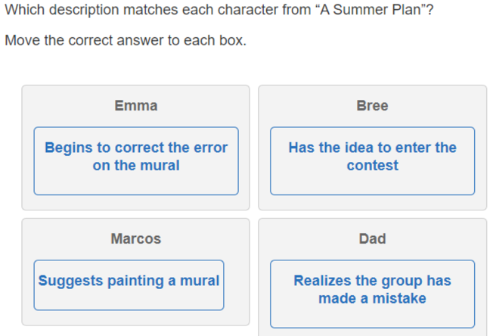
MTG | Match-Table Grid | The student checks a box to indicate if information from a column header matches information from a row. | 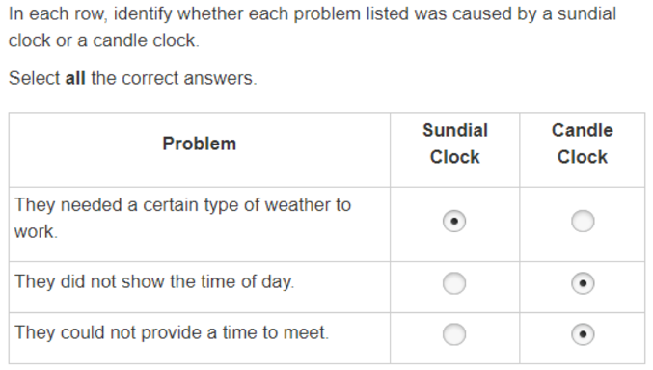
HT | Hot Text | Excerpted sentences from the text are presented in this item type. Certain words, phrases, or sentences are highlighted. This indicates that the text is selectable (‘hot’). The student can then click on the option to select it. | 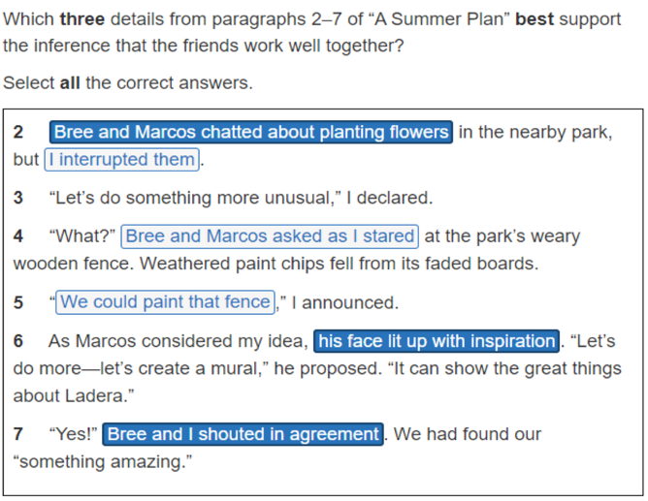
SCR | Short Constructed response | The student uses a keyboard to enter a response into a text field. These items can usually be answered in a sentence two. | 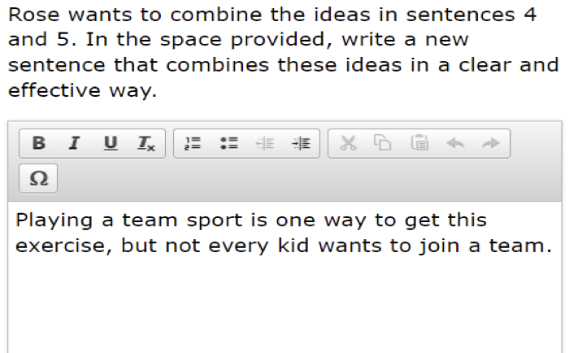
WP | Writing Prompt | These items may require the student to use features of an online word processor. The student can perform various tasks within the online word processor such as bold text, use bullet points, underline, etc. | 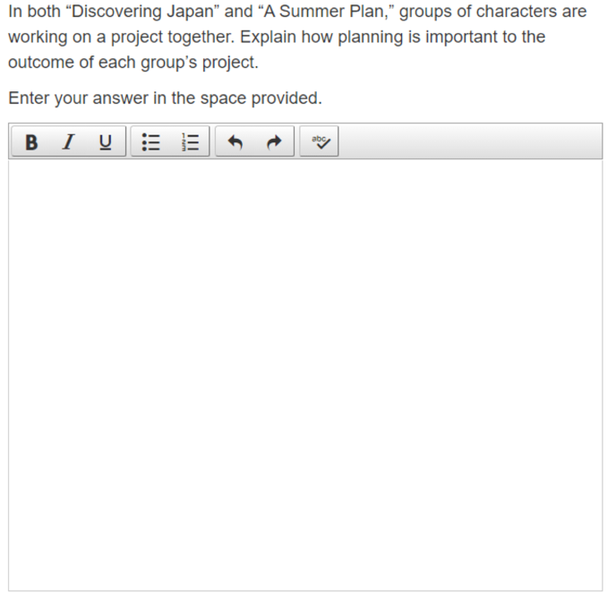

MATHEMATICS

Code | Name | Description | Example
BG | Bar Graph | Bar graph interaction allows students to drag bars vertically or horizontally along numerical values. Individual bars, histograms, and clusters are supported. | 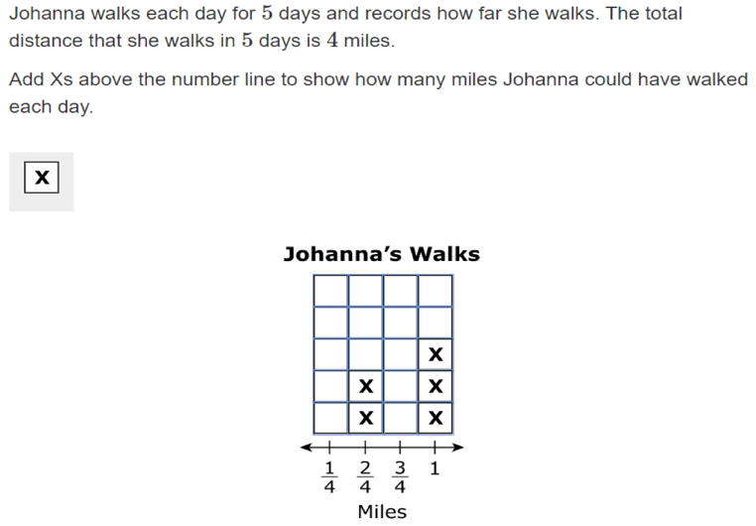
GRR | Graphical Response | The student uses the point, line, or arrow tools to create a  response on a graph. The item type may also require the student to select numbers, words, phrases, or  images and use the drag-and-drop feature to place them into a graphic. For paper-based assessments,  this item type may be replaced with another item type that assesses the same standard and can be  scanned and scored electronically | 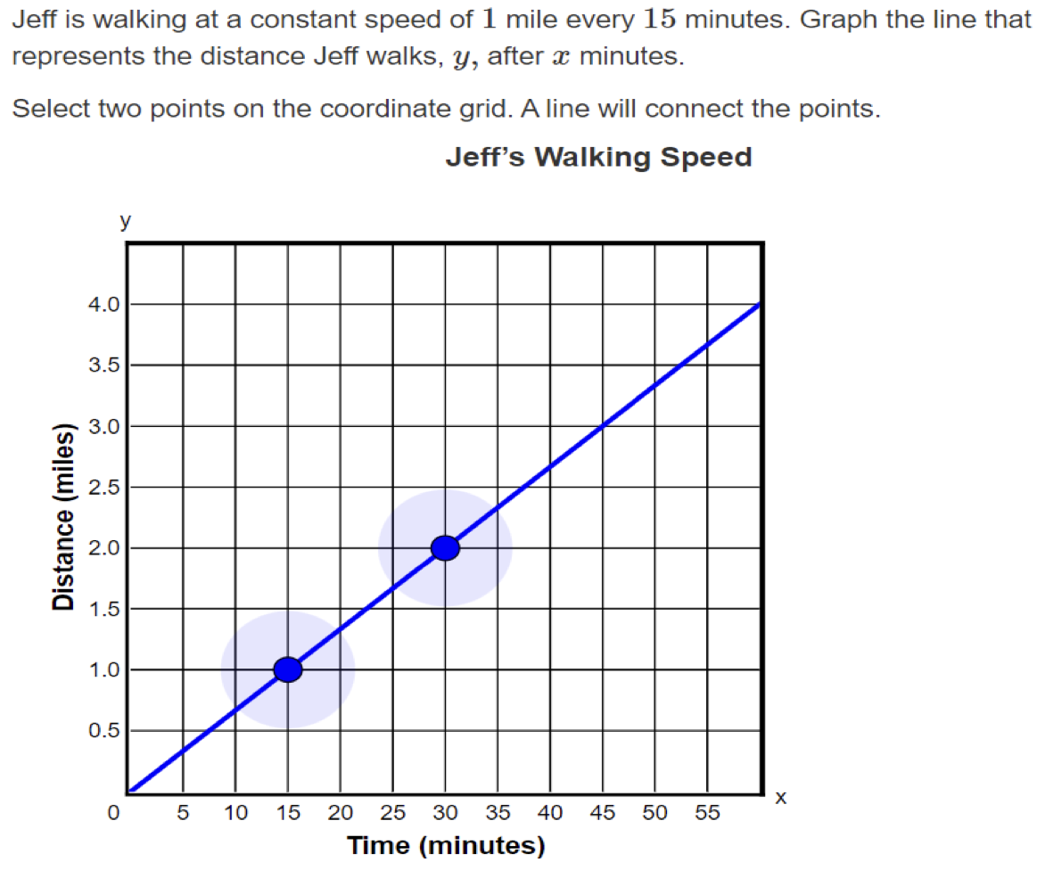
MCR  MSR | Choice  Multiple Choice  Multiple Select | Choice (also called Multiple Choice, Choice Interaction, or Multiple Select) allows the student to choose the correct answer(s) from pre-set responses. | 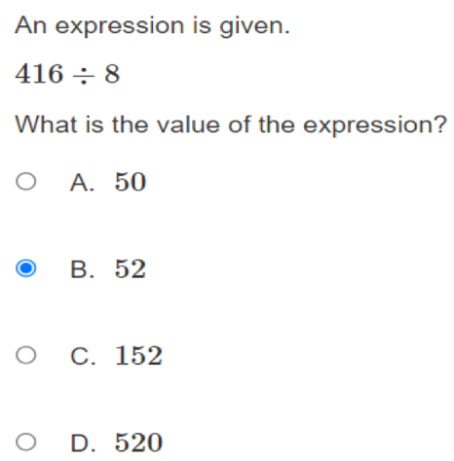
 |  |  | 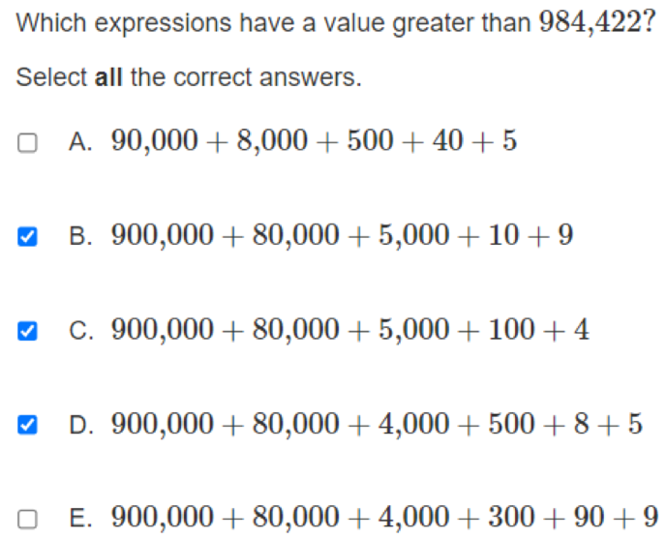
EQR or EE | Equation Editor  Equation Response | Equation Editor allows the student to use a palette of buttons to enter a numerical response or to create mathematical expressions. | 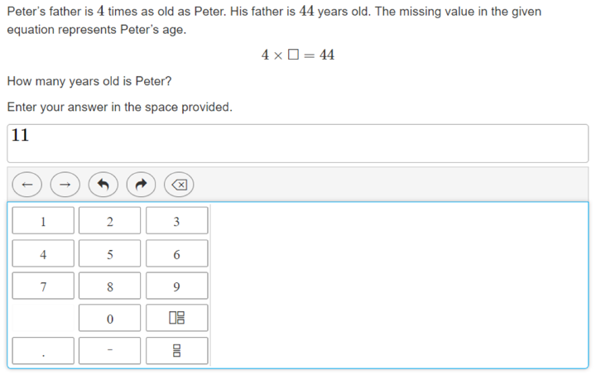
FM  GR | Fraction Model  Graphical Response | Fraction Model allows the student to divide a shape (circle or rectangle) into varying numbers of segments by clicking a ‘Fewer’ or ‘Mare’ button and select those segments, which shades those segments with a solid color. | 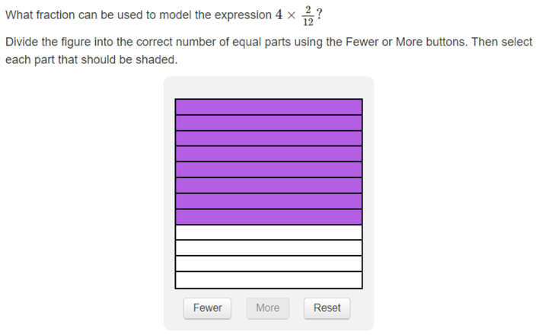
GM | Gap Match | Gap Match allows the student to drag texts or images (also called choices) to a gap (a location on a background image). | 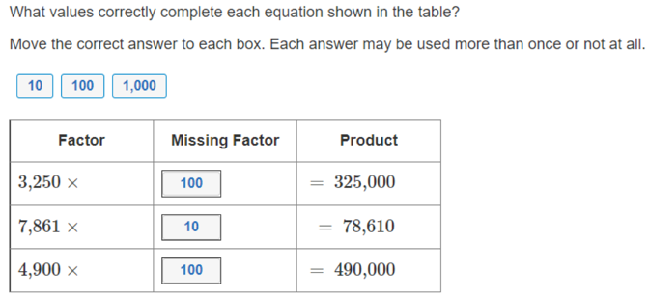
HS | Hot Spot | Hot Spot allows the student to select one or more areas called hot spots on an image. | 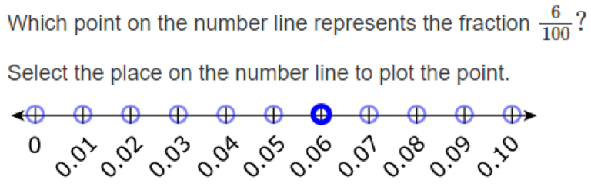
IC | Inline Choice | An Inline Choice item is like a fill-in-the-blank item where the student selects a single text option from a drop-down menu within a table or inline text. The item may contain multiple blanks. | 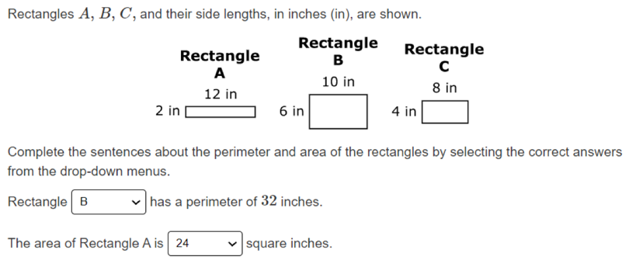
MTG | Match Table Grid | The Match Table grid interaction allows students to select radio buttons or check checkboxes in cells to indicate a match between the column and row labels. | 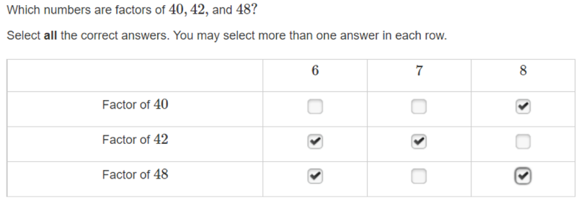
PG | Point Graph  Graphical Response | Point Graph allows the test-taker to plot points, line segments, continuous lines, and/or polygons. Point Graph items can use one or multiple graph interactions (composite graphs). | 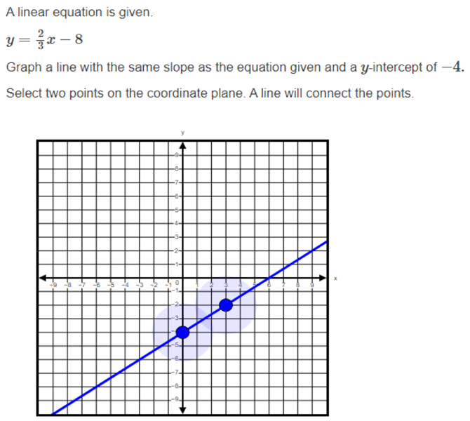
ST | Shape Transformation | Shape Transformation allows the test-taker to choose one of four variants of a single shape, drag it onto a four-quadrant grid, and position it on the grid. | 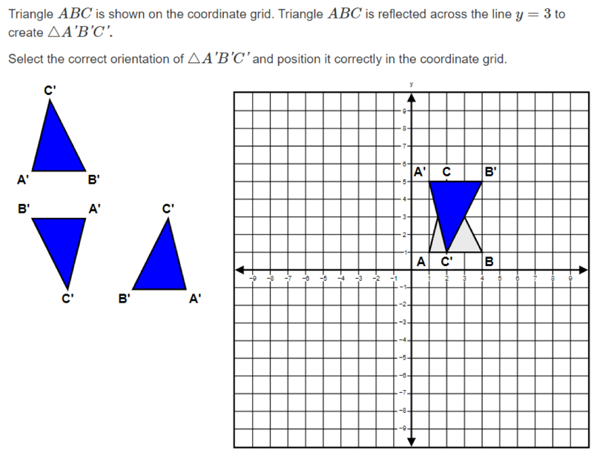
ETR | Editing Task Response | The student clicks on a blank, which reveals a drop-down menu containing options to complete an equation or expression, a statement, or other component. The student then selects the correct response. | 