Driving Question of a Thriving PLC:

What is it that we want our students to know and be able to do?  (e.g., actively unpacking standards & performance descriptors) | Not Yet  Somewhat  With Fidelity
What evidence would we accept that students have learned the essential content?  (e.g., creating DFA based on unpacking and observation) | Not Yet  Somewhat  With Fidelity
What instructional practices will produce our best results?  (e.g., engagement, clear revisited objectives, checking 4 understanding, differentiation, archiving, exemplars, closure, spiraling); Does my instruction match or exceed the level of rigor on the DFA? | Not Yet  Somewhat  With Fidelity
Reflect  (e.g., where is each student compared to standards (and PLDs minimally to proficient)?) | Not Yet  Somewhat  With Fidelity
What will we do if our students have not learned it?  (e.g., flex-grouping, guided groups, individual conferencing, re-assess to celebrate growth) | Not Yet  Somewhat  With Fidelity
What will we do to differentiate instruction when students already know it?  (e.g., Genius Hour strategies, deeper learning at or beyond Distinguished level of ALDs) | Not Yet  Somewhat  With Fidelity
What will we do to improve, catalog, and save our work?  (e.g., Data-driven continuous improvement strategies, Maintain a PLC instructional Warehouse) | Not Yet  Somewhat  With Fidelity
Repeat
Learning Progressions (a path to proficiency and beyond)
Big idea
Learning progressions describe how the skills might be demonstrated, both in their early forms and in increasingly advanced forms. It is critical for teachers to be able to identify the behaviors that relate to these skills if they are to intervene at the appropriate levels of challenge.
Clarifies Content, Skills, Vocabulary
Clarifies order of skills for learning
Standard
Learning  Progression | Learning  Progression

Learning Intentions
Big idea
Learning intentions expand each of the learning progressions into daily statements of expectations for students. Learning intentions are brief statements that explicitly describe what students should know, understand and be able to do as a result of the learning and teaching. Success criteria are linked to learning intentions. They are developed by the teacher and/or the student and describe what success looks like.

Clear learning intentions should help students focus not just on the task or activity taking place, but on what they are learning. Learning intentions are brief statements that explicitly describe what students should know, understand and be able to do as a result of the learning and teaching.
Clarifies Content, Skills, Vocabulary
Clarifies order of skills for learning
Expands each learning progression into daily statement of expectations for students
Standard
Learning  Progression |  | Learning  Progression
Learning Intention | Learning Intention | Learning Intention | Learning Intention | Learning Intention
Success Criteria (SC)
Big idea
When learning intention and success criteria are used in tandem and implemented with fidelity, research has shown a significant increase in student achievement. Success criteria are linked to learning intentions. They are developed by the teacher and/or the student and describe what success looks like. Quality success criteria makes the learning explicit and transparent for the students and the teacher.
Expands each learning progression into daily statement of expectations for students

Describes what success looks like in meeting each learning intention
Standard
Learning  Progression |  |  | Learning  Progression
Learning Intention |  | Learning Intention | Learning Intention |  | Learning Intention |  | Learning Intention
SC | SC | SC | SC | SC | SC | SC | SC
Standard sample:
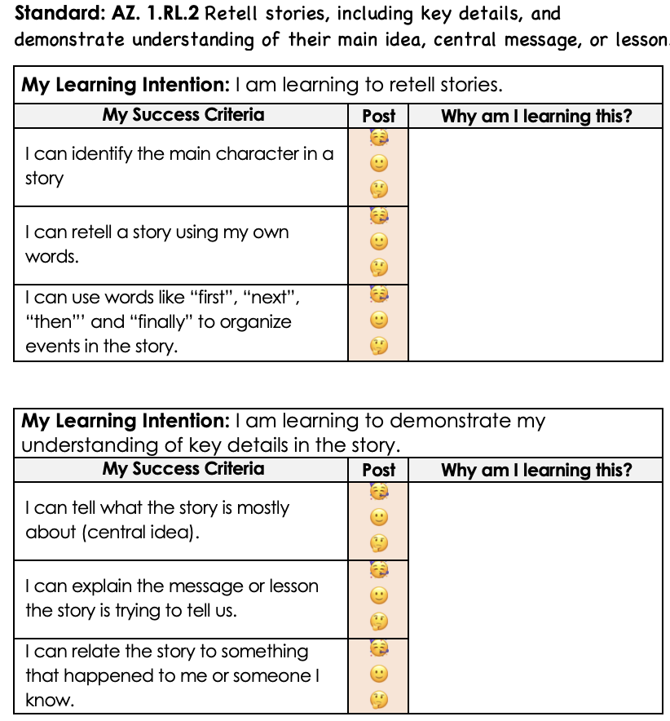
Searching for Opportunities:
Learning Progressions, Learning Intentions, and Success Criteria to Educate the Whole Child

Developing | Proficient | Distinguished
- My learning intentions are posted, but not accessible to students (visually or conceptually).  - My success criteria are posted, but not accessible to students (visually or conceptually).  - My learning intention and success criteria are communicated at the beginning of the lesson by the teacher.  - My students are able to answer the 3 critical questions with less than 50% proficiency.  - What am I Learning today?  - Why am I learning it?  - How will I know I have learned it?  - My student will refer to the board where the learning intention and success criteria are located and read or repeat verbatim.  - There is little evidence of an instructional framework. My primary instructional delivery method is teacher-centered/lecture. | - My learning intentions are posted and accessible to students. My learning intentions are written in student‐friendly language. They may or may not be aligned to the standard.  - My success criteria are posted and accessible to students. They may or may not be aligned to the learning intention.  - My learning intention and success criteria are communicated and referenced throughout the learning, mainly by the teacher.  - My students are able to answer the 3 critical questions with at least 50%-80% proficiency.  - My students are able to paraphrase the learning intention and the purpose for the learning but cannot explain how they will show success.  - There is some evidence of an instructional framework with active engagement.   | - My learning Intentions are posted and accessible to students throughout the learning. My learning intentions are written in student‐friendly language in a way that actively engages students in the learning process. Learning intentions state what the students will learn in relation to the standard rather than what they will do.  - My success criteria are posted, accessible to students, and aligned to the learning intention and rigor of the standard.  - My students and myself co-construct learning intention and success criteria through a variety of methods and are routinely reference throughout the learning by teacher and students.  - My students are able to answer the 3 critical questions with at least 80%-100% proficiency.  - My students are able to summarize the learning intention, the purpose for the learning, and how they will demonstrate achievement of the success criteria.  - There is evidence of effective instructional framework that includes student-centered learning experiences aligned to learning intention and success criteria for the day.
Learning Intentions
Learning Intentions are (brief) statements that explicitly describe what students should know, understand and be able to do as a result of the learning sequence. A learning intention clearly outlines what students will be learning rather than what students will be doing. The Learning Intention should focus on what we want students to learn/understand as opposed to what we want them to do (the task) or how we want them to do it (the activity). They should be linked closely to the standards and outcomes set out in curriculum documentation in whichever country/state you are based.

Additional tips when using Learning Intentions:
- Learning Intentions should be shared at the beginning of a lesson. They should also be referred to throughout the lesson and again at the conclusion.
- Learning Intentions provide a tool to assist in focusing on the importance of 'tuning in'; building on where learners are in their learning when introducing the Learning Intention. This includes setting the scene and explaining why we are learning this while linking to what is known.
- Learning Intentions should be written in student‐friendly language, in a way that actively engages students in the learning process.
- Use of Learning Intentions should put greater emphasis on the process of learning over the completion of a task or the end product.
- They should be meaningful and inform assessment and reporting and linked to curriculum outcomes

Success Criteria
Success Criteria are the measurable definitions of success used to determine whether, and how well, learners have met the learning intention. The Success Criteria should provide students with a range of entry points based on ability and leach students demonstrated level of understanding. The Success Criteria should provide a scaffold and focus for pupils while involved in the activity as the basis for feedback and self and peer assessment.

Success Criteria should:
- Provide students with appropriate challenges.
- Match teaching and learning activities and assessment tasks set by curriculum guidelines
- Be provided as a tool for the self-efficacy of ALL students knowing that can achieve all of them over the learning sequence (yet at their own level)
- Provide clarity on the process so that students actively seek feedback
- Be generalizable to allow effective transfer of learnt skills to different contexts.

