Providing Pathways to Excellence for Each Student

**Unwrap a Standard: *What do students have to know and be able to do?***

**Domain: Measurement & Data** and Geometry

**Domain/Reporting Category Weight** (if applicable)**:** 7% - 11% of items

**Standard: *4.MD.A.3*** Apply the area and perimeter formulas for rectangles in *mathematical problems* and problems in *real-world contexts* including problems with unknown side lengths.

**Performance Level Descriptors**

(AASA Format: Equation Response (EQ), Graphical Response (GRR), Muti Select Response (MSR)

|  |  |  |  |
| --- | --- | --- | --- |
| **Emerging (1)** | **Developing (2)** | **Proficient (3)** | **Distinguished (4)** |
| I can identify the area and perimeter for rectangles in *mathematical problems*. | I can identify the area and perimeter for rectangles in *mathematical problems* and problems in *real-world contexts*. | I can apply the area and perimeter formulas for rectangles in *mathematical problems* and problems in *real-world contexts* including problems with unknown side lengths. | I can explain the difference between the area and perimeter formulas for rectangles. Use the area and perimeter formulas to determine unknown side lengths of a rectangle. |
|  | | | |
| **Building Background Knowledge and skills: Flashback Standard**  Standard: (background knowledge)  **3.MD.C.6** Measure areas by counting unit squares (e.g., square cm, square m, square in, square ft, and improvised units. | | | |
|  | | | |
| **Extending Knowledge: Preview Standard**  Standard: (when will they use this)  **5.MD.C.4** Measure volumes by counting unit cubes, using cubic cm, cubic in, cubic ft, and improvised units. | | | |

Providing Pathways to Excellence for Each Student

**Unwrap a Standard: *What do students have to know and be able to do?***

**Domain: Measurement & Data** and Geometry

**Domain/Reporting Category Weight** (if applicable)**:** 7% - 11% of items

**Standard: *4.MD.A.3*** **Apply** the area and perimeter formulas for rectangles in *mathematical problems* and *problems in real-world contexts* **including problems with unknown side lengths**.

**Performance Level Descriptors**

(AASA Format: Equation Response (EQ), Graphical Response (GRR), Muti Select Response (MSR)

|  |  |  |  |
| --- | --- | --- | --- |
| **Emerging (1)** | **Developing (2)** | **Proficient (3)** | **Distinguished (4)** |
| I can **identify** the area and perimeter for rectangles in *mathematical problems*. | I can **identify** the area and perimeter for rectangles in *mathematical problems* and ***problems in real-world contexts***. | I can **apply** the area and perimeter formulas for rectangles in *mathematical problems* and problems in *real-world contexts* **including problems with unknown side lengths**. | I can **explain the difference** between the area and perimeter formulas for rectangles. **Use** the area and perimeter formulas to **determine unknown side lengths of a rectangle**. |
|  | | | |
| **Building Background Knowledge and skills: Flashback Standard**  Standard: (background knowledge)  **3.MD.C.6 Measure** areas by **counting** unit squares (e.g., square cm, square m, square in, square ft, and improvised units. | | | |
|  | | | |
| **Extending Knowledge: Preview Standard**  Standard: (when will they use this)  **5.MD.C.4 Measure** volumes by **counting** unit cubes, using cubic cm, cubic in, cubic ft, and improvised units. | | | |

**Standard Analysis**

What do students need to know? What do they need to be able to do?

|  |  |
| --- | --- |
| **Essential Knowledge/Concepts**  List the NOUNS   * Understand the **formulas** for **area** and **perimeter** of a **rectangle**. * Comprehend how to apply mathematical reasoning to solve **mathematical problems** * Comprehend how to apply mathematical reasoning to solve **practical problems.** * Justify a strategy to find the **length of a missing side** in a rectangle**.** | **Essential Skills**  List the VERBS or Verb Phrases:   * **Calculate** the perimeter of a rectangle. * **Calculate** the area of a rectangle * **Apply** mathematical concepts to real-world problems involving area and perimeter of a rectangle. * **Investigate** a strategy to find the length of a missing side in a rectangle. |
| **Essential Vocabulary**  List all key vocabulary words:  Right Angle, Rectangle, Area, Rectangle, Square, Base, Height, Formula, Side, | **Wonder Questions**  List open-ended and “second” questions:  What makes a quadrilateral a rectangle? Draw a quadrilateral that is not a rectangle.  How is area of a rectangle different from the perimeter of a rectangle? |

How will we engage students in determining what they have to know and be able to do?

What are the lesson-sized, student-friendly **learning targets** that describe what students are learning about or learning to do? “I am learning about… (concept)” or “I am learning to do … (skill)”

|  |  |  |  |  |
| --- | --- | --- | --- | --- |
| **Learning Targets:** | | | | |
| I am learning to identify the area of rectangles in *mathematical problems*. | I am learning to find the perimeter of rectangles in *mathematical problems*. | I am learning to find the perimeter of rectangles in *problems with real-world contexts.* | I am learning to find the area of rectangles in *problems with real-world contexts.* | I am learning to determine unknown side lengths of a rectangle*.* |

How will students demonstrate success towards the learning targets? What will they do or say to illustrate that success? These **success criteria** should be scaffolded, actionable, student-friendly, and aligned to the learning targets. (3-5 Success Criteria per Learning Target is ideal)

|  |  |  |  |  |
| --- | --- | --- | --- | --- |
| **Success Criteria:** | | | | |
| I can explain the meaning of area of a rectangle.  I can count unit cubes to find the area of rectangles.  I can calculate the area of a rectangle.  I can explain the meaning of my solution to area in a mathematical problem. | I can explain the meaning of perimeter of a rectangle.  I can calculate the perimeter of a rectangle.  I can explain the meaning of my solution to perimeter in a mathematical problem. | I can apply the formula for perimeter of a rectangle to math problems in context.  I can justify my solution for the perimeter of a rectangle in context. | I can apply the formula for area of a rectangle to math problems in context.  I can justify my solution for the area of a rectangle in context. | I can determine the length of an unknown length of a rectangle.  I can justify my solution for the unknown side length of a rectangle. |

What evidence will be collected to assess students’ level of mastery? (Exit tickets, CFAs, Projects?)

|  |
| --- |
| **Evidence of Student Understanding**  How will we know when they know it? How will we encourage each student to try?   * Exit Ticket (daily check for understanding) * Diagnostic Formative Assessment (DFA) (check for understanding of a standard) * Common Formative Assessment (CFA) |

**Possible Exit Tickets**

|  |  |  |  |  |
| --- | --- | --- | --- | --- |
| LT 1: Compare the area of two rectangles: one with a length of 6 units and a width of 4 units, and another with a length of 3 units and a width of 8 units. Which rectangle has a larger area? What does this mean to us? | LT2: Determine the perimeter of a rectangle with a length of 10 m and a width of 7 m. Draw an image and explain what your answer tells us about the rectangle. | LT3: Formulate a real-world problem involving the perimeter of a rectangle, such as designing a swimming pool for our school. What dimensions would you choose? Explain what your answer means about your real-world problem. | LT4: Investigate a real-world situation where you might need to calculate the area of a rectangle. What information would you need? | LT5: Anna’s art class is painting a mural to cover a wall in their school. They have enough paint to cover 96 sq. ft. The wall is 8 ft. tall. How wide can they make the mural? Explain how you solved the problem for Anna and her class. |

**Possible DFA: (check for understanding of a standard)**

(Purpose: to inform instructional decisions and to encourage each student to try)

**Alignment to 4.MD.A.3.0** (Flashback to 3.MD.C.6)

1. Count the boxes to find the area of rectangle A.

**Area of rectangle A = _______**

**Alignment to MD.A.3.1**

1. **PART A.** Find the total distance around the rectangle.

**PART B.** Is this an example of area or perimeter?

**Alignment to MD.A.3.2**

1. Hilda is creating a frame to place around a rectangular painting. The painting is 12 cm long and 8 cm high.

Circle the equation Hilda can use to design her frame?

|  |  |  |  |  |  |  |
| --- | --- | --- | --- | --- | --- | --- |
| **A = 12 x 8** |  | **P = 12 + 8** |  | **A = 12 x 8 + 12 x 8** |  | **P = 2 x 12 + 2 x 8** |

**Alignment to MD.A.3.2**

1. Maria is creating a rectangular garden for her mother. Her garden will be eight meters long and nine meters wide.

**PART A.** Draw and label a sketch of the garden.

**PART B.** Maria needs help finding the amount of space inside her garden. Find the area of the garden.

**Alignment to MD.A.3.3**

1. Find the length of the missing side in the given rectangle if the perimeter is 28 ft.

1. 3.5 ft.
2. 6 ft.
3. 20 ft.
4. 72 ft.

**Alignment to MD.A.3.3**

1. **PART A.** Draw a rectangle on the grid below with an area of 48 sq cm.

**PART B.** State the length and width of the rectangle.

**Alignment to MD.A.3.4**

1. Think of a time when knowing how to find the area or perimeter of a rectangle would have solved a question.

**PART A.** Describe the problem. Include approximate measures in your story to make it realistic.

**PART B.** Make a labeled sketch to illustrate your situation.

**PART C.** Solve your story.

|  |
| --- |
| **Instructional Strategies/Student Engagement?**  What will we do to help students develop understanding? How will each student be engaged and thinking?  *See Thinking Routines 5C with link to Routines* |

|  |  |
| --- | --- |
|  |  |
|  |  |

What materials and resources need to be gathered? Where are they found? (Unit numbers, page-numbers, copies, slides, games, etc.)

|  |
| --- |
| **Resources:**  Linking Cubes, Graph Paper |

**Arizona Department of Education Resources**  to Support Uncovering the Knowledge, Skills, and Vocabulary of Learning Targets

**Arizona Performance Level Descriptors**

**Standard**

|  |  |  |  |
| --- | --- | --- | --- |
| **Emerging** | **Developing** | **Proficient** | **Distinguished** |
| I can | I can | I can | I can |

**AASA Item Specifications**

|  |  |
| --- | --- |
| **Content Standard** |  |
| **Explanations** | Students developed understanding of area and perimeter in 3rd grade by using visual models.  While students are expected to use formulas to calculate area and  perimeter of rectangles, they need to understand and be able to  communicate their understanding of why the formulas work. |
| **Content Limits** | Figures are limited to rectangles.  Fractions are limited to like denominators.  Products of factor pairs are limited to the range 1-100.  Multiplication and division is limited to 2-digit by 1-digit, or 2-digit by 2-digit, where one number is a multiple of 10.  Addition and subtraction within 1000.  When constructing rectangles, the minimum grid size is 20 pixels, and in the context of a situation, one grid must be labeled with the appropriate dimension. That dimension should be “1 ____”, as items at this standard should not assess scale |
| **Context** | Context is allowed |

|  |  |
| --- | --- |
| **Sample Task Demands** | **Common Item Formats** |
| Students will be required to construct a rectangle with a given perimeter and/or area | Equation Response  Graphic Response  Multi-Select Response |
| Students will be required to calculate perimeter and/or area of a rectangle. |
| Students will be required to calculate an unknown side length given an area or perimeter |
| Students will be required to model with an expression or equation the area or perimeter of a rectangle with an unknown side length. |
| Students will be required to construct a rectangle based on given parameters (i.e. ranges of possible areas and/or perimeters.) |

**Sample AASA Items**

**Flashback Standard**

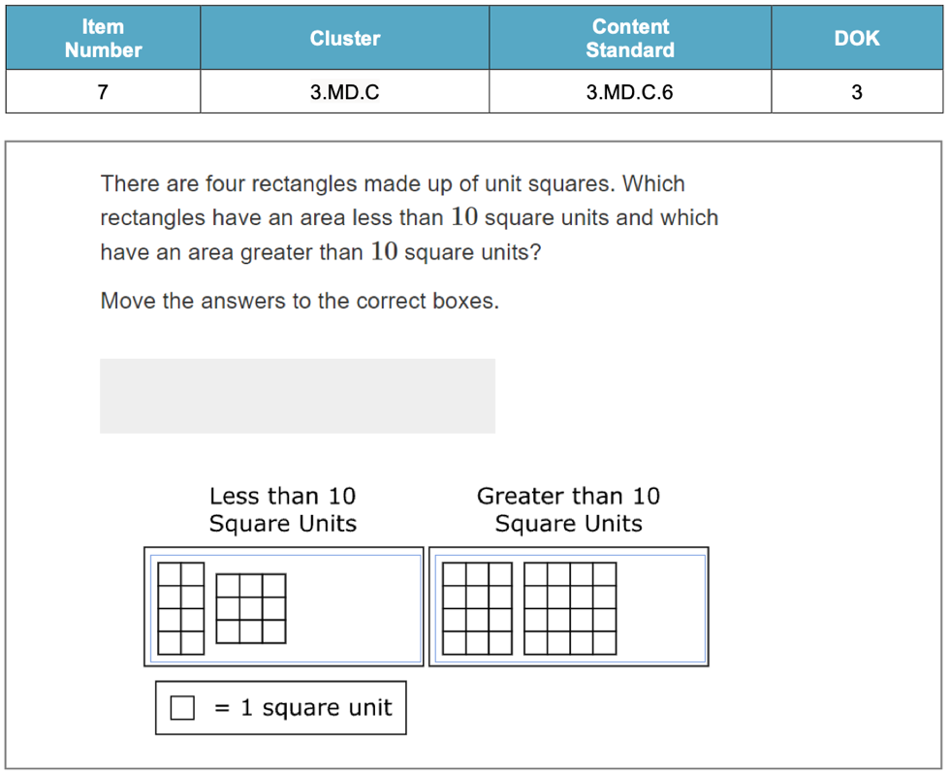

**Grade 4 Standard**

**Guided Group Lesson Date:**

**Standard:** **4. MD.A.3** **Apply** the area and perimeter formulas for rectangles in mathematical problems and problems in real-world contexts including problems with unknown side lengths.

|  |  |  |  |  |
| --- | --- | --- | --- | --- |
| Group Members | Emerging | Developing | Proficient | Distinguished |
|  |  |  |  |

Warm-Up:

|  |
| --- |
|  |

Vocabulary

|  |  |  |  |
| --- | --- | --- | --- |
| Emerging | Developing | Proficient | Distinguished |
| Lesson focus:  Cindy plans on painting a 12I by 8I rectangular accent wall in her home. She requests your help in determining whether she should use the area or perimeter formular to determine how much space she needs to paint. Use sentences and images to explain what you recommend. | Lesson focus:  Carlotta’s class is creating a rectangular garden on the school property. The vegetable plants they want in the garden require 36I square feet of space. Carlotta purchased 12I of fencing to enclose the garden. Does she have enough fencing to enclose the garden? Explain your thinking with pictures, equations, and sentences. | Lesson focus:  Carlos noticed perimeter of a rectangle is expressed in units. He also realized area of a rectangle is expressed in square units. Explain why the difference in expressing perimeter and area is important to apply to our solutions to mathematical problems. | Lesson focus:  Penny has been asked by her teacher to create two questions for the next quiz. She is tasked with creating a real-world area of a rectangle situation and a real-world perimeter of a rectangle situation. Inclue practical numbers to fit each real world situation. |

|  |  |  |
| --- | --- | --- |
| Observations: |  | Next Steps: |
| What you notice about your students during small group instruction. | What will you do with these students next? Change groups, repeat, etc. |