Providing Pathways to Excellence for Each Student
Unwrap a Standard: What do students have to know and be able to do?

Domain: Reading Standards for Literature
Domain/Reporting Category Weight (if applicable): 24% - 31% of AASA items

Where can this be found? Why do we care?

Standard: 7.RL.3 Analyze how particular elements of a story or drama interact (e.g., how setting shapes the characters or plot.

Performance Level Descriptors 7.RL.3 (HT, MC, MS, EbSR, GM/GMT, InC, M-TG, SCR)
Emerging (1) | Developing (2) | Proficient (3) | Distinguished (4)
I can identify particular elements of a story or drama (e.g., setting or characters). | I can explain how particular elements of a story or drama interact (e.g., how setting shapes the characters or plot). | I can analyze how particular elements of a story or drama interact (e.g., how setting shapes the characters or plot). | I can evaluate the relationships between particular elements of a story or drama (e.g., how setting shapes the characters or plot) and analyze the impact.
Building Background Knowledge and skills: Flashback Standard
Standard: Standard:6.RL.3 Describe how a particular story’s or drama’s plot unfolds in a series of episodes as well as how the characters respond or change as the plot moves toward a resolution.

Why bother?

Extending Knowledge and skills: Preview Standard
Standard: Standard: 8.RL.3 Analyze how particular lines of dialogue or incidents in a story or drama propel the action, reveal aspects of a character, or probe a decision.

Providing Pathways to Excellence for Each Student
Unwrap a Standard: What do students have to know and be able to do?

Domain: Reading Standards for Literature
Domain/Reporting Category Weight (if applicable): 24% - 31% of AASA items

Where can this be found? Why do we care?

Standard: 7.RL.3 Analyze how particular elements of a story or drama interact (e.g., how setting shapes the characters or plot.

Performance Level Descriptors 7.RL.3 (HT, MC, MS, EbSR, GM/GMT, InC, M-TG, SCR)
Emerging (1) | Developing (2) | Proficient (3) | Distinguished (4)
I can identify particular elements of a story or drama (e.g., setting or characters). | I can explain how particular elements of a story or drama interact (e.g., how setting shapes the characters or plot). | I can analyze how particular elements of a story or drama interact (e.g., how setting shapes the characters or plot). | I can evaluate the relationships between particular elements of a story or drama (e.g., how setting shapes the characters or plot) and analyze the impact.
Building Background Knowledge and skills: Flashback Standard
Standard: Standard:6.RL.3 Describe how a particular story’s or drama’s plot unfolds in a series of episodes as well as how the characters respond or change as the plot moves toward a resolution.

Why bother?

Extending Knowledge and skills: Preview Standard
Standard: Standard: 8.RL.3 Analyze how particular lines of dialogue or incidents in a story or drama propel the action, reveal aspects of a character, or probe a decision.

Standard Analysis
What do students need to know? What do they need to be able to do?

Essential Knowledge/Concepts  What Do Students Need to Know/Understand?  List the underlined nouns.  Elements of a Story Setting Character  Plot Conflict. Interact Analyze  Influence  FBS: Episodes Resolution  Why bother? How can we use these? |  |  |  |  | Essential Skills  What Do Students Need to Be Able to Do?  List the circled (or italicized) verbs.  Identify Explain Analyze Evaluate  Explain  FBS: Describe
DOK Level
Level of content complexity rather than content difficulty.

DOK 1 DOK 2 DOK 3
WONDER Questions  How can we capture student wonder?  *Including open-ended and ‘second’ questions  How does the setting shape the character in a story or drama?  How might a different setting change the outcome or the story?  Critique the effectiveness of the author’s use of setting in our story?  Create a new story or drama and design the setting to have a specific impact on the characters and plot. |  |  |  |  | Essential Vocabulary  What Do Students Need to Comprehend?  List all key vocabulary  Main idea Supporting details Setting  Character Plot Conflict  Elements of a Story Analyze Drama
Learning Targets aligned to the Standard
How will we engage students in determining what they have to know and be able to do?
What are the lesson-sized, student friendly learning targets that describe what students are learning about or learning to do? “I am learning about…(concept)” or “I am learning to do…(skill)”
Learning Targets
I am learning to identify key elements of a story or drama (setting, characters, plot, conflict, and theme. |  | I am learning to analyze how the setting influences characters’ actions, decisions, and relationships. |  | I am learning to how the setting shapes the plot and conflict in a story or drama. |  | I am learning to explain how characters and settings work together to develop the theme. | I am learning to organize my ideas clearly when discussing how elements of a story interact.
How can students use these?
Success Criteria aligned to the Learning Targets
How will students demonstrate success toward the Learning Targets? What will they say or do to demonstrate success?
These success criteria should be scaffolded, actionable, student-friendly, and aligned to the learning target,
I can accurately define each story element.  I can find and label examples of each element in a text.  I can explain how these elements are connected. | I can describe the setting in detail using evidence from the text.  I can explain how the setting affects the character’s behavior or choices.  I can make connections between the setting and the character’s development or challenges. |  | I can describe key elements in the plot and identify the conflict.  I can explain how the setting makes the conflict possible or more intense.  I can give examples of how changing the setting could change the plot. |  |  | I can identify a theme in the story or drama.  I can explain how characters’ experiences in the setting help express the theme.  I can support my explanation with details from the text. | I can use specific text evidence to support my analysis.  I can use clear topic sentences and transitions when writing or speaking.  I can revise my work to improve clarity and coherence.
Evidence of Student Understanding?
How will we know when they know it? How will we encourage each student to try?
- Exit Ticket (daily check for understanding)
- Diagnostic Formative Assessment (DFA) (check for understanding of a standard)
- Common Formative Assessment (CFA)

Possible EXIT Tickets (daily check for understanding)
LI1: How does the setting influence the main character’s decisions in the story? Use specific examples from the text to support your answer.
LI2: How does the setting influence the character’s decisions or actions in the story? Use specific examples from the text to support your answer.
LI3: How might the plot of the story change if it took place in a different time or location? Give at least one example to support your answer.
LI4: Explain how the character’s experiences are shaped by the setting. Use at least two details from the text to support your explanation.
LI5: How do the characters, setting, and plot work together to develop the main conflict in the story? Organize your response with clear ideas and supporting details from the text.

Possible DFA: (check for understanding of a standard)

Passage 1: Courage in the Struggle: The Civil Rights Movement
This text is provided courtesy of Vanderbilt University: Center of Latin American Studies

In the mid-20th century, the United States witnessed a powerful and transformative movement known as the Civil Rights Movement. This important chapter in history was driven by courageous individuals who stood up against racial injustice, aiming to secure equal rights for African Americans.

One key element that shaped the Civil Rights Movement was the setting. During this time, racial segregation was deeply rooted in the southern states, creating a harsh and unjust environment for African Americans. The setting of segregated schools, buses, and public spaces fueled the determination of brave individuals to challenge these discriminatory practices.

The characters in this historical drama were the heroes of the movement, individuals such as Martin Luther King Jr., Rosa Parks, and Malcolm X. These remarkable figures played pivotal roles in challenging the status quo, using nonviolent protests, speeches, and acts of civil disobedience to advocate for change. Their characters were shaped by their determination, resilience, and unwavering belief in justice, which influenced the plot of the movement.

The plot of the Civil Rights Movement unfolded as a series of events that aimed to dismantle racial segregation and discrimination. Iconic moments, such as the Montgomery Bus Boycott sparked by Rosa Parks' refusal to give up her seat, or the March on Washington where Martin Luther King Jr. delivered his famous "I Have a Dream" speech, were crucial turning points. These events were driven by the characters' actions and interactions with the oppressive setting, showcasing the power of individuals to make a difference.

In analyzing the story of the Civil Rights Movement, students can explore how the characters' responses to the challenging setting propelled the plot forward. Questions like, "How did the setting of segregation impact the characters' decisions?" or "What role did individuals like Martin Luther King Jr. play in shaping the movement's narrative?" encourage students to think critically about the interplay between setting, characters, and plot.

By studying the Civil Rights Movement, we learn valuable lessons about the importance of courage, resilience, and the potential for positive change. This historical drama serves as an inspiration for all, illustrating how individuals, driven by a common goal, can challenge injustice and pave the way for a more just and equal society.

Item #1: Alignment to ALD 7.RL.3.0 (Flashback to 6.RL.3)

Who were some of the key characters in the Civil Rights Movement?
- A. George Washington and Abraham Lincoln
- B. Rosa Parks and Malcolm X
- C. John F. Kennedy and Lyndon B. Johnson
- D. Susan B. Anthony and Elizabeth Cady Stanton
Why start with the easiest question and increase performance level of each question? How can we use the results?

Item #2: Alignment to ALD 7.RL.3.1

What is the setting of the Civil Rights Movement described in the story?
Circle the box that contains the best answer to the question

Washington D.C. Civil Rights March |  | Segregated schools, buses, and public spaces in southern states. |  | The public schools of Tucson, Arizona |  | African ports used in the slave trade.
Why simulate a Hot Text item with this standard?

Item #3: Alignment to ALD 7.RL.3.2

Which of the following shows how the setting of racial segregation in the southern states shaped the characters in the Civil Rights Movement?

- A. It made them more determined to challenge discriminatory practices.
- B. It discouraged them from taking any action.
- C. It made them more concerned to the inequality faced by African Americans.
- D. It forced them to conform to the status quo.

Item #4: Alignment to ALD 7.RL.3.3

How did the characters' responses to the challenging setting impact the plot of the Civil Rights Movement?

- A. They had no impact on the plot.
- B. They helped maintain the status quo.
- C. They propelled the plot forward towards positive change.
- D. They caused the movement to lose momentum

Item #5: Alignment to ALD 7.RL.3.3

Formulate an argument about the role of individual leadership in shaping the narrative of the Civil Rights Movement. How did figures like Martin Luther King Jr., Rosa Parks, and Malcolm X influence the direction and success of the movement

Item #6: Alignment to ALD 7.RL.3.4

Draw conclusions about how the character traits of resilience and determination contributed to the success of the movement. In what ways did the determination and resilience of individuals like Martin Luther King Jr. and Rosa Parks impact the overall progress and outcomes of the Civil Rights Movement?

Instructional Strategies/Student Engagement?
What will we do to help them know/understand/can do it? How will each student be engaged and thinking?

See Thinking Routines 5C with link to Routines

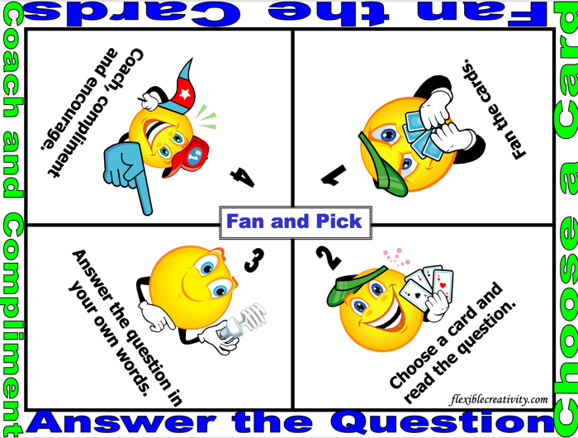 | 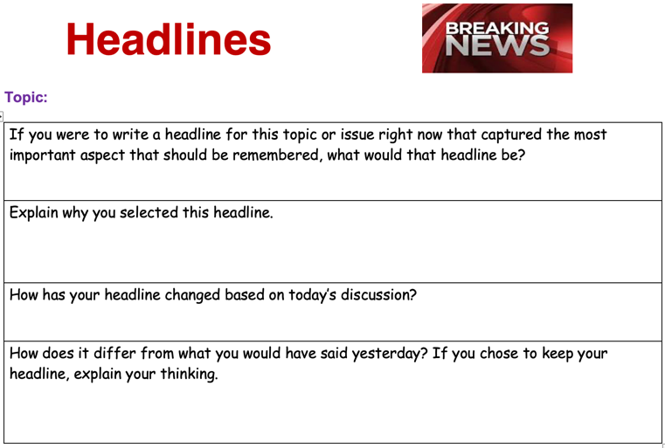
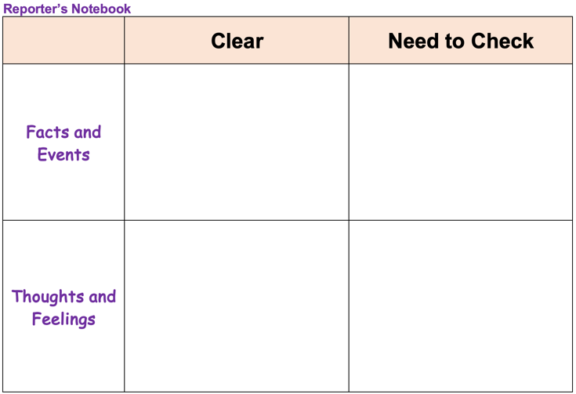 | 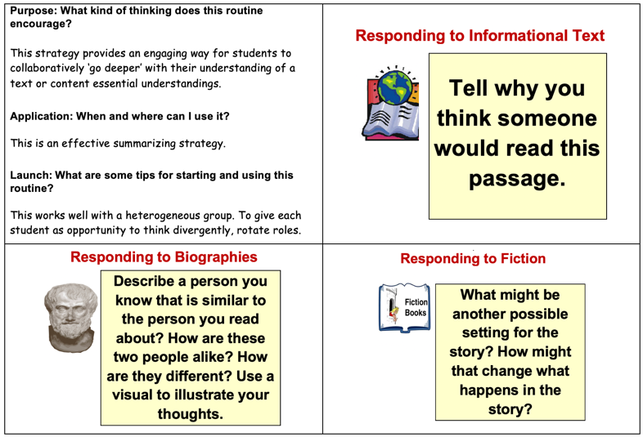
Additional Support and Extension
What will we do for students who still don’t know it? What will we do for students who already know it?

Guided Group Lesson Date:

Standard:

Group Members | Emerging | Developing | Proficient | Distinguished
 |  |  | Why individualize each student’s progress compared to standards?

Warm-Up:
With your partner, play a game of ‘Where Do I Belong’. Match Each main idea with one or more supporting details that support the main idea. Prepare to explain your selections.

Where can these be found?
Vocabulary

Main Idea Central Theme Key Details

Supporting Evidence Summary Recount Paraphrase Inference

Context Clues Key Details Supporting details

Emerging | Developing | Proficient | Distinguished
Lesson focus:  Choose a scene from the story and create a dialogue between two characters, showing their personalities and motivations. | Lesson focus:  Create a comic strip depicting a scene that exemplifies the interaction between the setting, characters, and plot. Include speech bubbles and captions to explain the signizicance. | Lesson focus:  With your partner, analyze a dialogue scene and explain how it develops the plot.  Why plan for data-driven small group instruction? | Lesson focus:  You have been hired by a publishing firm to investigate the point of view used in a story and analyze its impact on the narrative structure.

Observations:  Aren’t we done after providing one small group experience? |  | Next Steps:
What you notice about your students during small group instruction. |  | What will you do with these students next? Change groups, repeat, etc.

Where am I analyzing how elements of a story interact?
Criteria | Distinguished | Proficient |  | Developing | Emerging
Understanding of Elements | I demonstrated a thorough understanding of how specific elements interact to shape the story or drama. | I demonstrated a solid understanding of how specific elements interact to shape the story or drama. |  | I demonstrated partial understanding of how specific elements interact to shape the story or drama. | I demonstrated minimal understanding of how specific elements interact to shape the story or drama.
Analysis of Setting and its Influence | I analyzed the setting's impact on character development and plot progression with detailed and insightful observations. | I analyzed the setting's impact on character development and plot progression with accurate observations. |  | I provided a basic analysis of the setting's impact on character development and plot progression. | I provided limited analysis of the setting's impact on character development and plot progression.
Connection of Elements to Overall Theme | I articulated clear connections between the analyzed elements and the overall theme of the story or drama, demonstrating profound insight. | I articulated connections between the analyzed elements and the overall theme of the story or drama, demonstrating understanding. |  | I attempted to articulate connections between the analyzed elements and the overall theme of the story or drama. | I failed to articulate connections between the analyzed elements and the overall theme of the story or drama.
Presentation and Communication of Ideas | I presented ideas coherently and effectively, using appropriate vocabulary and providing strong supporting evidence to enhance understanding. | I presented ideas clearly, using language appropriate to the task and providing sufficient supporting evidence. |  | I presented ideas with limited clarity, occasionally using inappropriate language and providing insufficient supporting evidence. | I presented ideas in a disorganized and unclear manner, using inappropriate language and lacking supporting evidence
What are things I know? Explain. |  |  | What are my opportunities? Explain.

Arizona Department of Education resources for unpacking: 7.RL.3

AASA Item Specifications:
Stimuli Type | Reading Passage
Content Limits | The item should not be general or overarching questions about the elements of the story. The item may focus on the interaction of two or more story elements. The item should address characterization, including character traits, emotions and motivations.  Where can these be found? Why do we care?

Task Demand | Common Item Formats
Select textual evidence to support an inference about the interaction of two or more elements in a story. | - Multiple Select (MS)  - Multiple Choice (MC)  - Evidence-based Selected Response (EbSR)  - Infinite Choice  - Gap Match/ Gap Match Table (GM/GMT)  - Match-Table Grid  - Hot Text (HT)  - Short Constructed Response
Analyze how two or more elements interact in the story.
Where can this be found? How can we use these?

Sample AASA Items
Flashback Standard 6.RL.3
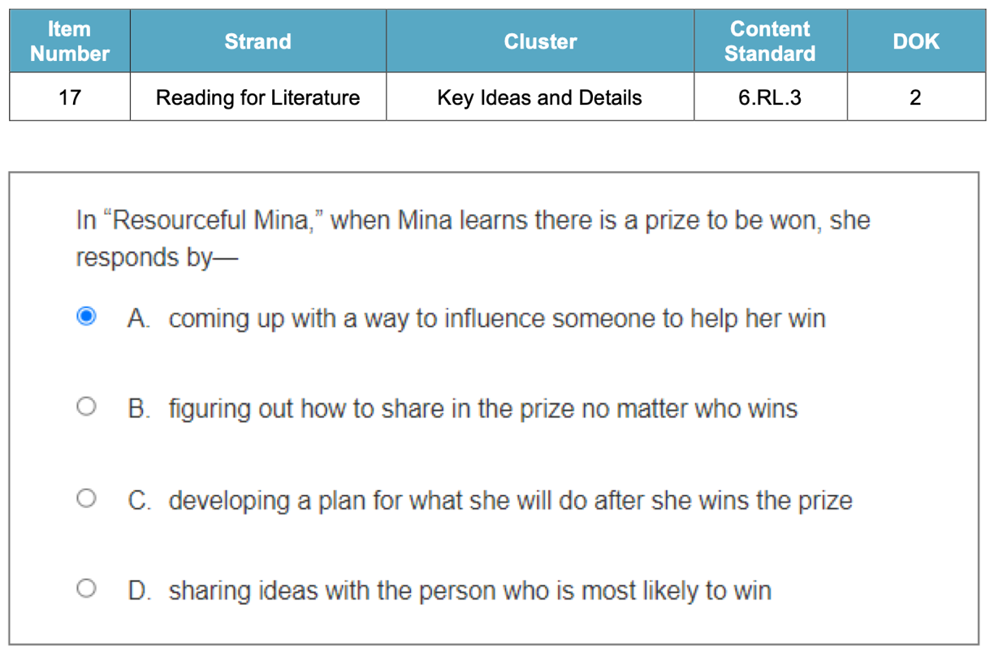 | 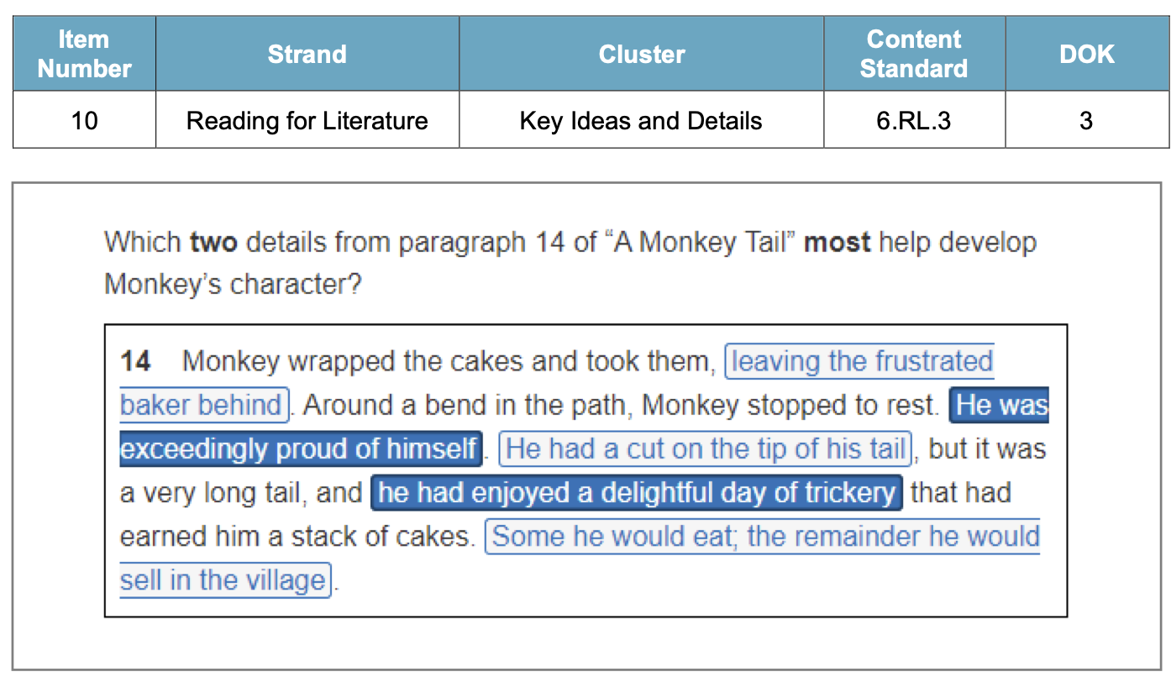
Standard 7.RL.3
