Providing Educational Excellence for All Students!

Curriculum
What do we want students to know and be able to do?
Assessment
How will we know when they know it?

ALL means ALL

Instruction
What will we do to ensure the success of each student?

Elevating the Essentials: Unpacking Standards to Target Curriculum, Assessment, & Instruction

Opportunity to learn (OTL) has the strongest relationship with student achievement of all school-level factors. It may seem like common sense, but data shows that success in mastery learning is directly related to “whether or not students have had an opportunity to study a particular topic or learn how to solve a particular type of problem presented by the test.” (Husen)

Prepared Especially for your
James Monroe HS Instructional Leaders
by Dan Mulligan, flexiblecreativity.com
Searching for Opportunities: Data Analysis
Using student achievement data for decision-making involves an ongoing cycle where educators analyze student performance (from assessments, work samples, attendance, etc.) to identify learning gaps, evaluate teaching effectiveness, and tailor instruction, grouping, goals, and interventions for continuous improvement, a process that empowers teachers and students to make informed choices for better academic outcomes. Key steps include establishing a data-driven culture, providing tools for data analysis, teaching students self-monitoring, and aligning data systems across the school or district.
How Data Informs Decisions:
- Instructional Adjustment: Teachers adapt lessons, assignments, and strategies in real-time based on student needs revealed by data.
- Personalized Learning: Data helps create individualized learning paths and identify students needing extra support or enrichment.
- Goal Setting: Students and teachers use data to set realistic, data-informed learning goals.
- Curriculum & Program Evaluation: Schools assess the effectiveness of their curriculum and assessment tools, optimizing resource allocation.
- Identifying Systemic Issues: Data reveals broader trends and challenges, guiding school-wide improvement plans.
The mission of James Monroe High School is  to provide character education, rigorous academics, and success beyond tests, fostering responsible 21st-century citizens through a student, faculty, parent, and staff partnership, believing all students can learn. | 

Compression and Elevation Charts
Compression of academic performance refers to the decrease in achievement gaps between subgroups over time.
Elevation of academic performance refers to an overall positive trend where student achievement or growth levels increase over time.
Compression and Elevation refer to the overall increase in the achievement of all students while at the same time decreasing achievement gaps between subgroups.
Searching for Opportunities: A Snapshot in Time  SOL English Reading Results  Longitudinal and Subgroup Analysis | 

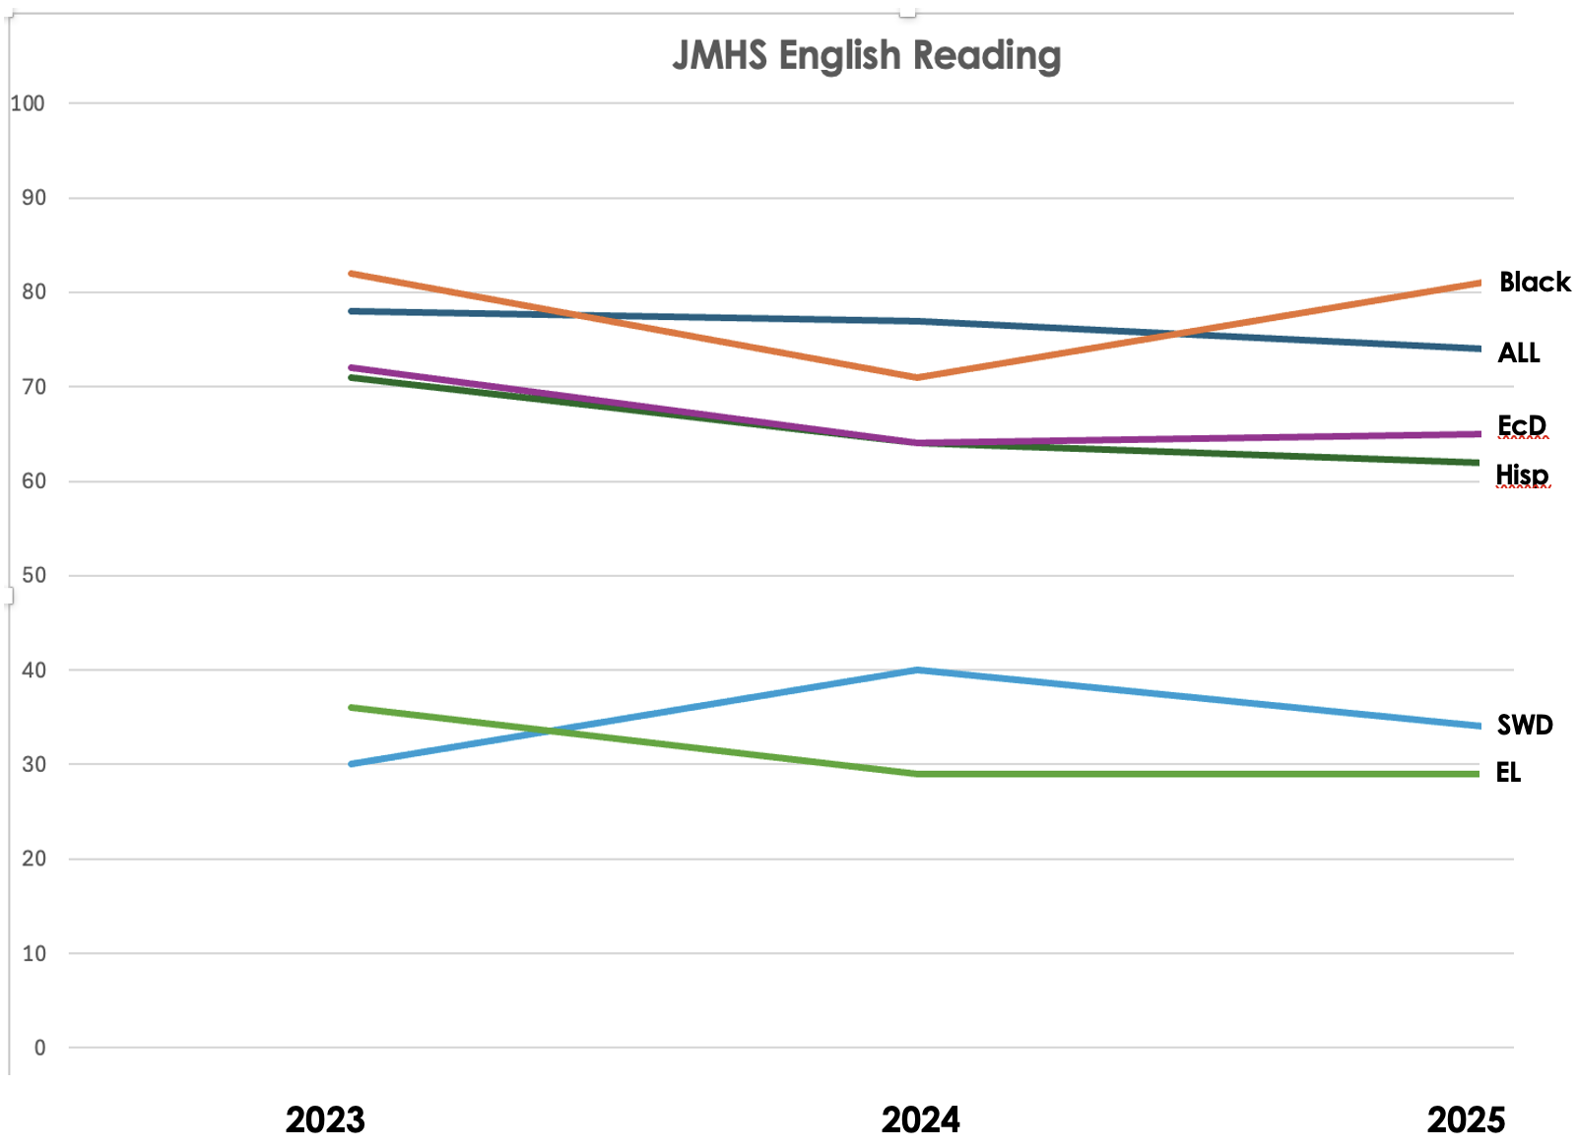

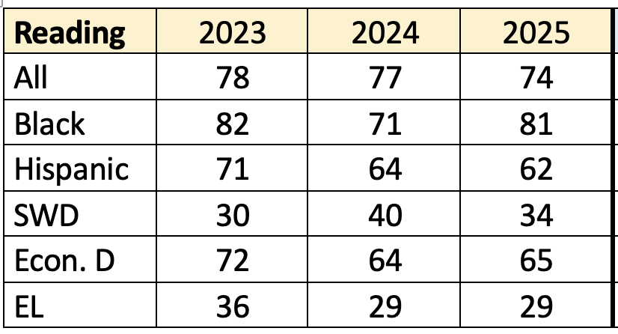
Searching for Opportunities: A Snapshot in Time  SOL Mathematics Results  Longitudinal and Subgroup Analysis | 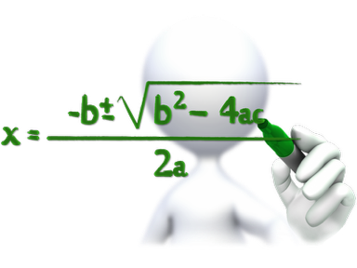

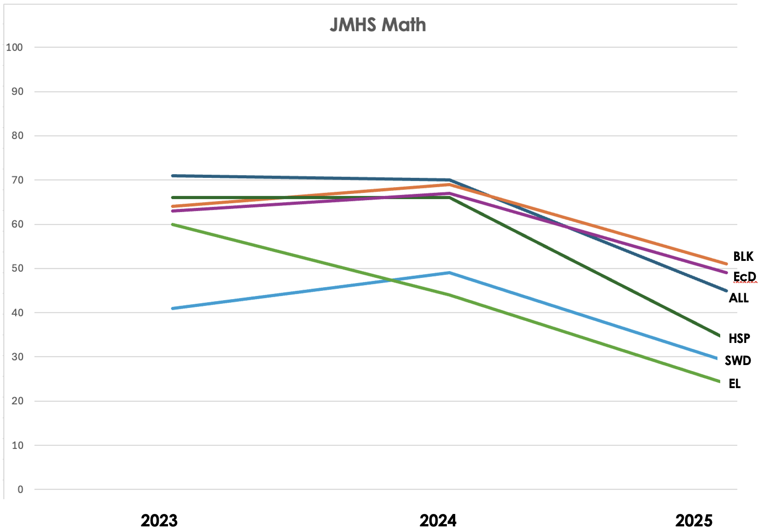

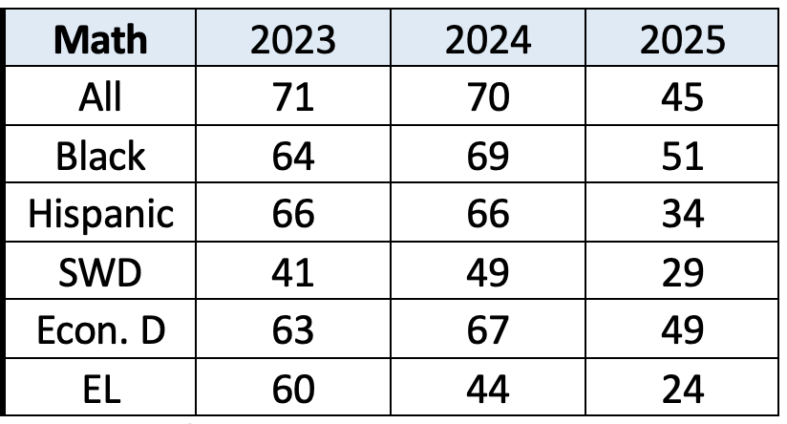
Searching for Opportunities: A Snapshot in Time  SOL Science Results  Longitudinal and Subgroup Analysis | 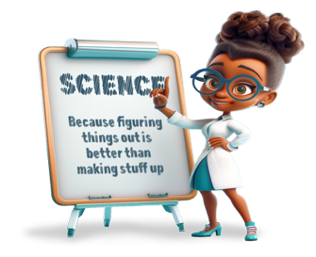

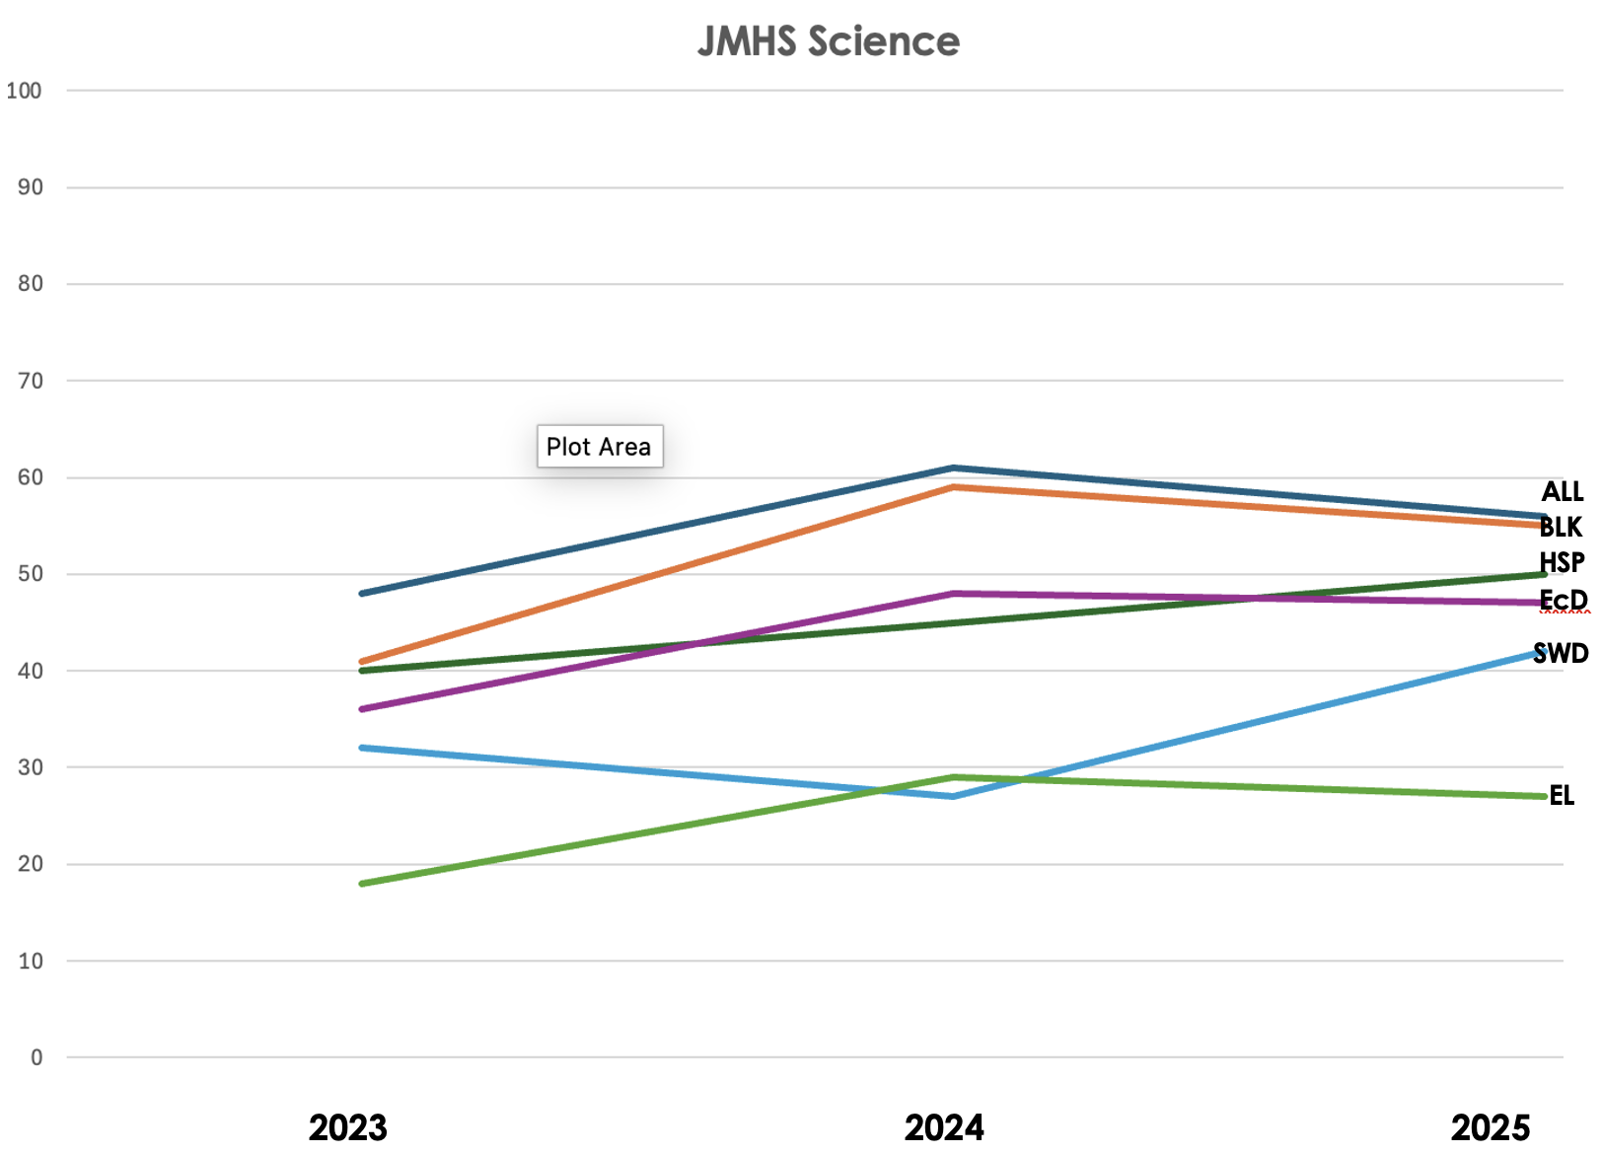

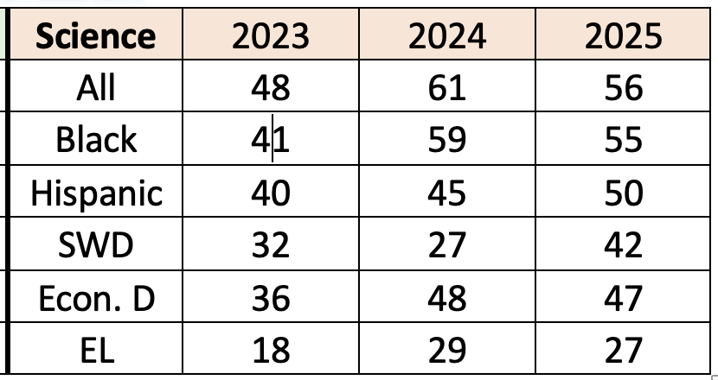
Searching for Opportunities: A Snapshot in Time  SOL History & Social Science Results  Longitudinal and Subgroup Analysis | 

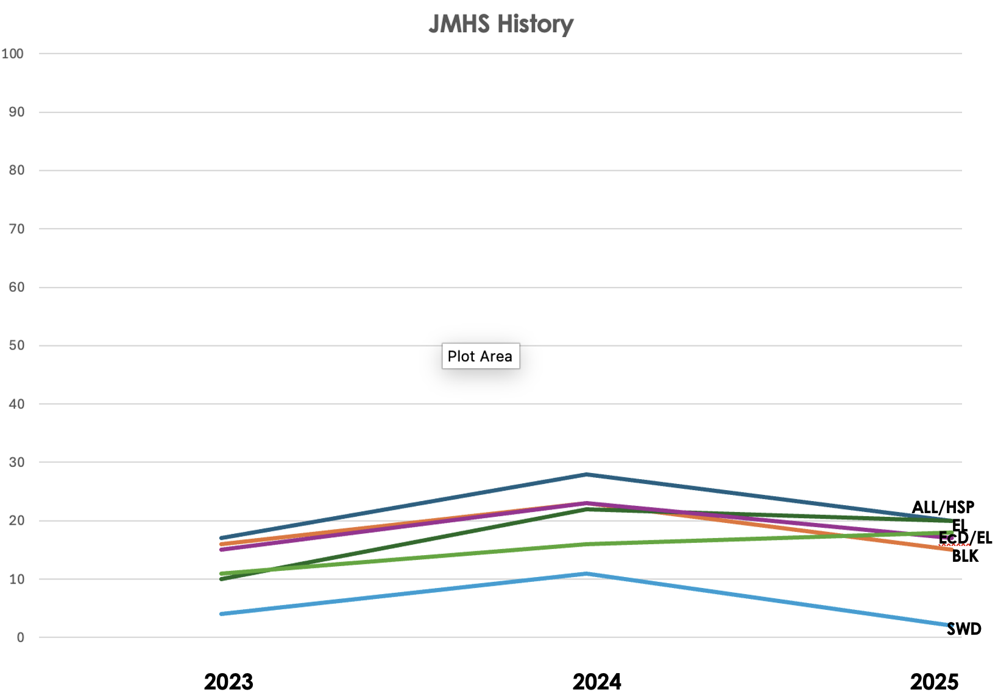

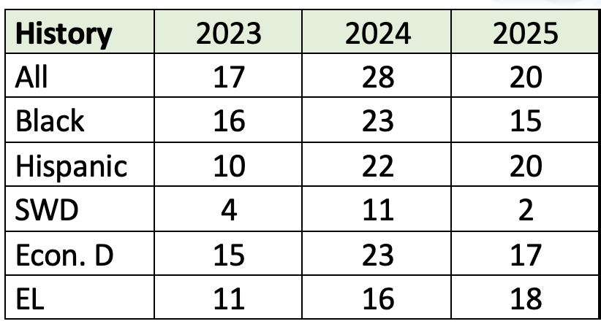
Elevating the Essentials to Radically Improve Student Learning
What we teach:  ~ Essential Knowledge  ~ Essential Skills  ~ Essential Vocabulary  ~ Essential Processes  Essential Student Skills  ~ Critical Thinking & Problem  Solving  ~ Collaboration  ~ Communication  ~ Creativity & Innovation  Essential Practices  ~ Make learning ‘safe’ for each  student. | How we teach:  Step 1:  Clear Learning Objectives  Step 2:  Modeling  Guided Practice  Independent Practice  Step 3:  Checking for  Understanding along the way  Step 4:  Extending and Appling  Knowledge | Instructional Frameworks  ~Clear objective: as well as,  showcase vocabulary  ~Five Minute Limit: teacher  talk limited to short intervals  ~Student Engagement:  active learning continually  through lesson  ~Summarizing: each  student summarizing  learning continually  ~Rehearsal Time: students  collaborate to compare and  contrast, share perspectives,  etc.  ~Formative Assessment:  Frequent check for  Understanding  ~TAPS: Total, Alone, Pairs,  Small-group
9 Ways to Teach Anything  ~Share clear learning  Goal(s)  ~Clarify and teach each  essential vocabulary  ~Model higher order  thinking  ~Ask second questions  ~Continually check for  understanding (formative)  ~Facilitate guided practice  ~Monitor independent  practice  ~Engage whole class in  discussion and debate  ~Integrate consistent  reading and writing with  clear feedback  ~Include opportunities to  summarize & extend and  apply new knowledge | All means All  A Guide to Research-Based Learning
Authentic Literacy Lessons

~Read: Close reading of a text, articles, books in all
content areas
~Annotate: Purposefully interacting with the text
~Discuss: Making connections, questioning, citing
evidence, debating
~Write: Facilitates free and creative thinking, applying
new vocabulary; requires specific feedback
Framework for Instructional Planning:
~ Establishing and sharing clear learning goals
~ Creating an Environment for Learning- provide students’ context for for learning;
check for and build background knowledge
~ Helping Students Develop Understanding – guide students in discovering and
developing understanding
~ Helping Students Extend and Apply Knowledge – closure that requires each
student to do something with and reflect on their understandings

Dan Mulligan, edited for 2025 – 2026
Unpacking the Essential Skills of Standards
Level of Complexity | Key Verbs that may Clue Level |  | Evidence of DOK
Level 1  Recall/Reproduction  Recall a fact, information, or procedure. Process information on a low level.  Bloom  Know/Remember  The recall of specifics and universals, involving little more than bringing to mind the appropriate material.  Comprehend/Understand  Ability to process knowledge on a low level such that the knowledge can be reproduced or communicated without a verbatim repetition. | Arrange  Calculate  Cite  Define  Describe  Draw  Explain  Give examples  Identify  Illustrate  Label  Locate  List  Match | Measure  Name  Perform  Quote  Recall  Recite  Record  Repeat  Report  Select  State  Summarize  Tabulate | - Explain simple concepts or routine procedures  - Recall elements and details  - Recall a fact, item or property  - Conduct basic calculations  - Order rational numbers  - Identify a scientific representation for simple phenomena  - Label locations  - Describe the features of a place or people  - Identify figurative language in a reading passage
Level 2  Skill/Concept  Use information or conceptual knowledge, two or more steps  Bloom  Apply  Uses information in another familiar situation.  Executes – carries out a procedure in a familiar task  Implements – uses a procedure in an unfamiliar task | Apply  Calculate  Categorize  Classify  Compare  Compute  Construct  Convert  Describe  Determine  Distinguish  Estimate  Explain  Extend  Extrapolate  Find  Formulate | Generalize  Graph  Identify patterns  Infer  Interpolate  Interpret  Modify  Observe  Organize  Predict  Relate  Represent  Show  Simplify  Solve  Sort  Use | - Solve routine multiple-step problems  - Describe non-trivial patterns  - Interpret information from a simple graph  - Sort objects  - Show relationships  - Apply a concept  - Organize, represent and interpret data  - Use context clues to identify the meaning of unfamiliar words  - Describe the cause/effect of a particular event  - Predict a logical outcome  - Identify patterns in events or behavior
Unpacking the Essential Skills of Standards
Level of Complexity | Key Verbs that may Clue Level |  | Evidence of DOK
Level 3  Strategic Thinking  Requires reasoning, developing a plan or a sequence of steps, some complexity  Bloom  Analyze  Breaking information into parts to explore understanding and relationships.  Evaluate  Checks/Critiques – makes judgements based on criteria and standards | Appraise  Assess  Cite evidence  Check  Compare  Compile  Conclude  Contrast  Critique  Decide  Defend  Describe  Develop  Differentiate  Distinguish | Examine  Explain how  Formulate  Hypothesize  Identify  Infer  Interpret  Investigate  Judge  Justify  Reorganize  Solve  Support | - Solve non-routine problems  - Interpret information from a complex graph  - Explain phenomena in terms of concepts  - Support ideas with details and examples  - Develop a scientific model for a complex situation  - Formulate conclusions from experimental data  - Compile information from multiple sources to address a specific topic  - Develop a logical argument  - Identify and then justify a solution  - Identify the author’s purpose and explain how  - Identify the author’s purpose and explain how it effects the interpretation of a reading selection
Level 4  Extended Thinking  Requires an investigation, time to think and process multiple conditions of the problem. Most on-demand assessments will not include Level 4 activities  Bloom  Synthesize  Putting together elements and parts to form a whole  Evaluation  Making value judgements about the method | Appraise  Connect  Create  Critique  Design  Judge  Justify  Prove  Report  Synthesize |  | - Design and conduct an experiment that requires specifying a problem, report results/solutions  - Synthesize ideas into new concepts  - Critique experimental designs  - Design a mathematical model to inform and solve a practical or abstract situation  - Connect common themes across texts from different cultures  - Synthesize information from multiple sources

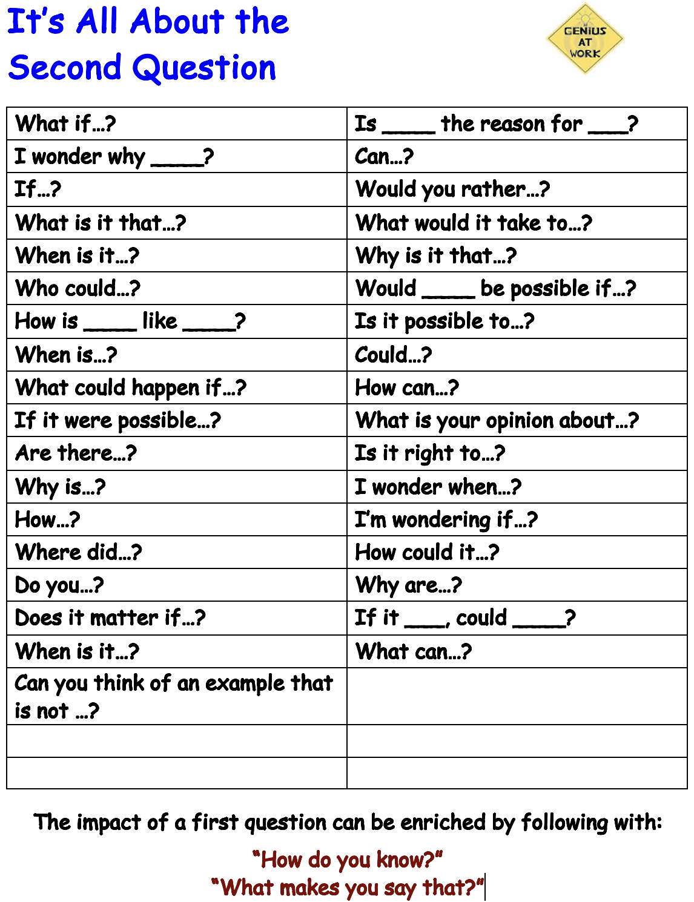
DOK Samples by Content area - ELA
ELA - Reading  DOK 1  - Support ideas by reference to verbatim or only slightly paraphrased details from the text.  - Use a dictionary to find the meanings of words.  - Recognize figurative language in a reading passage.  DOK 2  - Use context cues to identify the meaning of unfamiliar words, phrases, and expressions that could otherwise have multiple meanings.  - Predict a logical outcome based on information in a reading selection.  - Identify and summarize the major events in a narrative  DOK 3  - Explain or recognize how the author’s purpose affects the interpretation of a reading selection.  - Summarize information from multiple sources to address a specific topic.  - Analyze and describe the characteristics of various types of literature.  DOK 4  - Analyze and synthesize information from multiple sources.  - Examine and explain alternative perspectives across a variety of sources.  - Describe and illustrate how common themes are found across texts from different cultures | ELA -Writing  DOK 1  - Use punctuation marks correctly.  - Identify Standard English grammatical structures, including the correct use of verb tenses.  DOK 2  - Construct or edit compound or complex sentences, with attention to correct use of phrases and clauses.  - Use simple organizational strategies to structure written work.  - Write summaries that contain the main idea of the reading selection and pertinent details.  DOK 3  - Support ideas with details and examples.  - Use voice appropriate to the purpose and audience.  - Edit writing to produce a logical progression of ideas  DOK 4  - Write an analysis of two selections, identifying the common theme and generating a purpose that is appropriate for both.
DOK Samples by Content area - MATH
DOK 1  - Recall or recognize a fact, definition, or term  - Apply a well-known algorithm  - Apply a formula  - Determine area or perimeter of rectangles or triangles given a drawing and labels  - Identify a plane or three-dimensional figure  - Measure a length  - Perform a specified or routine procedure  - Evaluate an expression  - Solve a one-step word problem  - Retrieve information from a table or graph  - Recall, identify, or make conversions between and among representations or numbers (fractions, decimals, and percents), or within and between customary and metric measures  - Locate numbers on a number line, or points on a coordinate grid  - Solves linear equations  - Represent math relationships in words, pictures, or symbols | DOK 2  - Classify plane and three-dimensional figures  - Interpret information from simple graph  - Use models to represent mathematical concepts  - Solve a routine problem requiring multiple steps, or the application of multiple concepts  - Compare figures or statements  - Compare and contrast figures  - Provide justifications for steps in a solution process  - Extend a pattern  - Retrieve information from a table, graph, or figure and use it solve a problem requiring multiple steps  - Translate between tables, graphs, words and symbolic notation  - Select a procedure according to criteria and perform it
DOK 3  - Interpret information from a complex graph  - Explain thinking when more than one response is possible  - Make and/or justify conjectures  - Develop logical arguments for a concept  - Use concepts to solve problems  - Perform procedure with multiple steps and multiple decision points  - Generalize a pattern  - Describe, compare, and contrast solution methods  - Formulate a mathematical model for a complex situation  - Provide mathematical justifications  - Solve a multiple- step problem, supported with a mathematical explanation that justifies the answer  - Formulate an original problem, given a situation | DOK 4  - Relate mathematical concepts to other content areas  - Relate mathematical concepts to real-world applications in new situations  - Apply a mathematical model to illuminate a problem, situation  - Conduct a project that specifies a problem, identifies solution paths, solves the problem, and reports results  - Design a mathematical model to inform and solve a practical or abstract situations  NOTE: Level 4 requires applying one approach among many to solve problems. Involves complex restructuring of data, establishing and evaluating criteria to solve problems.

DOK Samples by Content area – Science
DOK 1  - Recall or recognize a fact, term, definition, simple procedure (such as one step), or property  - Demonstrate a rote response  - Use a well-known formula  - Represent in words or diagrams a scientific concept or relationship  - Provide or recognize a standard scientific representation for simple phenomenon  - Perform a routine procedure, such as measuring length  - Perform a simple science process or a set procedure (like a recipe)  - Perform a clearly defined set of steps  - Identify, calculate, or measure  NOTE: If the knowledge necessary to answer an item automatically provides the answer, it is a Level 1 | DOK 2  - Specify and explain the relationship between facts, terms, properties, or variables  - Describe and explain examples and nonexamples of science concepts  - Select a procedure according to specified criteria and perform it  - Formulate a routine problem given data and conditions  - Organize, represent, and compare data  - Make a decision as to how to approach the problem  - Classify, organize, or estimate  - Compare data  - Make observations  - Interpret information from a simple graph  - Collect and display data  NOTE: If the knowledge necessary to answer an item does not automatically provide the answer, then the item is at least a Level 2. Most actions imply more than one step. NOTE: Level 3 is complex and abstract. If more than one response is possible, it is at least a Level 3 and calls for use of reasoning, justification, evidence, as support for the response.
DOK 3  - Interpret information from a complex graph (such as determining features of the graph or aggregating data in the graph)  - Use reasoning, planning, and evidence  - Explain thinking (beyond a simple explanation or using only a word or two to respond)  - Justify a response  - Identify research questions and design investigations for a scientific problem  - Use concepts to solve non-routine  - problems/more than one possible answer  - Develop a scientific model for a complex situation  - Form conclusions from experimental or observational data  - Complete a multi-step problem that involves planning and reasoning  - Provide an explanation of a principle  - Justify a response when more than one answer is possible  - Cite evidence and develop a logical argument for concepts  - Conduct a designed investigation  - Research and explain a scientific concept  - Explain phenomena in terms of concepts. | DOK 4  - Select or devise an approach among many alternatives to solve problem  - Based on provided data from a complex experiment that is novel to the student, deduct the fundamental relationship between several controlled variables.  - Conduct an investigation, from specifying a problem to designing and carrying out an experiment, to analyzing its data and forming conclusions  - Relate ideas within the content area or among content areas  - Develop generalizations of the results obtained and the strategies used  - and apply them to new problem situations  NOTE: Level 4 activities often require an extended period of time for carrying out multiple steps; however, time alone is not a distinguishing factor if skills and concepts are simply repetitive over time.

DOK Samples by Content area – History and Social Science

DOK 1  - Recall or recognition of: fact, term, concept, trend, generalization, event, or document  - Identify or describe features of places or people  - Identify key figures in a particular context meaning of words  - Describe or explain: who, what, where, when  - Identify specific information contained in maps, charts, tables, graphs, or drawings | DOK 2  - Describe cause-effect of particular events  - Describe or explain how (relationships or results), why, points of view, processes, significance, or impact  - Identify patterns in events or behavior  - Categorize events or figures in history into meaningful groups  - Identify and summarize the major events, problem, solution, conflicts  - Distinguish between fact and opinion  - Organize information to show relationships  - Compare and contrast people, events, places, concepts  - Give examples and non-examples to illustrate an idea/concept
DOK 3  - Explain, generalize, or connect ideas, using supporting evidence from a text/source  - Apply a concept in other contexts  - Make and support inferences about implied causes and effects  - Draw conclusion or form alternative conclusions  - Analyze how changes have affected people or places  - Use concepts to solve problems  - Analyze similarities and differences in issues or problems  - Propose and evaluate solutions  - Recognize and explain misconceptions related to concepts | DOK 4  - Analyze and explain multiple perspectives or issues within or across time periods, events, or cultures  - Gather, analyze, organize, and synthesize information from multiple (print and non-print) sources  - Make predictions with evidence as support  - Plan and develop solutions to problems  - Given a situation/problem, research, define, and describe the situation/problem and provide alternative solutions  - Describe, define, and illustrate common social, historical, economic, or geographical themes and how they interrelate

DOK 3 Strategic Thinking & Reasoning
Tasks and classroom discourse falling into this category demand the use of planning, reasoning, and higher order thinking processes, such as analysis and evaluation, to solve real-world problems or explore questions with multiple possible outcomes. Stating one’s reasoning and providing relevant supporting/ evidence are key markers of DOK 3 tasks. The expectation established for tasks at this level require an in-depth integration of conceptual knowledge and multiple skills to reach a solution or produce a final product. DOK 3 tasks and classroom discourse focus on in-depth understanding of one text, one data set, one investigation, or one key source, whereas DOK 4 tasks expand the breadth of the task using multiple texts or sources, or multiple concepts/disciplines to reach a solution or create a final product.
DOK 3 Verb Clues
Critique, appraise, revise for meaning, assess, investigate, cite evidence, test hypothesis, develop a logical argument, use concepts to solve non-routine problems, explain phenomena in terms of concepts, draw conclusions based on data
DOK 3 Teacher Role  Questions to probe reasoning and underlying thinking, asks open-ended questions, acts as a resource and coach, provides criteria and examples for making judgments and supporting claims, encourages multiple approaches and solutions; determines when/where (text, concept) depth and exploration is most appropriate |  | DOK 3 Student Role  Uncovers and selects relevant and credible supporting evidence for analyses, critiques, debates, claims and judgments; plans, initiates questions, disputes, argues, tests ideas/solutions, sustains inquiry into topics or deeper problems, applies to the real world
DOK 3 Possible Products
- Complex Graph  - Set up a database  - Conduct or critique a designed investigation  - Video cast or podcast  - Analyze survey result | - Debate from a given perspective  - Develop storyboard for film or cartoon animation  - Multi-paragraph essay or short story  - Design a webpage |  |  | - Literary critique  - Play, book, music, or movie review  - Informational report with several subtopics  - Fact-based argument (Is this criticism supported by the historical facts
DOK 3 Potential Activities
- Analyze results of a questionnaire or survey (e.g., survey classmates/  - industry members to find out what they think about a current issue)  - Prepare an informational report about an area of study  - Write a letter to the editor after evaluating a product  - Prepare for and participate in a debate  - Use evidence to generate criteria for making judgments  - Make a booklet or brochure about a topic, organization, or issue  - Participate on a panel to discuss differing viewpoints on... |  |  | - Solve complex, non-routine problems that draw upon multiple skills, concepts, and processes  - Write an essay, short story, poem, or play  - Create complex graphs or databases where reasoning and approach to data organization is not obvious  - Design, conduct, or critique an investigation to answer a research question  - Propose an alternate solution to a problem studied  - Prepare a speech to support your perspective about ...  - Explain and apply abstract terms and concepts to real-world situations

DOK 3 Potential Questions
- What are the possible design flaws in …?  - What is the theme/the lesson learned ... ?  - How would the theme change if …?  - What underlying bias is there ... ?  - What inferences will these facts support ..?  - How does the author create tension/suspense…?  - What is the author’s chain of reasoning or point of view for …?  - How is ____ related to ____?  - What conclusions can you draw _____?  - How would you adapt____ to create a different____?  - How would you test____?  - Can you predict the outcome if____?  - What is the best answer? Why?  - What conclusion can be drawn from these three texts?  - What is your interpretation of this text? Support your rationale. | - What is the impact on the reader /viewer for use of this (rhetorical device, analogy, figurative language use, visual image, etc.)?  - What conclusions can you draw ... ?  - How can you prove that your solution or estimate is reasonable?  - What evidence can you find to support ... ?  - What ideas justify this position ... ?  - How would you describe the sequence of____?  - What facts would you select to  - support____?  - Can you elaborate on the reason____?  - What would happen if___?  - Can you formulate a theory for___?  - How would you test___?  - Can you elaborate on the reason___?

DOK 3 Content Specific aligned to Bloom’s Taxonomy (source: Hess)
Revised Bloom’s Taxonomy | ELA and Social Studies | Math and Science
REMEMBER  Retrieve knowledge from long-term memory, recognize, recall, locate, identify | Not Applicable | Not Applicable
UNDERSTAND  Construct meaning, clarify, paraphrase, represent, translate, illustrate, give examples, classify, categorize, summarize, generalize, infer a logical conclusion, predict, compare/contrast, match like ideas, explain, construct models | - Explain, generalize, or connect ideas using supporting evidence (e.g., quote, example, text reference)  - Identify/make inferences about explicit or implicit themes  - Describe how word choice, point of view, or bias may affect the readers’ interpretation of a text  - Write multi-paragraph composition for specific purpose, focus, voice, tone & audience | - Use concepts to solve non-routine problems  - Explain, generalize, or connect ideas using supporting evidence  - Make and justify conjectures  - Explain thinking when more than one response/solution is possible  - Explain phenomena in terms of concepts
APPLY  Carry out or use a procedure in a given situation, carry out (apply) to a familiar task, or use (apply) to an unfamiliar task | - Apply a concept in a new context  - Revise final draft for meaning or progression of ideas  - Apply internal consistency of text organization and structure composing a full composition  - Apply word choice, point of view, style to impact readers’/viewers’ interpretation of a text | - Design investigation for a specific purpose or research question  - Conduct a designed investigation  - Use concepts to solve non-routine problems  - Use and show reasoning, planning, and evidence  - Translate between problem & symbol notation when not a direct translation
ANALYZE  Break into constituent parts, determine how parts relate, differentiate between relevant-irrelevant, distinguish, focus, select, organize, outline, find  coherence, deconstruct (e.g. For bias or point of view) | - Analyze information within a text or source  - Analyze interrelationships among concepts, issues, problems  - Analyze or interpret author’s craft (literary devices, viewpoint, or potential bias) to create or critique a text or to support text interpretations  - Use reasoning and evidence to generate criteria for making and supporting an argument of judgment (e.g., Was FDR a great president? Who was the greatest ball player?) | - Compare information within data sets or texts or across related data sets  - Analyze and draw conclusions from data, citing evidence  - Generalize a pattern  - Interpret data from complex graph  - Analyze similarities/differences between research procedures or solutions
EVALUATE  Make judgments based on criteria, check, detect, inconsistencies, or fallacies, judge, critique | - Cite evidence and develop a logical argument for conjectures  - Describe, compare, and contrast solution methods  - Verify reasonableness of results  - Justify or critique conclusions drawn | - Cite evidence and develop a logical argument for concepts or solutions  - Describe, compare, and contrast solution methods  - Verify reasonableness of results
CREATE  Reorganize elements into new patterns/structures, generate, hypothesize, design, plan, produce | - Synthesize information within one source or text  - Develop a complex model for a given situation  - Develop an alternative solution | - Synthesize information within one data set, source or text  - Formulate an original problem given a situation  - Develop a scientific/ mathematical model for a complex situation

Differentiation Chart
Multiple Strategies to Reach EACH Student

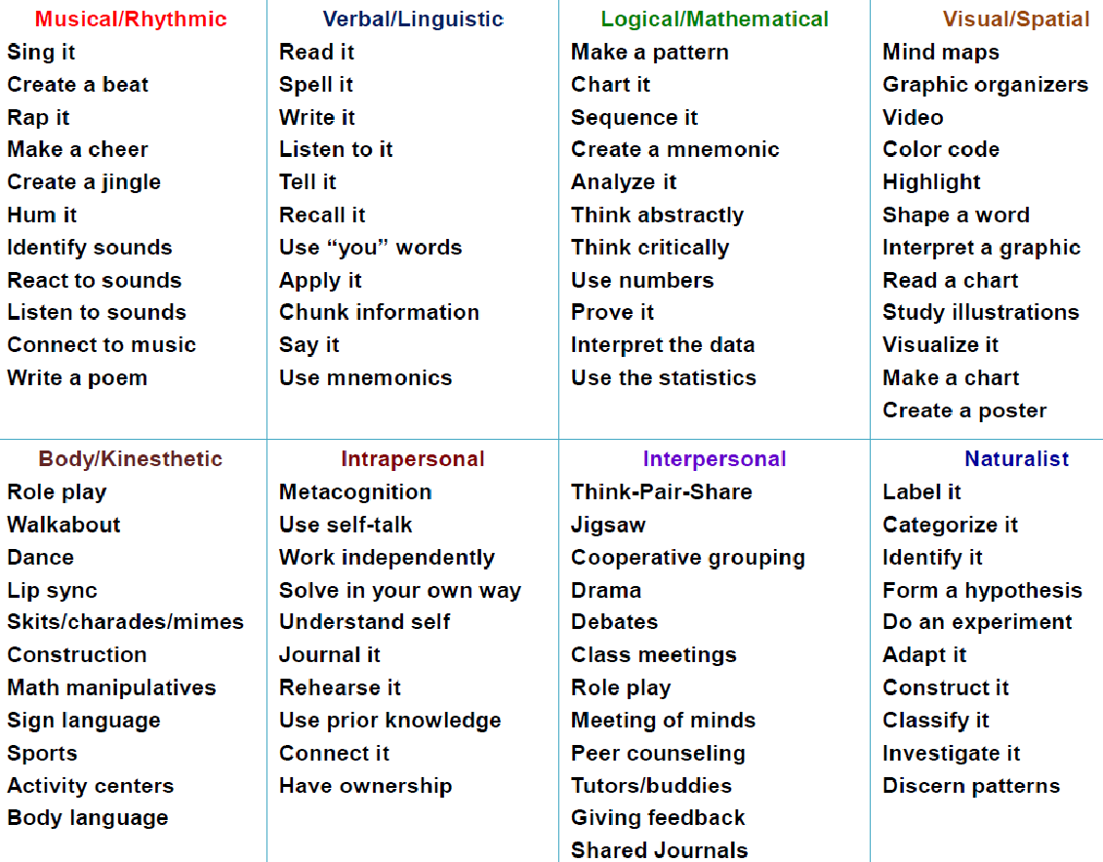

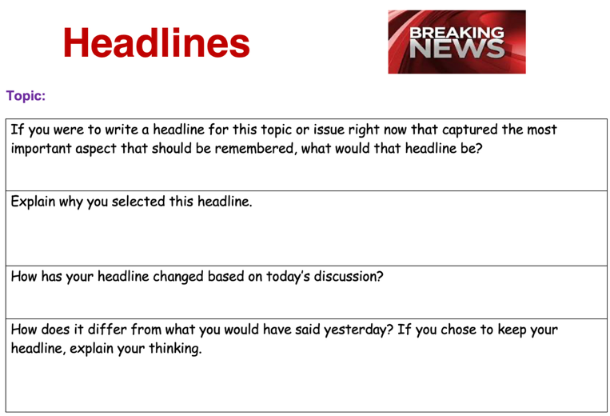 | 