Learning Intention & Success Criteria Games | 
Challenge 1: With your partner, determine what (if any) additional success criteria would assist students on their journey to proficiency with the learning intention.
Essential Standard: AZ Math 3.OA.A.3
Use multiplication and division within 100 to solve word problems in situations involving equal groups arrays and measurement quantities.

Learning Progression: Use models and representations to solve multiplication or division word problems within 100.
Learning Intentions | Success Criteria
I am learning about representing a multiplication or division word problems as equal groups. | I can identify the factors of a multiplication word problem as the number of groups and amount of groups
I am learning about representing a multiplication or division word problem as an array. | I can
I am learning about representing a multiplication or division word problem as an equation with unknown numbers. | I can represent the multiplication or division word problem as an equation.
I am learning about problem solving with multiplication or division to find an unknown.

Challenge 2: Determine which of the success criteria would be most appropriate for the learning intention.
Standard: Essential AZ ELA 8.RL.4
Determine the meaning of words and phrases as they are used in a text, including figurative and connotative meanings; analyze the impact of specific word choices on meaning and tone, including analogies or allusions to other text.
Learning Intentions | Success Criteria
I am learning about figurative language and its impact on the reader. | I can explain why the author might have used figurative language.  I can use the dictionary to write the definition of words.  I can identify the grammar component of words in a text.  I can distinguish between literal language and figurative language.  I can explain the difference between denotative meaning and connotative meaning of words.  I can define and identify various forms of figurative language.

Challenge 3: Determine The learning intention and success criteria for the following EXIT TICKET.
Essential AZ 4.MD.A.3 Apply the area and perimeter formulas for rectangles in mathematical problems and problems in real-world contexts including problems with unknown side lengths

Rectangles A, B, C and their side lengths, in inches (in) are shown.
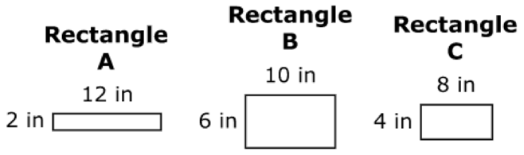
Complete the sentences about the perimeter and area of the rectangles by filling in each box.
Rectangle ______ has a perimeter of 32 inches.
The area of rectangle A is ____ square inches.
Learning Intentions | Success Criteria
I am learning | I can

