Teacher Clarity Samples
Learning Targets and Proficiency Scales
Math: I am learning to solve multistep linear inequalities, graph the solution on a number line, and interpret the solution in context. |  | Reading: I am learning to explain how a character changes throughout a story.
 | I can explain what the solution means in the real-world situation. |  | I can give reasons for the change using events or interactions from the story.
 | I can write the solution using words, symbols, and a graph.
 | I can graph the solution accurately using open or closed circles and arrows. |  | I can describe how a character changes or grows from the beginning to the end of the text.
 | I can simplify and solve the inequality step by step. |  | I can identify a character that changes throughout a story.
 | I can apply the properties of inequality correctly, including reversing the inequality when multiplying or dividing by a negative number. |  | I can identify a character that changes throughout a story.

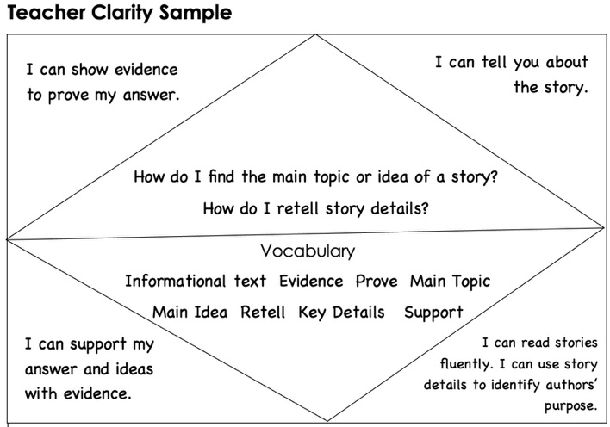
Learning Progressions, Learning Intentions, and Success Criteria to Educate the Whole Child

Developing | Proficient | Distinguished
- My learning intentions are posted, but not accessible to students (visually or conceptually).  - My success criteria are posted, but not accessible to students (visually or conceptually).  - My learning intention and success criteria are communicated at the beginning of the lesson by the teacher.  - My students are able to answer the 3 critical questions with less than 50% proficiency.  - What am I Learning today?  - Why am I learning it?  - How will I know I have learned it?  - My student will refer to the board where the learning intention and success criteria are located and read or repeat verbatim.  - There is little evidence of an instructional framework. My primary instructional delivery method is teacher-centered/lecture. | - My learning intentions are posted and accessible to students. My learning intentions are written in student‐friendly language. They may or may not be aligned to the standard.  - My success criteria are posted and accessible to students. They may or may not be aligned to the learning intention.  - My learning intention and success criteria are communicated and referenced throughout the learning, mainly by the teacher.  - My students are able to answer the 3 critical questions with at least 50%-80% proficiency.  - My students are able to paraphrase the learning intention and the purpose for the learning but cannot explain how they will show success.  - There is some evidence of an instructional framework with active engagement. | - My learning Intentions are posted and accessible to students throughout the learning. My learning intentions are written in student‐friendly language in a way that actively engages students in the learning process. Learning intentions state what the students will learn in relation to the standard rather than what they will do.  - My success criteria are posted, accessible to students, and aligned to the learning intention and rigor of the standard.  - My students and myself co-construct learning intention and success criteria through a variety of methods and are routinely reference throughout the learning by teacher and students.  - My students are able to answer the 3 critical questions with at least 80%-100% proficiency.  - My students are able to summarize the learning intention, the purpose for the learning, and how they will demonstrate achievement of the success criteria.  - There is evidence of effective instructional framework that includes student-centered learning experiences aligned to learning intention and success criteria for the day.

