Format Resource: AzMERIT Item Types
ELA Item Types
- Hot Text
- Multi-Select
- Grid Item
- Multiple Choice
- Open Response

ELA Example 1: HOT TEXT
After reading a passage, answer the following:

Part A:
Select the author’s purpose for writing this text.

Part B:
Select a sentence from the text that supports this purpose.

OR
The author is concerned about the loss of _____ in our society.
Select a line in the first paragraph that demonstrates how the author distinguishes the point of view.

ELA Example 2: Multi-Select
These will commonly have key words such as: “select all” or the fill in space will be square rather than circular.
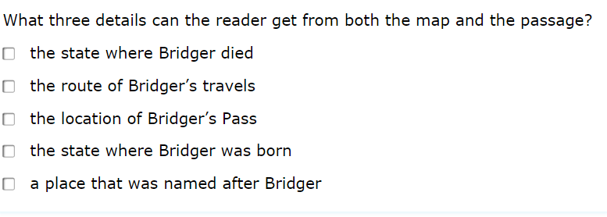

ELA Example 3: Grid Item
Requires the student to drag descriptions, analyses, or elements of a poem’s structure into a graphic organizer. This will likely be numbered or lettered on the paper test.
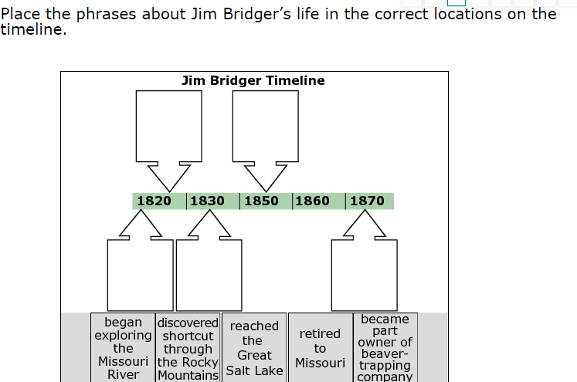

ELA Example 4: Open Response:
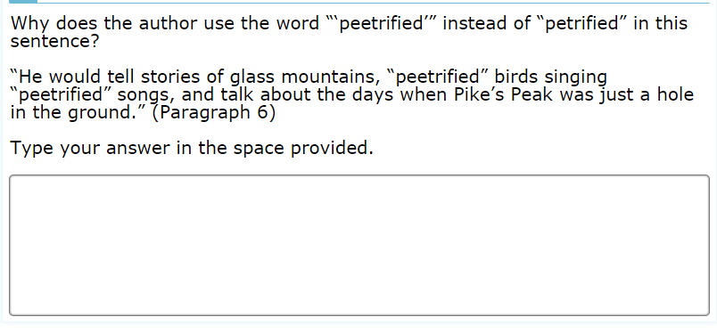

Format Resource: AzMERIT Item Types
Math Item Types
- Multi-step Response
- Equation Response
- Multiple Choice Response
- Graphic Response – Drag and Drop, Drawing, Hot Spot
- Table Response
- Natural Language Response

Math Example 5: Multi-Select
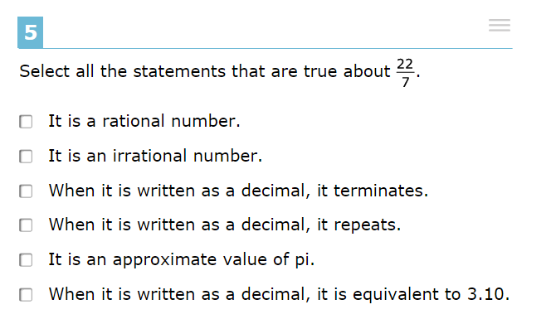
Math Example 6: Equation Response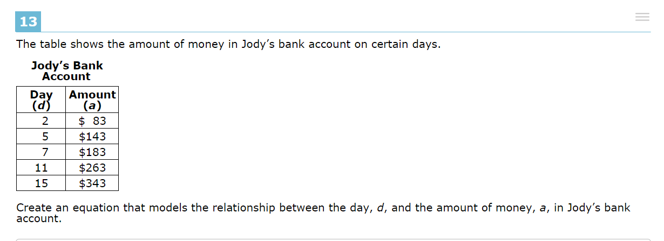
Math Example 7: Graphic Response
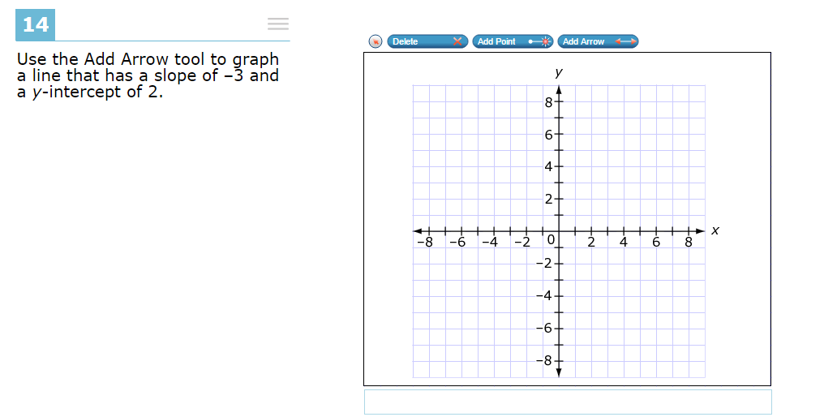
Math Example 8: Table Response:
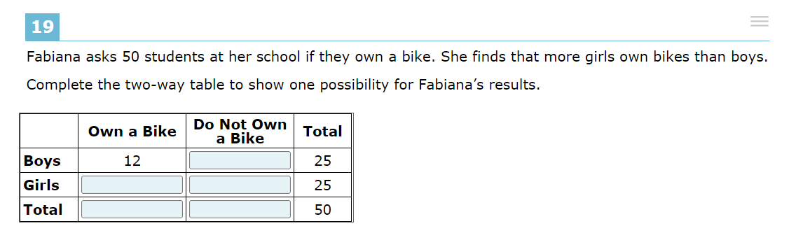
Example 9: Natural Language Response
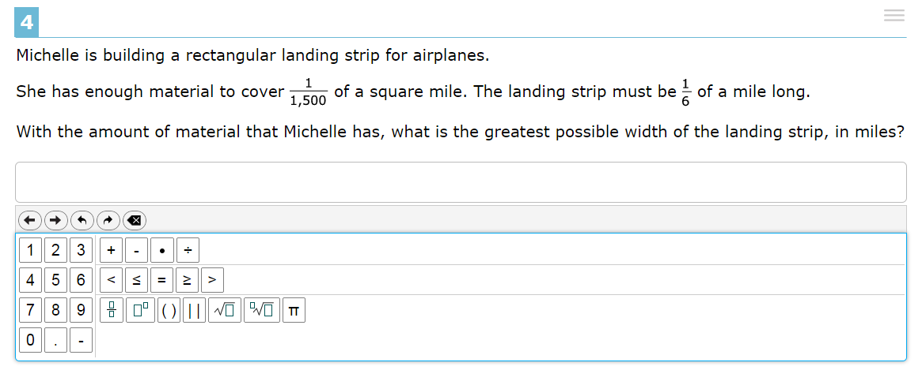
Other Math Examples:
