CFA: G9
Item #1: Alignment to  PLD: G13b.0  Draw a line connecting each geometric solid to the correct formula to calculate its volume.  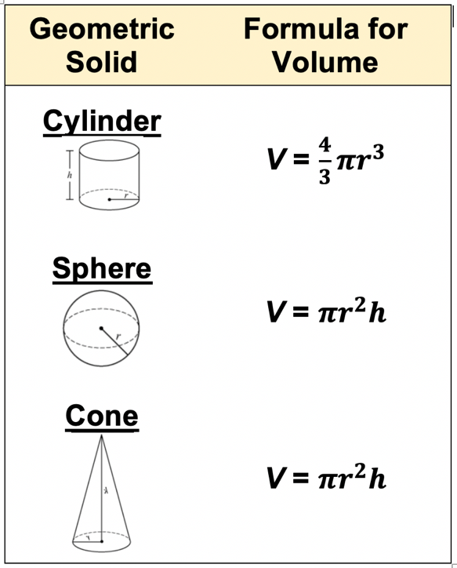 | Item #2: Alignment to PLD: G13b.1  Shanita is curious to know how much ice cream the interior of her sugar cone can hold. Given the dimensions of her cone below, which equation can be used to calculate the volume?  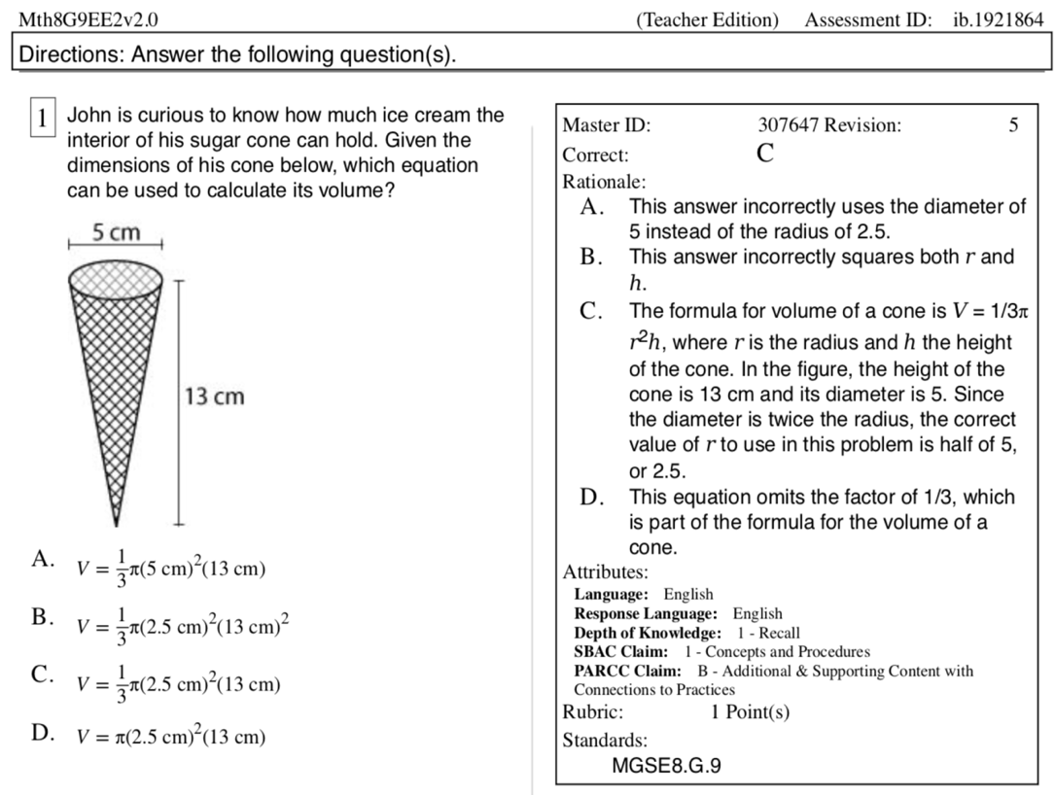
Item # 3: Alignment to PLD: G13b.2  Directions: Write your answer in the box below after showing your thinking.  The cylinder below has a volume of 80 $π$ cm³. What is the value of r?  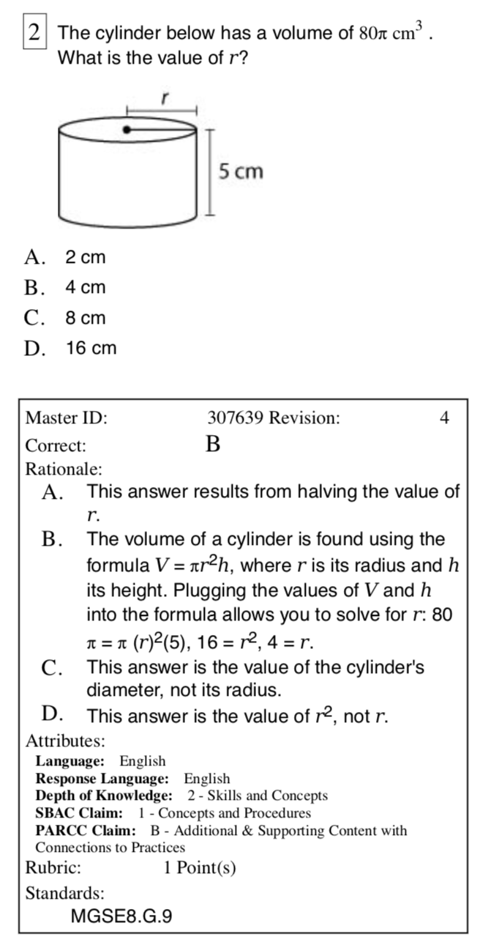 | Item # 4: Alignment to PLD: G13b.3  Peter usually purchases a small can of tomato sauce as shown below.  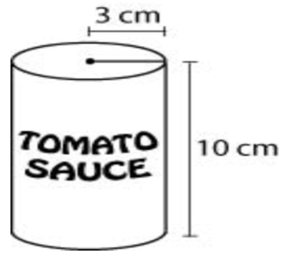  At a grocery store, she sees a can of tomato sauce that has a radius and height that are twice that of the small can. The volume of this large can is equal to the volume of how many of the small cans?  - 2  - 4  - 8  - 16

Item #5: Alignment to PLD: G13b.3  If the radius of a sphere increases from 3 feet to 9 feet, by how many cubic feet does the volume of the sphere increase?  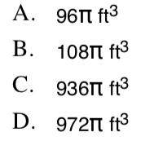 | Item #6: Alignment to PLD: G13b.4  A company makes tennis balls. Each tennis ball is a sphere with a diameter of approximately 6.7 centimeters.  - What is the approximate volume, in cubic centimeters, of 1 tennis ball? S how your work or explain your answer?  - The company sells the tennis ball in a cylindrical cam in which 3 tennis balls fit snugly, as shown below  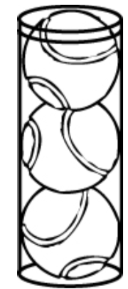  What is the volume, in cubic centimeters, of the space inside the can surrounding the tennis balls? Show your work or explain your answer.

G.9 Apply the formulas for the volume of cones, cylinders, and spheres and use them to solve real- world and mathematical problems.

My Learning Goal | Getting Started | On my Way | I’m There | Notes to Self
I recognize the formula for volume of a cone, cylinder, pyramid, and sphere.
I substitute values in the correct formula for volume.
I apply the formula of volume.
I apply volume to real-world problems.

