Creating Choice Boards

What are Choice Boards:
- Graphic Organizers
- Often set-up in a grid
- Supports differentiation
- Purposefully organized

Why bother?
- Stimulate student engagement
- Empower students to choose “How” they learn
- Encourages responsibility and independence
- Allows differentiation in one document

How to create a choice board:
- Good news: There are MANY of different ways to design how you are going to execute choice boards. NOTE: There is no substituting for the power of a PLC collaboratively sharing resources to design a choice board.

Types of Choice Boards
- Must Do, May Do Choice Board (usually weekly or by unit)
- Must Do is an assignment everyone has to do 1st each day.
- May Do allows each student to choose from 3 activities that relate to the standard (objective) for the day using a variety of methods.
- Accountability ideas:

Template for Must Do, May Do

 | Monday | Tuesday | Wednesday | Thursday | Friday
Must Do
May Do once you have completed your must do.
Complete two May Do each day.

Sample of Must Do, May Do

 | Monday | Tuesday | Wednesday | Thursday | Friday
Must Do | Nearpod  Lesson  WJCPM | Exponential Expressions | Function Exploration | Absolute Value Equations
May Do once you have completed your must do.  Complete two May do each day. | Irrational Numbers  Activity | Exponential  Sliders | Identify the Function | Calibration | Catch up, Genius Hour, Conferencing
 | Pi in the Sky | Fractional Exponent Applications | Exploring Functions | Application of Absolute Value | Catch up, Genius Hour, Conferencing
 | The iPad is a Pythagorean Triple | Properties of Exponents | Hospital  Monitor | Complex Absolute Value | Catch up, Genius Hour, Conferencing

- Think-Tac-Toe Choice Board
NOTE: The grey boxes do not necessarily need to be on the student version
- Rows coordinate to the components of the standard/objective (e.g., 8.2a, 8.2b, …) or actionable steps (e.g., compare, organize, ….
- Columns are different methods to show their learning.
- Provide specific directions as to HOW they are to work (e.g., vertical horizontal, any 3, …).
- Make sure each option shows what they are learning to the same extent but not necessarily in the same way.

Template for Think-Tac-Toe

 | Written | Tech | Hybrid
First Component of the Standard
Second Component of the Standard
Third Component of the Standard

Sample of a Think-Tac-Toe (Pick one from each row)

 | Written | Tech | Hybrid
Comparing | Create and explain a Venn Diagram comparing and contrasting Rome and Athens | Playposit  LINK HERE | Label Directions  Blank Map
Study Tool | Use your notes to create a study guide for an absent student. | Quizizz  LINK HERE | Create a timeline of the major events involving Rome and Athens
Grapes/ Organization | Write an essay about the GRAPES for Rome. | Create a video that explains the GRAPES for Rome | Create a sideshow of the GRAPES of Rome.

Note: GRAPES stands for geography, religion, achievements, politics, economics, and social structures.

Variation: We can design a Think-Tac-Toe with the middle box as a ‘must do’.

 | Written | Tech | Hybrid
Comparing | Create and explain a Venn Diagram comparing and contrasting Rome and Athens | Playposit  LINK HERE | Label Directions  Blank Map
Study Tool | Use your notes to create a study guide for an absent student. | Required Box  Quizizz  LINK HERE | Create a timeline of the major events involving Rome and Athens
Grapes/ Organization | Write an essay about the GRAPES for Rome. | Create a video that explains the GRAPES for Rome | Create a sideshow of the GRAPES of Rome.

- Total Points Choice Board
- Multiple options for completing activities
- Can be a day, week, or unit
- Quicker/easier items worth less points
- Longer/more difficult worth more points
- Everyone must get a total value of points (e.g., 100 pts.)

Template for Total Points

20
40
60

Sample of Total Points

Culture Choice Board
20 | La Sobremesa  Come to Ms. Sauders’ room on 4/21 or 2/28 during C lunch. Bring your lunch; be on time; sign up in advance; Practice Spanish with your friends. | Comida Autentica  Make an authentic Spanish/Argentine dish for friends/family/class. Turn in mini photo journal with at least 10 pictures with captions in Spanish underneath along with the recipe. | Pen-Pals  Keep up a conversation with your friends via email or hand-written letters in Spanish. Pen-Pals must respond/write at least three times at least 100 words. Print and turn in.
40 | Personas Importantes  Research a Hispanic historical figure or hero. Learn as much as you can about this person. Create visual representing this person and schedule a time to come (or during class) to give a brief presentation. | Noche de Pelicula  Host/Attend a Spanish movie night a someone’s house. Proof: 1. Photo documentation, 2. Parent Signature, 3. Your recorded critique of the film. | Celebracion de Dia de Independencia  Meet at Mi Familia at 6:30 pm for dinner. Conversation must be in Spanish during the meal. Must sign up in advance.
60 | Dia de Independencia de Mexico  Mexico’s Independence Day is September 15th. Research this holiday and make a video at least 5nminutes long teaching the viewer about it. Must be completely in Spanish with at least 2 brief interviews with Native Spanish speakers. | Voluntario  Volunteer at least two hours in a community or public-school ESL classroom. For proof you will need at least one photo and a brief description of what you did in Spanish. | Entrevista  Interview a native Spanish speaker in Spanish. Minimum 15 minutes. Record conversation.

- Project Choice Board
- A variety of options for a large project
- All options can cover 1 general rubric

Sample of Project Choice Board

Historical Figure Choice Board

Trading Cards  Create a trading card. Be sure to include a picture of the figure and detailed information about their significance related to the unit of study. | Write a Letter  Write a letter to the figure describing your opinion about their contributions to society. Be sure to include correct letter format. | Write an Essay  Write an essay about the contributions and significance of an historical figure. Be sure to write in formal language and cite your sources.
Storybook  Create a children’s storybook about an historical figure. Be sure to write in a language for an 8-year-old and include visuals to keep the child engaged. Web option: storybird.com | Timeline  Create an illustrated timeline of an historical figure. For each event, be sure to include a title of the event, description, date and visual. Web option: timelinebuilder.com | Sensory Figure  Use your imagination to create a sensory figure. For each sense, describe what the person would say, think, feel, hear, see, etc.
Presentation  Create a presentation using prezi.con or PowerPoint. Be sure to include visuals transitions, and animation. | Face Book Page  Create a Face Book page for a historical figure using either paper or a web-based template. | X-Ray Poster  Create a large poster of an historical figure and place flaps for handset, etc. For example, under the head flap, write what the person was thinking.
Website  Create a web-based website for a historical figure. Use Weebly.com. | Poster  Create a large poster using paper or create a web-based version using glogster.com. | Your Own Idea  Do you have a creative idea that is not on the list? Propose your idea to your teacher.

NOTE: Choice Boards can be placed on the first page of a google slide show.

- Summative PBA Choice Board
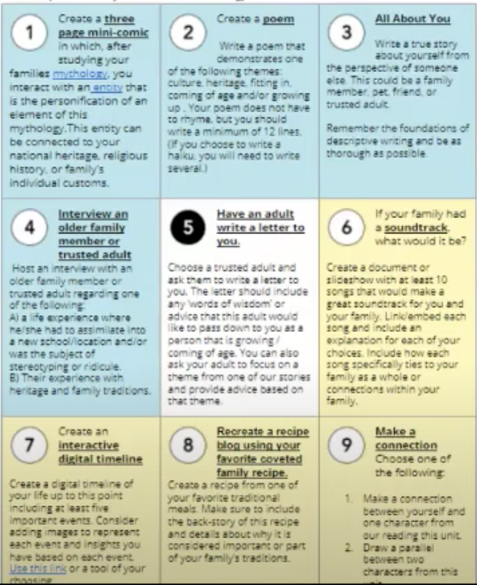

- Learning Preference Choice Board

Musical/Rhymical | Verbal/Linguistic | Visual Spatial
Body/Kinesthetic | Create a Proposal | Intrapersonal
Interpersonal | Naturalist | Logical/Mathematical

Your choice must include the following:

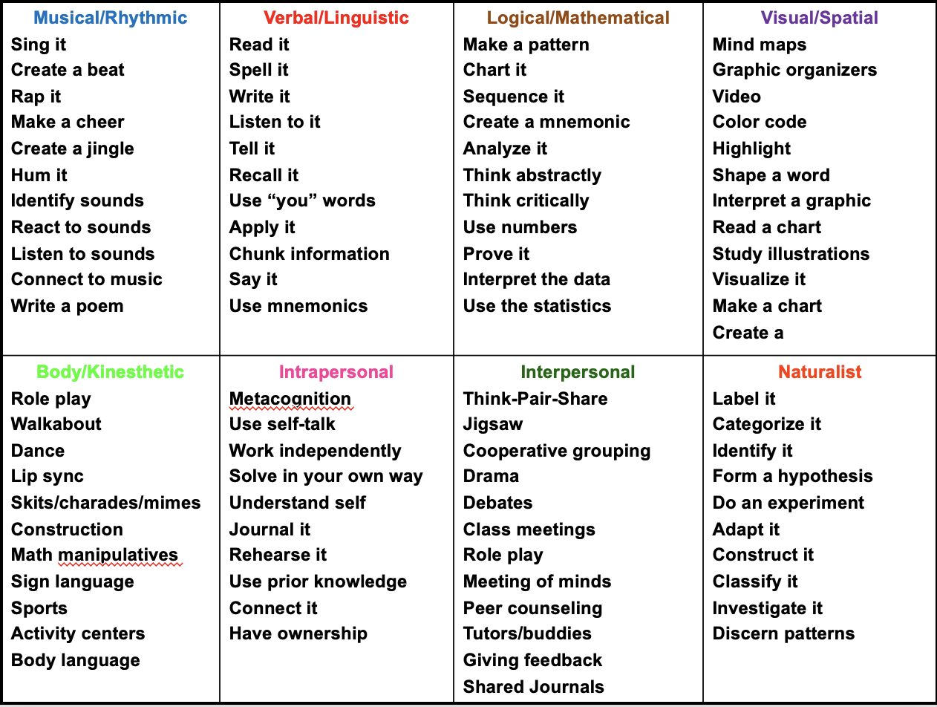
Readiness Choice Board Ideas

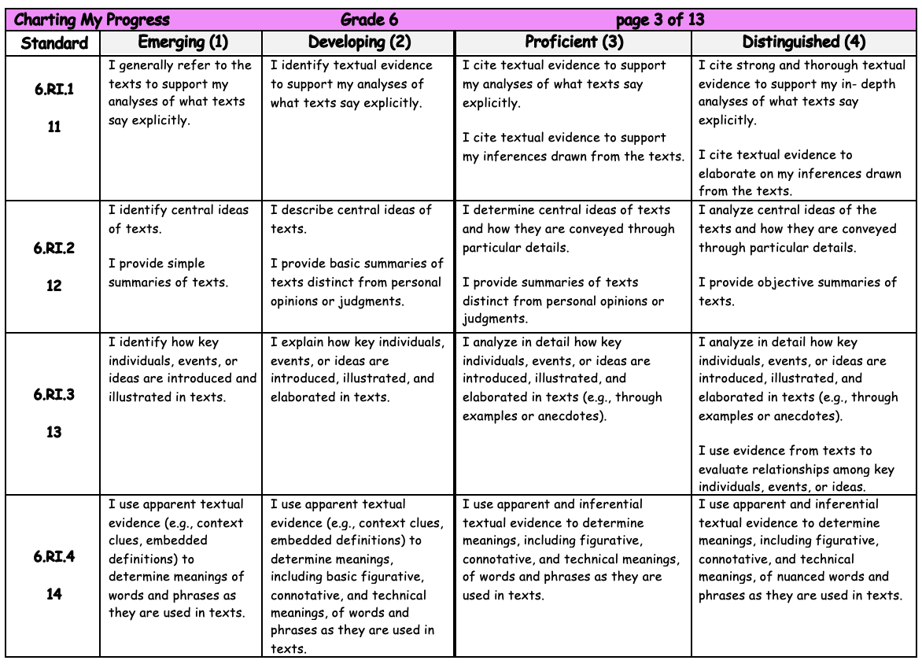
Be purposeful:
- Focus on the essential knowledge and skills of standards
- Provide choice based on learning preference: visual, auditory, linguistic, kinesthetic, etc.
- All choices involve fair and equitable work

Process to Create a Choice Board
Step 1: Focus on what is essential. What are the 1 or 2 standards?

ES.8 The student will investigate and understand how freshwater resources are influenced by geological processes and the activities of humans.

 | Style/Option 1 | Style/Option 2 | Style/Option 3

Step 2: Break the standard into essential elements.
 | Style/Option 1 | Style/Option 2 | Style/Option 3
Identification of sources
The effects of human usage on water quality
Identification of the major watershed systems

Step 3: Determine different learning preference ways to equitably sow what they know.
 | Style/Option 1 | Style/Option 2 | Style/Option 3
Identification of sources | Student will write a report on freshwater sources | Draw and label a source map detailing the different kinds of water sources. | Create a Google slides, prezi, Adobe Spark, or create a movie presentation on different water sources.
The effects of human usage on water quality | Write a paper explaining the effects of humans on water quality. | Write a song that expresses the impact humans have on water quality. | Create a Google slides, prezi, Adobe Spark, or create a movie presentation on the effect humans have on water sources.
Identification of the major watershed systems

