Let’s CUBE It!
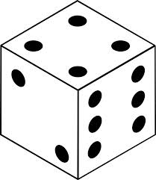

Team Name: ________________________

Topic: __________________________

- Describe it: What is it?
Words… | Image…

- Explain it: How would you make it clearer for someone to understand it?
Words… | Images…

- Apply it: What does it make you think of? What can you do with it?
Words… | Images…

- Analyze it: What are its essential parts? How is it made? What is it composed of?
Words… | Images…

- Judge it: Argue for or against it. Support your thinking.
Words… | Images…

- Create with it: What is something you can do with it?
Words… | Images…

