Providing Pathways to Excellence for Each Student
Math 6
Unwrap a Standard: What do students have to know and be able to do?

Domain: Expressions and Equations
Domain/Reporting Category Weight (if applicable): 29% - 33% AASA items
Cluster: 6.EE.B Reason about and solve one-variable equations and inequalities.
Standard: 6.EE.B.5 Understand solving an equation or inequality as a process of reasoning to find the value(s) of the variables that make that equation or inequality true. Use substitution to determine whether a given number in a specified set makes an equation or inequality true.

Performance/Achievement Level Descriptors
Emerging (1) | Developing (2) | Proficient (3) | Distinguished (4)
I can understand solving an equation or inequality as a process of reasoning to find the value(s) of the variables that make that equation or inequality true.  I can use substitution to identify a whole number in a specified set that makes an equation or inequality true. | I can understand solving an equation or inequality as a process of reasoning to find the value(s) of the variables that make that equation or inequality true.  I can use substitution to identify a number in a specified set that makes an equation or inequality true. | I can understand solving an equation or inequality as a process of reasoning to find the value(s) of the variables that make that equation or inequality true.  I can use substitution to determine if a set of numbers contains only solutions of an inequality or equation. | I can explain how solving an equation or inequality is the process of reasoning to find the value(s) of the variables that make that equation or inequality true.
AASA Item types: EQR, MCR, MIR, MSR

Building Background Knowledge and skills: Flashback Standard
Standard: 5.OA.A.2 Write simple expressions that record calculations with numbers, and interpret numerical expressions without evaluating them (e.g., express the calculation “add 8 and 7, then multiply by 2” as 2 x (8 + 7). Recognize that 3 x (18,932 + 921) is three times as large as (18,932 + 921), without having to calculate the indicated sum or difference.
Extending Knowledge and skills: Preview Standard
Standard: 7.EE.B.4 Use variables to represent quantities in mathematical problems and problems in real-world context and construct simple equations and inequalities to solve problems.

Essential Knowledge/Concepts  What Do Students Need to Know/Understand?  List the underlined nouns. | Essential Skills  What Do Students Need to Be Able to Do?  List the circled (or italicized) verbs.
DOK Level
Level of content complexity rather than content difficulty.
WONDER Questions  How can we capture student wonder?  *Including open-ended and ‘second’ questions | Essential Vocabulary  What Do Students Need to Comprehend?  List all key vocabulary
Learning Objectives aligned to the Standard
What are the Learning Intentions and Success Criteria that will guide student progress?

Evidence of Student Mastery?
How will we know when they know it?
How will we encourage each student to try?

Specific Instructional Framework?
What will we do to help them know/understand/can do it?
What will we do for students who still don’t know it?
What will we do for students who already know it?

Providing Pathways to Excellence for Each Student
Math 6
Unwrap a Standard: What do students have to know and be able to do?

Domain: Expressions and Equations
Domain/Reporting Category Weight (if applicable): 29% - 33% AASA items
Cluster: 6.EE.B Reason about and solve one-variable equations and inequalities.
Standard: 6.EE.B.5 Understand solving an equation or inequality as a process of reasoning to find the value(s) of the variables that make that equation or inequality true. Use substitution to determine whether a given number in a specified set makes an equation or inequality true.

Performance/Achievement Level Descriptors
Emerging (1) | Developing (2) | Proficient (3) | Distinguished (4)
I can understand solving an equation or inequality as a process of reasoning to find the value(s) of the variables that make that equation or inequality true.  I can use substitution to identify a whole number in a specified set that makes an equation or inequality true. | I can understand solving an equation or inequality as a process of reasoning to find the value(s) of the variables that make that equation or inequality true.  I can use substitution to identify a number in a specified set that makes an equation or inequality true. | I can understand solving an equation or inequality as a process of reasoning to find the value(s) of the variables that make that equation or inequality true.  I can use substitution to determine if a set of numbers contains only solutions of an inequality or equation. | I can explain how solving an equation or inequality is the  process of reasoning to find the value(s) of the  variables that make that equation or inequality true.
AASA Item types: EQR, MCR, MIR, MSR

Building Background Knowledge and skills: Flashback Standard
Standard: 5.OA.A.2 Write simple expressions that record calculations with numbers, and interpret numerical expressions without evaluating them (e.g., express the calculation “add 8 and 7, then multiply by 2” as 2 x (8 + 7). Recognize that 3 x (18,932 + 921) is three times as large as (18,932 + 921), without having to calculate the indicated sum or difference.
Extending Knowledge and skills: Preview Standard
Standard: 7.EE.B.4 Use variables to represent quantities in mathematical problems and problems in real-world context and construct simple equations and inequalities to solve problems.

Essential Knowledge/Concepts  What Do Students Need to Know/Understand?  List the underlined nouns.  equation inequality variable value  number whole number process solution  solution set less than greater than  equal to substitution unknown | Essential Skills  What Do Students Need to Be Able to Do?  List the circled (or italicized) verbs.  understand solving solve reason  find use substitution explain solve
DOK Level
Level of content complexity rather than content difficulty.

DOK 1 DOK 2 DOK 3
WONDER Questions  How can we capture student wonder?  *Including open-ended and ‘second’ questions  What are some similarities and differences in the solution of an equation and the solution of an inequality?  Why is substitution a useful strategy in solving equations?  Analyze a real-world scenario where solving an inequality is necessary. | Essential Vocabulary  What Do Students Need to Comprehend?  List all key vocabulary  equation inequality variable value  number whole number process solution  solution set less than greater than  equal to substitution unknown reason
Learning Objectives aligned to the Standard
What are the Learning Intentions and Success Criteria that will guide student progress?

See attached learning intention and success criteria

Evidence of Student Mastery?
How will we know when they know it?
How will we encourage each student to try?

See attached Diagnostic Formative Assessment
Specific Instructional Framework?
What will we do to help them know/understand/can do it?
What will we do for students who still don’t know it?
What will we do for students who already know it?

See attached thinking routines

Arizona resources to Consider

AASA Item Specifications
Content Standards | Understand solving an equation or inequality as a process of reasoning to  find the value(s) of the variables that make that equation or inequality true.  Use substitution to determine whether a given number in a specified set  makes an equation or inequality true.
Explanations | Beginning experiences in solving equations should require students to  understand the meaning of the equation as well as the question being asked.  Solving equations using reasoning and prior knowledge should be required  of students to allow them to develop effective strategies such as using  reasoning, fact families, and inverse operations. Students may use balance  models in representing and solving equations and inequalities.
Content Limits | Nonnegative rational numbers  One-variable linear equations and inequalities  An equation or inequality should be given if a context is included
Context | Context is allowed

Sample Task Demands | Common Item Formats
Students will be required to choose which value(s)  satisfy an equation or inequality. | • Equation Response  • Multiple Choice  • Matching Item Response  • Multi-Select Response
Students will be required to choose a set of numbers which contains only solutions to an inequality
Students will be required to determine the value
of an expression that makes the equation true.

AASA Sample Items (clarifying vertical articulation)
Flashback  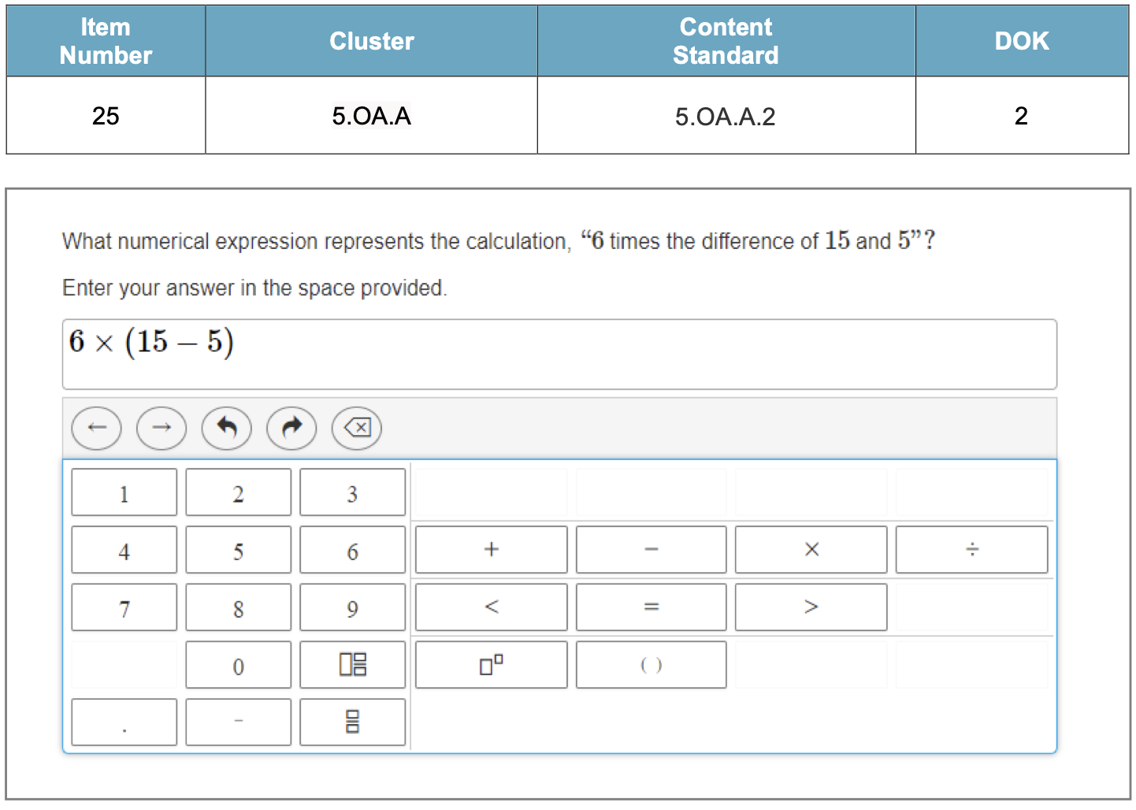 | On Grade-level  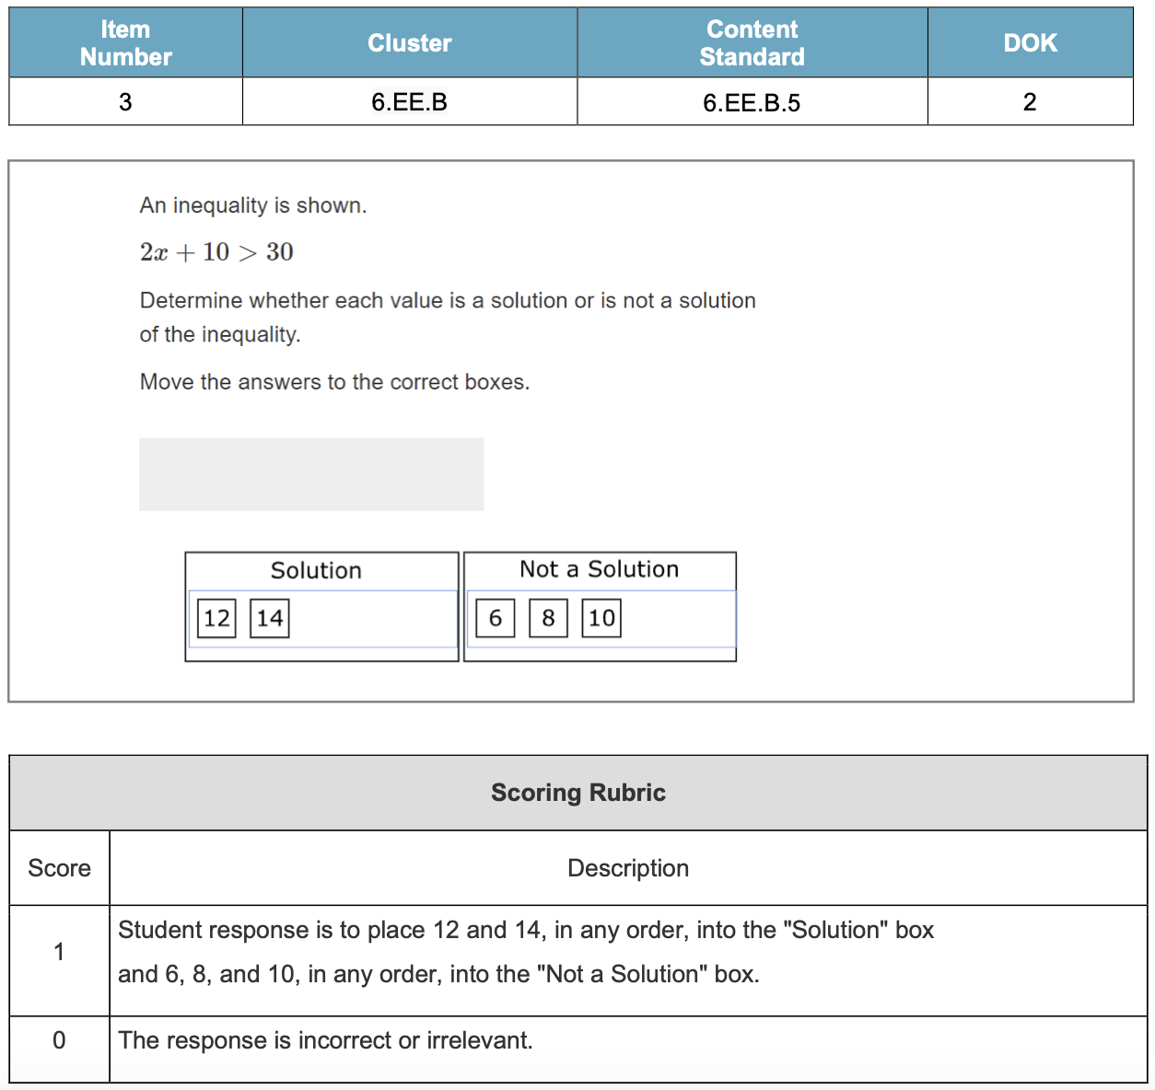
Preview 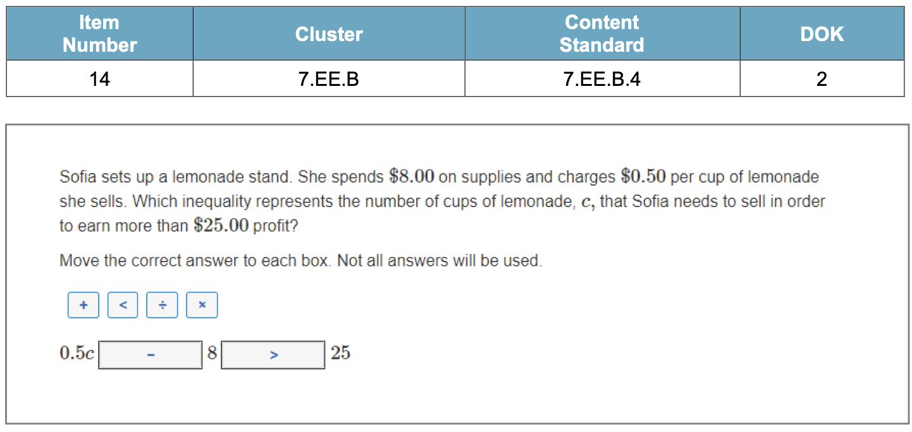
Create a Diagnostic Formative Assesment (DFA)
How will we know when they know it?
How will we encourage each student to try?

Item #1: Alignment to PLD 6.EE.B.5.0 (Flashback to 5.OA.A.2)

What numerical expression represents the calculation, “4 times the sum of 8 and 7”?

Place your answer in the space provided.

Item #2: Alignment to PLD 6.EE.B.5.1

Maria used the substitution method to determine if 3 is in the solution set of the inequality: $x+4< 7$.

She showed her thinking by:
Step 1: Substituting 3 in place of x in the inequality $x+4< 7$
Step 2: That resulted in (3) + 4 = 7 and 7 = 7.
Step 3: She concluded 3 is in the solution set of $x+4< 7$

PART A. Do you agree with Maria? (yes or no) ________
PART B. Explain your thinking in the box below.

Item #3: Alignment to PLD 6.EE.B.5.2

PART A. Tonya challenged you to use the substitution method to find the solution of the equation $4x-2=0.$
She provided a clue for you by saying the solution is either 0, $\frac{1}{2}$ , or 2.
What is the solution to the equation?

PART B. Explain your thinking in the box provided.

Item #4: Alignment to PLD 6.EE.B.5.3

An inequality is shown.

3$x+7> 18$

Determine whether each value is a solution or not a solution of the inequality.

Move the answers to the correct boxes.
0, 4, 8, 12

Solution | Not a Solution

Item #5: Alignment to PLD 6.EE.B.5.3

Select each set of numbers which contains only solutions to the inequality:

2$x+8≥ 12$
- A. { 1, 2, 3 }
- B. { 0, 4, 6 }
- C. {2, 4, 6}
- D. { 8, 9, 10}

Item #6: Alignment to PLD 6.EE.B.5.3

Which of the following inequalities has a solution set of $\{3, 5, 7, 9\}$ ?

- A. $x+3<11$
- B. $x>8$
- C. $x+3≤11$
- D. $x<8$

Item #7: Alignment to PLD 6.EE.B.5.4

A theme park has a log ride that can hold 12 people. They also have a weight limit of 1500 lbs. per log for safety reasons. If the average adult weighs 150 lbs., the average child weighs 100 lbs. and the log itself weighs 200, the ride can operate safely if the inequality 150A + 100C + 200 ≤ 1500 is satisfied (A is the number of adults and C is the number of children in the log ride together). There are several groups of children of differing numbers waiting to ride. Group one has 4 children, group two has 3 children, group three has 9 children, group four 6 children while group five has 5 children.
If 4 adults are already seated in the log, which groups of children can safely ride with them?
My Learning Intention and Success Criteria 6.EE.B.5 Individual Component Version

My Learning Intention: I am learning to use substitution to determine whether a given number in a specified set makes an equation or inequality true.
My Success Criteria | Post | Why am I learning this?
I can write simple expressions that record calculations with numbers. | I’m There  On My Way  Getting Started
I can interpret numerical expressions. | I’m There  On My Way  Getting Started
I can choose which value(s) of a solution set satisfy an equation or inequality. | I’m There  On My Way  Getting Started
I can choose a set of numbers which contains only solutions to an inequality. | I’m There  On My Way  Getting Started
I can determine the value of an expression that makes an equation true using the substitution method. | I’m There  On My Way  Getting Started
I can explain how solving an equation or inequality is the process of reasoning to find the value(s) of the variables that make that equation or inequality true. | I’m There  On My Way  Getting Started
What do I want to remember?

Guided Group Lesson

Standard:6.EE.B.5 I am learning to use substitution to determine whether a given number in a specified set makes an equation or inequality true.

Group Members | Emerging | Developing | Proficient | Distinguished

Warm-Up:
With a partner, students use balance models in representing and solving equations and inequalities. Individual students then complete a ‘What makes me say that’ chart and use the chart to explain their findings to another student from a different pair of students.

Vocabulary
equation inequality variable value

number whole number process solution substitution method

solution set less than greater than

equal to substitute unknown reason

Transformation Point on the line Function

Emerging | Developing | Proficient | Distinguished
Students play a game of ‘Where Do I Belong’. Each pair of students is provided with equation cards, solution cards, and possible rationale cards. Students place the cards in three columns labeled: Equation, Solution, and Rationale that make each row true. | Pairs of students use their Think Pads to record their predictions of ‘Is a Solution’, or ‘Not a Solution’ for a given list of inequalities and possible solution sets Then using the substitution method verify each prediction and place the final answer in a chart labeled, ‘What makes me say this’. | Students use the ‘Dinner Menu’ template to choose whether to use balance models, the substitution method, or steps to solve equations/inequalities to determine the solution set of a series of given mathematical statements. | Play a game of ‘Be the Teacher’. Students are given possible solutions. Student teams create more than one inequality that will b true for each given solution.

Observations: |  | Next Steps:
What you notice about your students during small group instruction. |  | What will you do with these students next? Change groups, repeat, etc.

