**ELA 7.RI.2**

**Unwrap a Standard: *What do students have to know and be able to do?***

**Strand:** Reading Standards for Informational Text

**Strand/Reporting Category Weight:** 25% - 30% of AASA items

**Standard:** **ELA 7.RI.2**

Determine two or more central ideas in a text and analyze their development over the course of the text; provide an objective summary of the text.

|  |  |  |  |
| --- | --- | --- | --- |
| **Emerging (1)** | **Developing (2)** | **Proficient (3)** | **Distinguished (4)** |
| I can identify a central idea of the text.  I can provide a basic sequence of events or ideas in a text. | I can identify two or more central ideas of a text.  I can provide a summary of a text. | I can determine two or more central ideas in a text and analyzes their development over the course of the text.  I can provide an objective summary of a text. | I evaluate two or more central ideas and analyze their development over the course of the text.  I can provide a comprehensive, objective summary of a text. |
|  | | | |
| **Building Background Knowledge and skills: Flashback Standard**  **Standard:** **ELA 6.RI.2** Determine a central idea of a text and how it is conveyed through particular details; provide a summary of the text distinct from personal opinions or judgements. | | | |
|  | | | |
| **Extending Knowledge and skills: Preview Standard**  **Standard:** **ELA 8.RI.2** Determine a central idea of a text and analyze its development over the course of the text, including its relationship to supporting ideas; provide an objective summary of the text. | | | |

|  |  |
| --- | --- |
| **Essential Knowledge/Concepts**  ***What Do Students Need to Know/Understand?***  **List the underlined nouns.** | **Essential Skills**  ***What Do Students Need to Be Able to Do?***  **List the circled (or *italicized*) verbs.** |
| **DOK Level**  **Level of content complexity rather than content difficulty.** |
| **WONDER Questions**  ***How can we capture student wonder?***  **\*Including open-ended and ‘second’ questions** | **Essential Vocabulary**  ***What Do Students Need to Comprehend?***  **List all key vocabulary** |
| **Learning Intentions and Success Criteria aligned to the Standard**  ***What ‘I can’ statement(s) will clarify the objective for students?*** | |
| **Evidence of Student Mastery?**  ***How will we know when they know it?***  ***How will we encourage each student to try?*** | |
| **Specific Instructional Framework?**  ***What will we do to help them know/understand/can do it?***  ***What will we do for students who still don’t know it?***  ***What will we do for students who already know it?*** | |

**Resources for DFA Development (ELA 7.RI.2):**

**AASA Item Specifications (ELA 7.RI.2)**

**Performance Level Descriptors**

**AASA Sample Items:**

|  |  |
| --- | --- |
| FLASHBACK   |  **|

**ELA 7.RI.2**

**Unwrap a Standard: *What do students have to know and be able to do?***

**Strand:** Reading Standards for Informational Text

**Strand/Reporting Category Weight:** 25% - 30% of AASA items

**Standard:** **ELA 7.RI.2**

**Determine** two or more central ideas in a text and **analyze** their development over the course of the text; provide an objective summary of the text.

|  |  |  |  |
| --- | --- | --- | --- |
| **Emerging (1)** | **Developing (2)** | **Proficient (3)** | **Distinguished (4)** |
| I can **identify** a central idea of the text.  I can **provide** a basic sequence of events or ideas in a text. | I can **identify** *two or more* central ideas of a text.  I can **provide** a summary of a text. | I can **determine** *two or more* central ideas in a text and **analyze** their development over the course of the text.  I can **provide** an objective summary of a text. | I **evaluate** two or more central ideas and **analyze** their development over the course of the text.  I can **provide** a comprehensive, objective summary of a text. |
|  | | | |
| **Building Background Knowledge and skills: Flashback Standard**  **Standard:** **ELA 6.RI.2** **Determine** a central idea of a text and how it is conveyed *through particular details*; **provide** a summary of the text *distinct from personal opinions or judgements*. | | | |
|  | | | |
| **Extending Knowledge and skills: Preview Standard**  **Standard:** **ELA 8.RI.2 Determine** a central idea of a text and **analyze** its *development over the course of the text*, including its relationship to supporting ideas; **provide** an objective summary of the text. | | | |

|  |  |
| --- | --- |
| **Essential Knowledge/Concepts**  ***What Do Students Need to Know/Understand?***  **List the underlined nouns.**  **Fiction Nonfiction Central idea**  **Facts Opinions Evidence Cite**  **Inference Conclusion Explicit Information**  **Implicit Information Objective summary**  **Sequence of events** | **Essential Skills**  ***What Do Students Need to Be Able to Do?***  **List the circled (or *italicized*) verbs.**  **Identify Determine Analyze Justify**  **Infer Cite Provide Evaluate** |
| **DOK Level**  **Level of content complexity rather than content difficulty.**  **DOK 1 DOK 2 DOK 3** |
| **WONDER Questions**  ***How can we capture student wonder?***  **\*Including open-ended and ‘second’ questions**   * Why did the author write this passage? * What inferences can you make? * What information would you need to support the inference? * What can you conclude from this passage? * Why do you think that? Can you give specific examples from the text that support your thinking? * Can you show me where in the text the author says that? | **Essential Vocabulary**  ***What Do Students Need to Comprehend?***  **List all key vocabulary**  **Fact Opinion Implicit Information**  **Explicit Information Central (Main) Idea**  **Infer Inference Evidence**  **Nonfiction Sequence** |
| **Learning Intentions and Success Criteria aligned to the Standard**  ***What ‘I can’ statement(s) will clarify the objective for students?*** | |
| **Evidence of Student Mastery?**  ***How will we know when they know it?***  ***How will we encourage each student to try?*** | |
| **Specific Instructional Framework?**  ***What will we do to help them know/understand/can do it?***  ***What will we do for students who still don’t know it?***  ***What will we do for students who already know it?*** | |

Diagnostic Formative Assessment:

Passage 1 – The Life Line

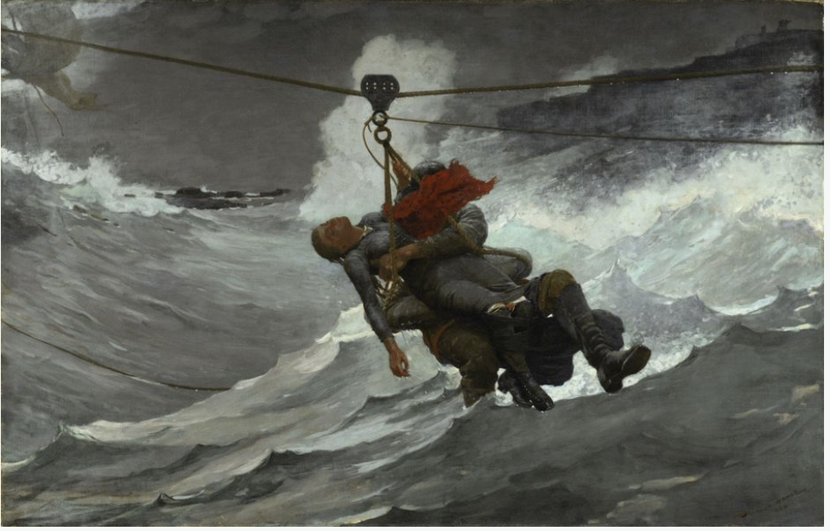

This painting depicts a suspenseful moment during a heroic rescue. Crashing waves, dark threatening skies, and fierce winds surround the two figures in the center. Remnants of a sinking ship are barely visible in the upper left. Only a thin rope supports the weight of the man and woman, who are suspended above the turbulent sea. The woman’s clothing and hair are soaking wet, her head hangs back, and her right arm dangles above the water. She holds onto the rope with her left hand, indicating that she is conscious. Perhaps the figures on the distant cliff on the right wait to help the man and woman as soon as they reach the shore.

One year before he painted The Life Line, American artist Winslow Homer witnessed a demonstration of a lifesaving device like the one shown in this picture. He included details that show how it worked. For example, the slack of rope in the water on the left indicates that the people are being pulled to safety by the lower rope on the right. In addition, notice how only the right half of the upper rope has water droplets along its bottom edge. The left half was wrung dry as the pulley moved from left to right.

Homer left some details of this story a mystery. A red scarf flaps in the wind and hides the man’s face. Why could this be? Homer also left the conclusion of the story unclear. It is up to us to imagine how this adventure ends.

Philadelphia Museum of Art: The George W. Elkins Collection, E1924-4-15

## Alignment to ELA 7.RI.2.0 (flashback to ELA 6.RI.2)

1. Which artist painted The Life Line?
2. Edward Hopper
3. Winslow Homer
4. Thomas Moran
5. James Whistler

## Alignment to ELA 7.RI.2.1

#### What is this text mostly about?

1. the painting The Life Line

#### Winslow Homer’s inspiration

#### a heroic rescue at sea

#### how lifesaving devices work

Passage 2 – Excerpt from New York Times article: **Suffrage wins in Senate; Now goes to states**

## Thursday, June 5, 1919

WASHINGTON, June 4 - After a long and persistent fight advocates of woman suffrage won a victory in the Senate today when that body, by a vote of 56 to 25, adopted the Susan Anthony amendment to the Constitution. The suffrage supporters had two more than the necessary two-thirds vote of Senators present. Had all the Senators known to be in favor of suffrage been present the amendment would have had 66 votes, or two more than a two-thirds vote of the entire Senate.

The amendment, having already been passed by the House, where the vote was 304 to 89, now goes to the States for ratification, where it will be passed upon in the form in which it has been adopted by Congress, as follows:

"Article-, Section 1. - The right of citizens of the United States to vote shall not be denied or abridged by the United States or by any State on account of sex.

"Section 2. - Congress shall have power, by appropriate legislation, to enforce the provisions of this article."

Leaders of the National Woman's Party announced tonight that they would at once embark upon a campaign to obtain ratification of the amendment by the necessary three-fourths of the States so that women might have the vote in the next Presidential election. To achieve this ratification, it will be necessary to hold special sessions of some Legislatures which otherwise would not convene until after the Presidential election in 1920. Miss Alice Paul, Chairman of the Woman's Party, predicted that the campaign for ratification would succeed and that women would vote for the next President.

Suffragists thronged the Senate galleries in anticipation of the final vote, and when the outcome was announced by President Pro Tem. Cummins, they broke into deafening applause. For two minutes the demonstration went on, Senator Cummins making no effort to check it.

***Use the article "Excerpt from New York Times Article: Suffrage Wins in Senate; Now Goes to States" to answer questions 1 to 2.***

## Alignment to ELA 7.RI.2.2

### What victory did advocates of woman suffrage win on June 4 in Washington?

|  |
| --- |
|  |

Paired text 3 – Ronald Reagan’s Proclamation of Women’s History Month, 1987

From earliest times, women have helped shape our Nation. Historians today stress all that women have meant to our national life, but the rest of us too should remember, with pride and gratitude, the achievements of women throughout American history.

Those achievements span the wide range of human endeavor. They have not been attained without the quiet courage and sacrifice of millions of women, some famed, most not. Women have established themselves in business and the professions, and today women outnumber men as undergraduates at our colleges and universities. Women have fought for moral and social reform and have taken part in and led many great social and political movements of our land. Women have founded many of our philanthropic, cultural, educational, and charitable institutions. Women have served our Nation with valor and distinction during wartime, nursing the wounded, piloting airplanes, performing vital jobs in defense plants. Women have forged a place for themselves in public life, serving on the Supreme Court, in the Congress, and in Cabinet posts; becoming Ambassadors; and holding Federal Executive posts that affect the lives of every citizen.

Most importantly, as women take part in the world of work, they also continue to embrace and nurture the family as they have always done. All Americans can be truly grateful for the role of women as the heart of the family and for their every accomplishment today and throughout our history.

The Congress, by Senate Joint Resolution 20, has designated the month of March 1987 as "Women's History Month" and authorized and requested the President to issue a proclamation in observance of this event.

Now, Therefore, I, Ronald Reagan, President of the United States of America, do hereby proclaim March 1987 as Women's History Month. I call upon all Americans to mark this month with appropriate observances to honor the achievements of American women.

In Witness Whereof, I have hereunto set my hand this sixteenth day of March, in the year of our Lord nineteen hundred and eighty-seven, and of the Independence of the United States of America the two hundred and eleventh.

***Use the article "Ronald Reagan's Proclamation of Women's History Month, 1987" to answer questions 3 to 4.***

## Alignment to ELA 7.RI.2.3

### What was the goal of this proclamation? Support your answer with evidence from the text.

***Use the articles "Excerpt from New York Times Article: Suffrage Wins in Senate; Now Goes to States" and "Ronald Reagan's Proclamation of Women's History Month, 1987" to answer questions 5.***

## Alignment to ELA 7.RI.2.3

### Contrast the ways in which the Senate’s passage of the Susan Anthony amendment and Reagan’s proclamation of Women’s History Month aimed to affect women’s position in society. Support your answer with details from both texts.

## Alignment to ELA 7.RI.2.4

### Which event was more important to advancing the position of women in society, the Senate’s passage of the Susan Anthony amendment or Reagan’s proclamation of Women’s History Month? Why? Support your argument using information from both texts.

**My Success Criteria Chart** (to be included in each student’s notebook)

|  |  |  |  |  |
| --- | --- | --- | --- | --- |
| **Success Criteria** | **Getting Started** | **On My Way** | **I’m There** | **Things to Remember** |
| I can identify a central idea of the text. |  |  |  |  |
| I can provide a basic sequence of events or ideas in a text. |  |  |  |  |
| I can identify *two or more* central ideas of a text. |  |  |  |  |
| I can provide a summary of a text. |  |  |  |  |
| I can determine *two or more* central ideas in a text and analyze their development over the course of the text. |  |  |  |  |
| I evaluate two or more central ideas and analyze their development over the course of the text. |  |  |  |  |
| I can provide a comprehensive, objective summary of a text. |  |  |  |  |

Guided Group Lesson Date:

**ELA 7.RI.2**

Determine two or more central ideas in a text and analyze their development over the course of the text; provide an objective summary of the text.

|  |  |  |  |  |
| --- | --- | --- | --- | --- |
| Group Members | Emerging | Developing | Proficient | Distinguished |
|  |  |  |  |

Warm-Up:

|  |
| --- |
| With your partner, |

Vocabulary

Fact Opinion Implicit Information

Explicit Information Central (Main) Idea Nonfiction

Infer Inference Evidence Sequence

|  |  |  |  |  |
| --- | --- | --- | --- | --- |
| Emerging | Developing | Proficient | | Distinguished |
| Lesson focus:  You are considering a summer 2024 internship with the National Oceanic and Atmospheric Administration (NOAA). Read the passage [Saving Indonesia’s Corral Reefs](https://www.readworks.org/article/Saving-Indonesias-Coral-Reefs/4a5d90e0-09c9-45c0-9e52-404e0a26b68a#!articleTab:content/questionsetsSection:25493/). According to the text, what is one example of how human activities out of the water put stress on coral reefs in the water? Cite evidence from the text in your response. | Lesson focus:  The basic requirements to apply to be an astronaut include U.S. citizenship with a master's degrees in science, technology, engineering, and mathematics (STEM) fields and a minimum of two years of relevant professional experience or at least 1,000 hours of pilot-in-command time in jet aircraft.  Read the passage [Climbing Space](https://www.readworks.org/article/Climbing-Space/348ea084-9b0a-4339-af68-58229061ca0f#!articleTab:content/questionsetsSection:900/) . According to Kennedy, what are some ways going to the moon will help scientists. Explain what makes you say that? | Lesson focus:  Biosecurity researchers ensure the preservation of our unique flora and fauna and the safety of the human population by investigating potential threats (like bioterrorism or illegal imports). With your partner, read the passage [Racing to Protect Mule Deer Migration](https://www.readworks.org/article/Protecting-Migrating-Animals/874ae96b-cc34-48fe-a102-b711f5c5fd7f#!articleTab:content/questionsetsSection:23924/contentSection:084c7cec-596b-4585-9ef4-a565b7264c25/) and watch the video [Path of the Pronghorn](https://www.readworks.org/article/Protecting-Migrating-Animals/874ae96b-cc34-48fe-a102-b711f5c5fd7f#!articleTab:content/questionsetsSection:23924/contentSection:e98b14c3-7a0a-4b51-95a5-3ad3504e989c/). Compare the **solutions** that conservationists put into action to help mule deer and pronghorn migrate. Use details from both the text and the video to support your comparison. | Lesson focus:  The job of a historian is to first gather data from a variety of sources, make hypotheses about the data gathered, and begin to form conclusions about all of these aspects of life at that particular time and place. Read the passage French-Native American Relations in the Great Lakes Region and the passage Nothing but Firing. One text describes the interaction between William Kieft and Native Americans in New Netherland. The other text describes the interaction between the French and Native Americans in the Pays d'en Haut region. Contrast these two interactions. Use evidence from both texts to support your answer. | |

|  |  |  |
| --- | --- | --- |
| Observations: |  | Next Steps: |
| What you notice about your students during small group instruction. | What will you do with these students next? change groups, repeat, etc. |