Grade 8 ELA
Unwrap a Standard: What do students have to know and be able to do?

Domain: Reading Standards for Informational Text
Domain Weight: 25% - 30% of AASA assessment items
Standard: 8.RI.3 Analyze how a text makes connections among and distinctions between individuals, ideas, or events (e.g., through comparisons, analogies, or categories).

Emerging (1) | Developing (2) | Proficient (3) | Distinguished (4)
I can identify that a text makes explicit connections among and distinctions between individuals, ideas, or events (e.g., through comparisons, analogies, or categories). | I can describe how a text makes explicit connections among and distinctions between individuals, ideas, or events (e.g., through comparisons, analogies, or categories). | I can analyze how a text makes connections among and distinctions between individuals, ideas, or events (e.g., through comparisons, analogies, or categories). | I can evaluate how a text makes connections among and distinctions between individuals, ideas, or events (e.g., through comparisons, analogies, or categories).
Flashback Standard: 7.RI.3 Analyze the interactions between individuals, events, and ideas in a text (e.g., how ideas influence individuals or events, or how individuals influence ideas or events).
Preview Standard: 9-10.RI.3 Analyze how the author constructs an analysis or series of ideas or events, including the order in which the points are made, how they are introduced and developed, and the connections that are drawn between them.
Arizona Performance Level Descriptors 8.RI.3 (HT, MC, MS, IC, SCR, EbSR, GM/GMT)
AZ resources for unpacking: 8.RI.3

AASA Item Specifications:
Stimuli Type | Reading Passage
Content Limits | The item should not ask general or overarching questions about individuals, ideas, or events in the text, but rather should focus on the connections and distinctions between them. The item may ask the student to compare, contrast, or categorize individuals, ideas, or events in the text.

Task Demand | Common Item Formats
Analyze how a specific individual, idea, or event from the text connects or is made distinct from another individual, idea, or event. | - Multiple Select (MS)  - Multiple Choice (MC)  - Evidence-based Selected Response (EbSR)  - Gap Match/ Gap Match Table (GM/GMT)  - Hot Text (HT)  - Inline Choice  - Short Constructed Response
Select textual evidence that supports an analysis about the connection or distinct between individuals, ideas, or events in the text.
Determine how the text makes a connection or distinction between individuals, ideas, or events in the text and analyze the effect of this connection or distinction.

Sample AASA Items FLASHBACK STANDARD (7.RI.3)

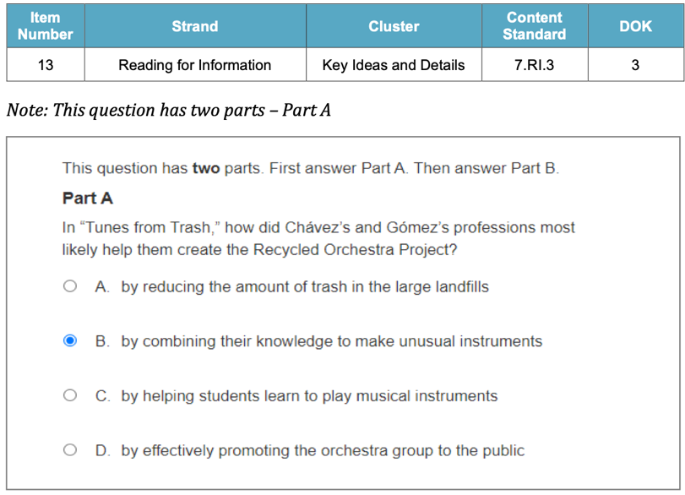 | 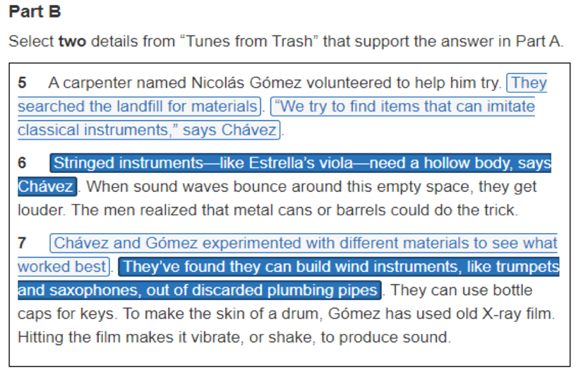

Sample AASA Items

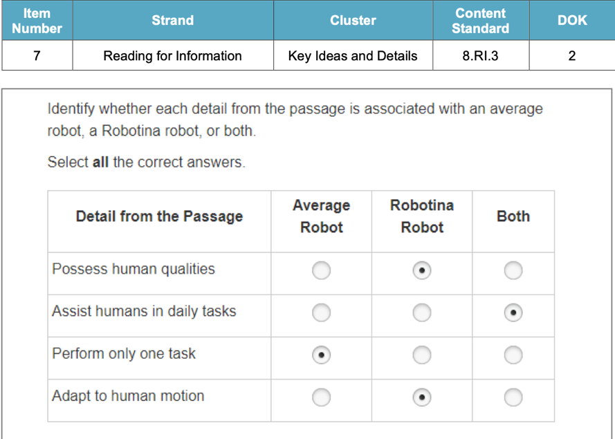
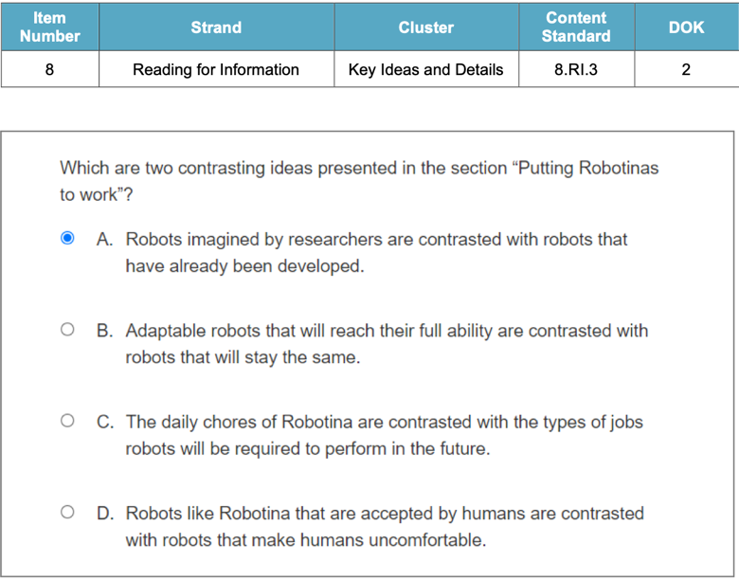
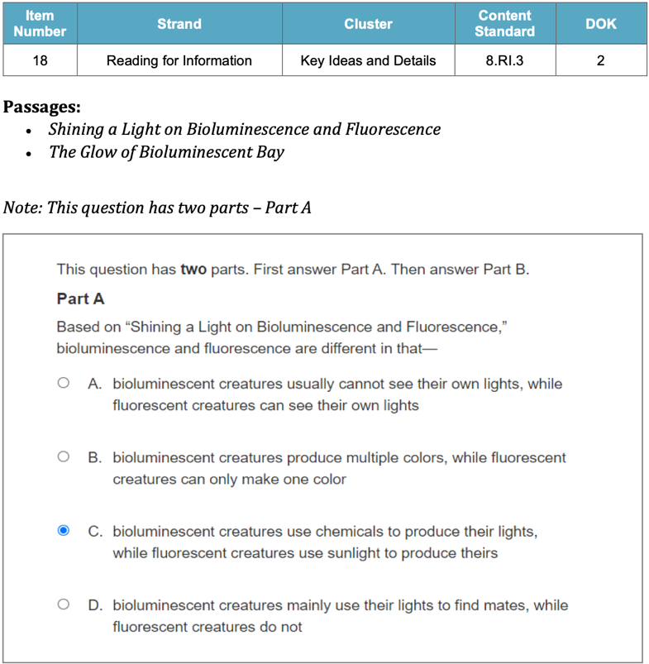 | 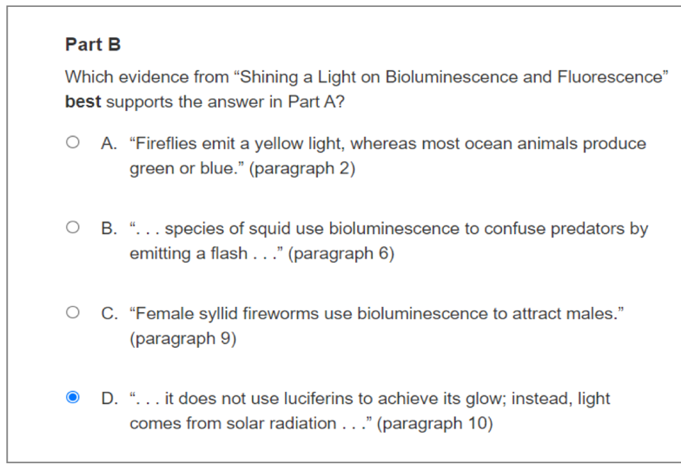

Grade 8 ELA
Unwrap a Standard: What do students have to know and be able to do?

Domain: Reading Standards for Informational Text
Domain Weight: 25% - 30% of AASA assessment items
Standard: 8.RI.3 Analyze how a text makes connections among and distinctions between individuals, ideas, or events (e.g., through comparisons, analogies, or categories).
Emerging (1) | Developing (2) | Proficient (3) | Distinguished (4)
I can identify that a text makes explicit connections among and distinctions between individuals, ideas, or events (e.g., through comparisons, analogies, or categories). | I can describe how a text makes explicit connections among and distinctions between individuals, ideas, or events (e.g., through comparisons, analogies, or categories). | I can analyze how a text makes connections among and distinctions between individuals, ideas, or events (e.g., through comparisons, analogies, or categories). | I can evaluate how a text makes connections among and distinctions between individuals, ideas, or events (e.g., through comparisons, analogies, or categories).
Flashback Standard: 7.RI.3 Analyze the interactions between individuals, events, and ideas in a text (e.g., how ideas influence individuals or events, or how individuals influence ideas or events).
Preview Standard: 9-10.RI.3 Analyze how the author constructs an analysis or series of ideas or events, including the order in which the points are made, how they are introduced and developed, and the connections that are drawn between them.
Arizona Performance Level Descriptors 8.RI.3 (HT, MC, MS, IC, SCR, EbSR, GM/GMT)

Essential Knowledge/Concepts  What Do Students Need to Know/Understand?  List the underlined nouns  Main Idea Key Details Text Detail  Implicit Explicit Supporting Details  Analogies. Events Categories  Connections Comparison Analyze  FBS: Main Topic | Essential Skills  What Do Students Need to Be Able to Do?  List the circled (or italicized) verbs  Identify Paraphrase Recount Determine  Explain Describe Analyze. Compare  Contrast  FBS: Identify Explain
DOK Level
Level of content complexity rather than content difficulty.

DOK 1 DOK 2 DOK 3
Essential Questions/Tasks  How can we capture student wonder?  *Including open-ended and ‘second’ questions  Why do you think the author included certain details in the story? How do they help convey the main idea?  What clues or hints in the text helped you figure out the main idea?  Compare and contrast two key details from the text. How are they similar, and how are they different?  Create two questions that are answered in the text. | Essential Vocabulary  What Do Students Need to Comprehend?  List all key vocabulary  Main Idea Central Theme Key Details  Supporting Evidence Summary  Recount Paraphrase Inference  Context Clues Key Details. Supporting details
Learning Objectives aligned to the Standard
What are the Learning Intentions and Success Criteria that will guide student progress?

See attached visible learning chart (LISCAZ8.RI.3)
Evidence of Student Mastery?
How will we know when they know it?

See attached Diagnostic Quick Check (DFA AZ8.RI.3)
Specific Instructional Framework?
What will we do to help them know/understand/can do it?
What will we do for students who still don’t know it?
What will we do for students who already know it?

See attached Thinking Routines and Small Group Strategies (DFA AZ8.RI.3)

Evidence of Student Mastery?
How will we know when they know it?
Passage 1: The Civil Rights Movement and Its Central Figures

The Civil Rights Movement in the United States, spanning from the 1950s to the 1960s, was a pivotal period marked by the fight for equal rights and an end to racial segregation. One of the central figures in this movement was Martin Luther King Jr., a charismatic leader known for his advocacy of nonviolent civil disobedience. King played a crucial role in organizing protests, including the Montgomery Bus Boycott and the March on Washington, where he delivered his famous "I Have a Dream" speech.

Another prominent leader was Rosa Parks, often referred to as the "Mother of the Civil Rights Movement." Parks became an icon of resistance when she refused to give up her bus seat to a white passenger in Montgomery, Alabama, sparking the Montgomery Bus Boycott and drawing attention to the injustice of racial segregation on public transportation.

The Civil Rights Act of 1964 and the Voting Rights Act of 1965 were significant legislative achievements that aimed to dismantle institutionalized racial discrimination. These acts were the result of collective efforts by various activists and leaders, illustrating the power of collaboration and unified advocacy.
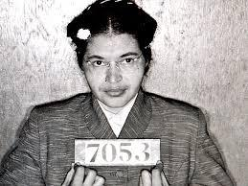 | 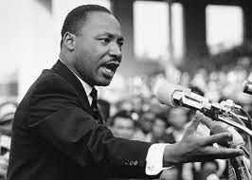

Item #1: Alignment to ALD 8.RI.3.0 (Flashback to 7.RI.3)

What was one of the central figures in the Civil Rights Movement known for advocating?
  - Violent civil disobedience
  - Political campaigning
  - Nonviolent civil disobedience
  - Peaceful negotiations

Item #2: Alignment to ALD 8.RI.3.1
What were the Civil Rights Act of 1964 and the Voting Rights Act of 1965 aimed to do?
Circle the box that contains the best answer to the question
Allow more marches in Washington D.C. |  | Improve bus service in Montgomery, Alabama |  | Dismantle institutionalized racial discrimination |  | Create larger voting booths

Item #3: Alignment to ALD 8.RI.3.2

The Civil Rights Act of 1964 and the Voting Rights Act of 1965 illustrated the power of
  - Individual efforts
  - International cooperation
  - Collaboration and unified advocacy
  - Military intervention

Item #4: Alignment to ALD 8.RI.3.3

According to the passage, two key figures in the Civil Rights Movement, and what specific actions did they take to contribute to the cause?

- Martin Luther King Jr. and Rosa Parks; King organized protests like the Montgomery Bus Boycott, while Parks sparked the boycott by refusing to give up her bus seat.
- Malcolm X and Rosa Parks; Malcolm X delivered the "I Have a Dream" speech, while Parks organized the March on Washington.
- Martin Luther King Jr. and Malcolm X; King led the Montgomery Bus Boycott, while Malcolm X played a key role in passing the Civil Rights Act of 1964.
- Rosa Parks and Malcolm X; Parks delivered the "I Have a Dream" speech, while Malcolm X sparked the Montgomery Bus Boycott

Item #5: Alignment to ALD 3.RI.2.3

According to the passage, which legislative acts were significant outcomes of the Civil Rights Movement?

- The Civil Rights Act of 1964
- The Voting Rights Act of 1965
- Both the Civil Rights Act of 1964 and the Voting Rights Act of 1965
- Neither the Civil Rights Act of 1964 nor the Voting Rights Act of 1965

Item #6: Alignment to ALD 3.RI.2.4

Analyze the connections between the Montgomery Bus Boycott and the larger goals of the Civil Rights Movement.

Step 4: Create a My Personal Goals Chart for each student to note their progress with each success criteria.

Success Criteria | Getting Started | On My Way | I’m There | Notes to Self
I can identify the main individuals, ideas, or events presented in the passage.
I can demonstrate an understanding of the relationships between individuals, ideas, or events within the text.
I can identify and explain how the passage establishes connections between different individuals, ideas, or event.
I can analyze patterns in the text to understand how certain individuals, ideas, or events are consistently linked or differentiated.
I can compare and contrast different individuals, ideas, or events within the text to deepen the analysis.
I can demonstrate critical thinking by questioning and exploring the reasons behind the author's choices in connecting or distinguishing elements in the text.
I can support my analyses with specific examples or quotes from the passage to illustrate points about connections and distinctions.
I can synthesize information from the passage to draw conclusions about the overarching themes or messages conveyed through connections and distinctions

Step 5:
Collaboratively determine small group experiences to move each student toward proficiency and beyond.

Guided Group Lesson Date:

Standard:

Group Members | Emerging | Developing | Proficient | Distinguished

Warm-Up:
With your partner, play a game of ‘Where Do I Belong’. Match Each main idea with one or more supporting details that support the main idea. Prepare to explain your selections.

Vocabulary

Main Idea Central Theme Key Details

Supporting Evidence Summary Recount Paraphrase Inference

Context Clues Key Details Supporting details

Emerging | Developing | Proficient | Distinguished
Lesson focus:  With your partner, create a Venn Diagram to note similarities and differences between Martin Luther King Jr. and Rosa Parks as leaders in the Civil Rights Movement. | Lesson focus:  Using the What makes you say that? gameboard, formulate an argument on the importance of collaboration and unified advocacy in achieving legislative change. Cite supporting details from the text. | Lesson focus:  Analyze the connections between the Montgomery Bus Boycott and the larger goals of the Civil Rights Movement. | Lesson focus:  With your team, create a plan to address a present-day social justice issue by applying concepts learned from the Civil Rights Movement.

Observations: |  | Next Steps:
What you notice about your students during small group instruction. |  | What will you do with these students next? Change groups, repeat, etc.

Charting My Progress Reaching My Personal Goals ELA 8 Individual Component Version

Learning Intention: 8.RI.3 I am learning to analyze how a text makes connections among and distinctions between individuals, ideas, or events (e.g., through comparisons, analogies, or categories).
My Success Criteria | ? | Why am I learning This?
I can identify the main individuals, ideas, or events presented in the passage. | I’m There  On My Way  Getting Started
I can demonstrate an understanding of the relationships between individuals, ideas, or events within the text. | I’m There  On My Way  Getting Started
I can identify and explain how the passage establishes connections between different individuals, ideas, or event. | I’m There  On My Way  Getting Started
I can analyze patterns in the text to understand how certain individuals, ideas, or events are consistently linked or differentiated. | I’m There  On My Way  Getting Started
I can compare and contrast different individuals, ideas, or events within the text to deepen the analysis. | I’m There  On My Way  Getting Started
I can demonstrate critical thinking by questioning and exploring the reasons behind the author's choices in connecting or distinguishing elements in the text. | I’m There  On My Way  Getting Started
I can support my analyses with specific examples or quotes from the passage to illustrate points about connections and distinctions. | I’m There  On My Way  Getting Started
I can synthesize information from the passage to draw conclusions about the overarching themes or messages conveyed through connections and distinctions | I’m There  On My Way  Getting Started
Vocabulary:
Main Idea Supporting Details Paraphrase Key Details Comparison

Implicit Explicit Summarize Analogy

What stuck with me? Why is it important to remember?
(include any combination of images, numbers, and words)

Currently, where am I with analyzing how a text to make connections among and distinctions between individuals, ideas, or events.

 | Distinguished | Proficient | Developing | Emerging
Making connections between individuals, ideas, or events | I clearly identify and analyze multiple connections between individuals, ideas, or events in the text. | I identify and analyze connections between individuals, ideas, or events in the text, but I may not be as thorough or clear as necessary. | I attempt to identify and analyze connections between individuals, ideas, or events, but my work lacks depth or accuracy. | I do not identify or analyze connections between individuals, ideas, or events in the text
Identifying distinctions between individuals, ideas, or events | I clearly identify and analyze multiple distinctions between individuals, ideas, or events in the text. | I identify and analyze distinctions between individuals, ideas, or events in the text, but I may not be as thorough or clear as necessary. | I attempt to identify and analyze distinctions between individuals, ideas, or events, but my work lacks depth or accuracy. | I do not identify or analyze distinctions between individuals, ideas, or events in the text.
Presenting ideas in an organized and structured manner | I present my ideas in a clear, logical, and well-organized manner that enhances understanding. | I present my ideas in a generally clear and logical manner, but my work may lacks some organization or coherence. | I present my ideas in a somewhat disorganized manner, making it difficult to follow the analysis. | My ideas are presented in a disorganized and unclear manner, making it extremely difficult to follow my analysis.
Supporting Analysis of text with effective use of evidence and examples | I provide thorough and compelling evidence and examples to support my analysis of connections and distinctions in the text. | I provide sufficient evidence and examples to support my analysis of connections and distinctions in the text, but my work may lack some depth or clarity. | I provide limited evidence and examples to support my analysis of connections and distinctions in the text. | I fail to provide any meaningful evidence or examples to support my analysis of connections and distinctions in the text

What are things I know? Explain. | What are my opportunities? Explain.

Small Group Choice Board Samples

Options | Description
Compare and Contrast | Create a Venn diagram to compare and contrast two characters from a book you have read.
Analogies Galore | Write five analogies that connect different ideas or concepts. Provide explanations for each analogy.
Categorize the Events | Organize a series of historical events into categories based on their impact or significance.
Text-to-Self Connections | Write a journal entry explaining how a recent event in your life relates to a character or situation in a book you are currently reading.
Idea Web | Create a visual representation of how different ideas or concepts are connected to each other in a text.
Compare Media Formats | Compare and contrast the way a story is presented in a book and its film adaptation. Write a short essay highlighting the similarities and differences.
Distinctions in Poetry | Analyze two poems and identify the distinctions in their themes, tone, and literary devices used.
Making Connections in History | Investigate how two historical periods are connected or influenced by each other. Present your findings in a timeline or infographic.
Song Analysis | Choose a song and analyze its lyrics to identify how the artist connects different ideas or events and makes distinctions between them.

