**Diagnostic Common Assessment**

**Understanding the Target to Create a Pathway to Excellence**

***Ensuring each student is a thinker, problem solver, and communicator***

**Unwrap a Standard: *What do students have to know and be able to do?***

**Statistics and Probability**

Summarize, represent, and interpret data on a single count or measurement variable. (S-ID)

|  |  |  |  |
| --- | --- | --- | --- |
| **Charting My Progress ACT PLD Number and Quantity** | | | |
| **Emerging (1)** | **Developing (2)** | **Proficient (3)** | **Distinguished (4)** |
| I can interpret and evaluate a function for a given integer input.  I can identify the key features of a function (e.g., slope, average rate of change, horizontal or vertical shift, and zeroes) from an equation, graph, or table. | I can interpret and evaluate a function for a given integer input.  I can identify the key features of a function (e.g., slope, average rate of change, horizontal or vertical shift, and zeroes) from an equation, graph, or table.  I can find the next few terms from a sequence in and out of context. | I can represent, interpret, and solve problems in and out of context involving linear functions and systems of linear functions with information coming from context, graphs and tables.  I can use relationships between slope and intercepts to build linear functions with specific properties (e.g., parallel and perpendicular lines).  I can understand coordinate quantities and rates (including slope) and their application to linear and quadratic relationships in context, graphically, and out of context. | I can flexibly interpret varied relationships, notation, equations, and key characteristics of functions in order to apply them in a sequence of calculations with problems that have rich context or higher levels of abstraction.  I can interpret many functions, describe the nature of the function (including end behavior), its attributes and features, its solutions, and its constraints. |
|  | | | |
| **Building Background Knowledge from prior grades: Flashback standard:**  **8.SP.A.2** Know that straight lines are widely used to model relationships between two quantitative variables. For scatter plots that suggest a linear association, informally fit a straight line, and informally assess the model fit by judging the closeness of the data points to the line. | | | |

**Arizona ACT Math:** Functions **A1.F-IF.B.6**

|  |  |
| --- | --- |
| **Essential Knowledge/Concepts**  ***What Do Students Need to Know/Understand?***  **List the underlined nouns.**  **Function Integer Slope Rate of Change**  **Horizontal Shift Vertical Shift**  **Zeroes Sequence Systems of Functions**  **Parallel Perpendicular End Behavior** | **Essential Skills**  ***What Do Students Need to Be Able to Do?***  **List the circled (or *italicized*) verbs.**    **Interpret Evaluate Identify**  **Determine Represent Solve**  **Explain** |
| **DOK Level**  **Level of content complexity rather than content difficulty.**  **DOK 1 DOK 2 DOK 3** |
| **Wonder Questions**  ***How can we capture student wonder?***  **\*Including open-ended and ‘second’ questions**  What are some examples of a constant rate of change in your day? Explain your thinking.  Why are some slopes undefined?  When is something not a functional relationship. Give an example and explain how you know it is not a function. | **Essential Vocabulary**  ***What Do Students Need to Comprehend?***  **List all key vocabulary**  **Function Integer Rate of Change**  **Slope Horizontal Shift Vertical Shift**  **Zeroes Sequence Systems of Functions**  **Parallel Perpendicular End Behavior** |
| **Learning Objectives aligned to the Standard**  ***What ‘I can’ statement(s) will clarify the objective for students?*** | |
| **Evidence of Student Mastery?**  ***How will we know when they know it?*** | |
| **Specific Instructional Framework?**  ***What will we do to help them know/understand/can do it?***  ***What will we do for students who still don’t know it?***  ***What will we do for students who already know it?*** | |

**Evidence of Student Mastery?**

***How will we know when they know it?***

**Item #1:** Alignment to ACT PLD.NQ .**0** (Flashback to 8.SP.2)

**Data relating students’ scores on two projects assigned in a business course are shown on the graph. Sketch an estimated line of best fit for the data on the graph.**

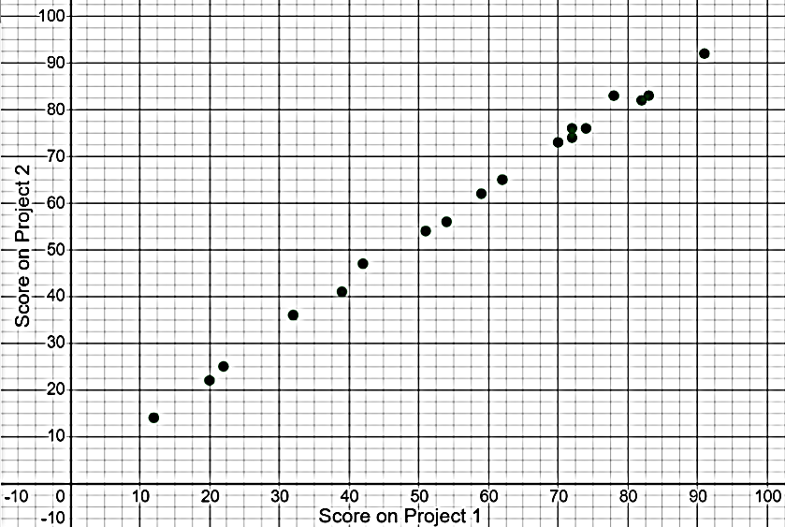

**Item #2:** Alignment to ACT PLD.NQ.**1**

**You calculate a line of best fit for a scatter plot and arrive at the equation y = 0.31x + 22.**

**Based on this, you conclude that the slope of the line is _______________ and the y-intercept of the line is _______________.**

**Item #3:** Alignment to ACT PLD.NQ.**2**

**The graph shows the number of questions answered correctly by students on a pretest and post-test over a certain set of standards.**

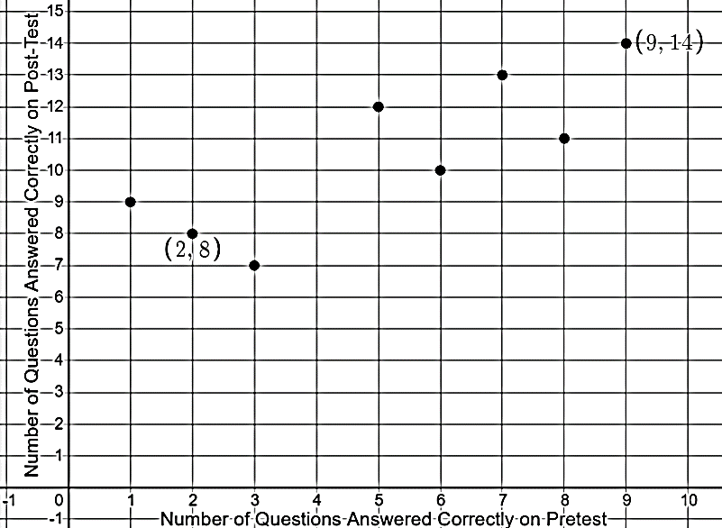

**You visually estimate that a trend line should pass through the data points (2, 8) and (9, 14). What is the slope of that line?**

**Item #4:** Alignment to ACT PLD.NQ 7.**3**

**Data relating students’ scores on two projects assigned in a business course are shown on the graph.** 

**Describe the relationship between the variables; be sure to explain what you mean using this context.**

**Item #5:** Alignment to ACT PLD.NQ.**3**

**The table shows the percentages of students experiencing poverty and students participating in extracurricular activities for fifteen schools.**

|  |  |  |
| --- | --- | --- |
| **School** | **Percent of Students Experiencing Poverty** | **Percent of Students Participating in Extracurricular Activities** |
| Alpha High | 32 | 76 |
| Beta High | 41 | 66 |
| Gamma High | 29 | 74 |
| Delta High | 40 | 60 |
| Epsilon High | 27 | 78 |
| Zeta High | 19 | 73 |
| Eta High | 14 | 82 |
| Theta High | 15 | 85 |
| Iota High | 29 | 63 |
| Kappa High | 36 | 71 |
| Lambda High | 47 | 58 |
| Mu High | 38 | 64 |
| Nu High | 8 | 84 |
| Xi High | 22 | 78 |

**Part A: Use technology to determine the equation of the line of best fit for the data. Round to the nearest thousandth for the slope and y-intercept.**

**Part B: Explain what the slope means in the context of this data.**

**Part C: Explain what the y-intercept means in the context of this data.**

**Item #6:** Alignment to ACT PLD.NQ.**4**

**Based on the data in Item #5, if 100% of a school’s students were experiencing poverty, what would be the predicted percentage of students participating in extracurricular activities? Justify your answer.**

**Every Student, Every Day, No Excuses**

***Student Personal Goals to Celebrate and Chart Progress***

|  |  |  |  |  |
| --- | --- | --- | --- | --- |
| **My Learning Goal** | **Getting Started** | **On My Way** | **I’m There** | **Notes to Self** |
| I can identify the slope and y-intercept from a given linear equation. |  |  |  |  |
| I can calculate the average rate of change between two points. |  |  |  |  |
| For data where a linear model is appropriate, I can determine a linear function that represents the best fit for the data. |  |  |  |  |
| I can explain what the slope and y-intercept of a linear model mean in the context of the data. |  |  |  |  |
| I can analyze what linear models predict about populations represented on scatter plots. |  |  |  |  |

***What will we do for students who do not know it?***

***What will we do for students who already know it?***

Guided Group Lesson

Standard: Date:

|  |  |  |  |  |
| --- | --- | --- | --- | --- |
| Group Members | Emerging | Developing | Proficient | Distinguished |
|  |  |  |  |

Warm-Up:

|  |
| --- |
|  |



Vocabulary

|  |  |  |  |
| --- | --- | --- | --- |
| Emerging | Developing | Proficient | Distinguished |
| Lesson focus: | Lesson focus: | Lesson focus: | Lesson focus: |

|  |  |  |
| --- | --- | --- |
| Observations: |  | Next Steps: |
| What you notice about your students during small group instruction. | What will you do with these students next? Change groups, repeat, etc. |

**Key**

**Item #1:** Alignment to ACT PLD.NQ.**0** (Flashback to 8.SP.2)

**Data relating students’ scores on two projects assigned in a business course are shown on the graph. Sketch an estimated line of best fit for the data on the graph.**

*A sample line (generated by Desmos) is shown. Students’ lines do not have to be formally calculated, but should have a slope that clearly follows the general trend of the points, with the line positioned so that the numbers of points above and below are reasonably balanced.*

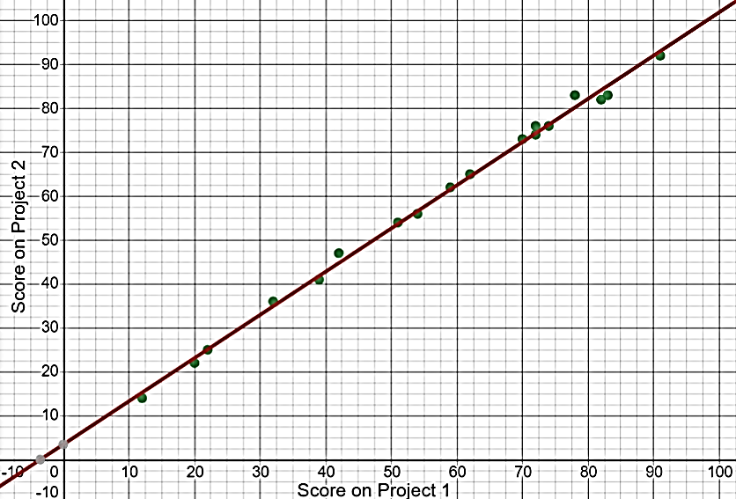

Rubric:

2 points: (Full understanding indicated.)The student’s line shows an appropriate direction and position to represent the data points .

1 point: (Partial understanding indicated.) The student’s line shows an appropriate slope, but is positioned above too many points or below too many points rather than balanced between the points OR the slope is too steep or not steep enough, but the points are balanced with relatively equal numbers above and below the line.

0 points: The slope of the student’s line does not match the data (too steep, not steep enough, or negative) AND the position of the line does not indicate a balance of points around the line drawn OR the student connects the dots or uses some other shape rather than drawing a line OR the student does not attempt the problem.

**Item #2:** Alignment to ACT PLD.NQ.**1**

**You calculate a line of best fit for a scatter plot and arrive at the equation y = 0.31x + 22.**

**Based on this, you conclude that the slope of the line is**  031  **and the y-intercept of the line is**  22 **.**

Rubric:

2 points: Both the slope and the y-intercept are identified correctly.

1 point: Either the slope or the y-intercept is identified correctly, but one is incorrect.

0 points: Neither the slope nor the y-intercept is identified correctly.

*Teacher note: Some students may mistakenly identify 0.31x as the slope instead of 0.31. PLCs should agree on how this error will be addressed in scoring.*

**Item #3:** Alignment to ACT PLD.NQ.**2**

**The graph shows the number of questions answered correctly by students on a pretest and post-test over a certain set of standards.**



**You estimate that a trend line should pass through the data points (2, 8) and (9, 14). What is the slope of that line?**

$\frac{6}{7}$, or approximately 0.857.

Rubric:

1 point: The student determines the correct slope.

0 points: The student does not determine the correct slope.

*Teacher note: If the assessment is being administered electronically, teachers may wish to give additional guidance regarding the format of the answer (rounding, for example) to ensure that correct answers are given in a format that will be scored as correct.*

**Item #4:** Alignment to ACT PLD.NQ.**3**

**Data relating students’ scores on two projects assigned in a business course are shown on the graph.** 

**Part A: Describe the relationship between the variables in general terms.**

*Sample answer: There is a strong positive relationship between the variables.*

**Part B: Explain what that description means in this context.**

*Sample answer: In this context, that means that students who earned higher scores on the first project tended to earn higher scores on the second project.*

Rubric:

2 points: The student identifies the relationship as a strong positive relationship and relates this to the context.

1 point: The student identifies the relationship as a strong positive relationship, but the contextual interpretation is missing, unclear, or incorrect OR the student clearly and correctly describes the contextual relationship but does not identify the relationship as strong and positive.

0 points: The student does not correctly describe or explain the relationship between the variables.

**Item #5:** Alignment to ACT PLD.NQ.**3**

**The table shows the percentages of students experiencing poverty and students participating in extracurricular activities for fifteen schools.**

|  |  |  |
| --- | --- | --- |
| **School** | **Percentage of Students Experiencing Poverty** | **Content Mastery Rating** |
| Alpha High | 32 | 76 |
| Beta High | 41 | 66 |
| Gamma High | 29 | 74 |
| Delta High | 40 | 60 |
| Epsilon High | 27 | 78 |
| Zeta High | 19 | 73 |
| Eta High | 14 | 82 |
| Theta High | 15 | 85 |
| Iota High | 29 | 63 |
| Kappa High | 36 | 71 |
| Lambda High | 47 | 58 |
| Mu High | 38 | 64 |
| Nu High | 8 | 84 |
| Xi High | 22 | 78 |

**Part A: Use technology to determine the equation of the line of best fit for the data. Round to the nearest thousandth for the slope and y-intercept.**

y = -0.672x + 91.341

*Using Desmos:*

*Enter the data in a table, then enter y1 ~ mx1 + b to generate the parameters for the line of best fit.*

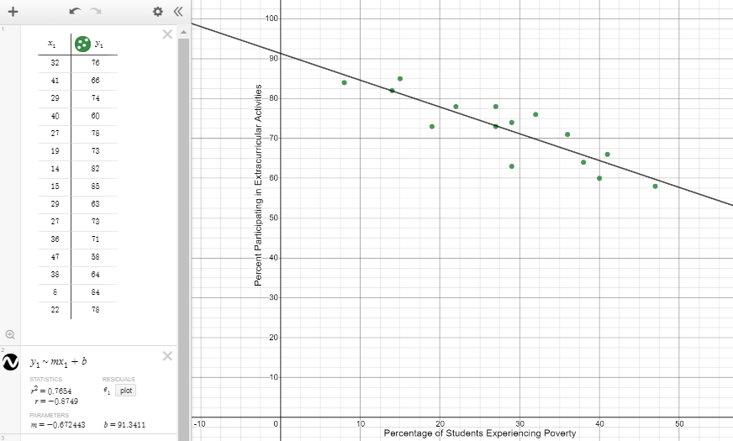

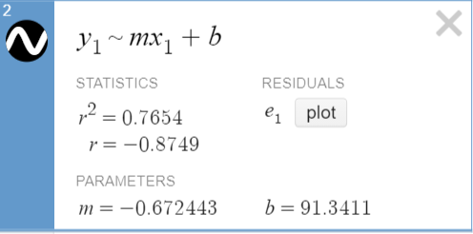

*Using TI-84:*

1: Stat > 1(Edit) > Enter x values in L1 and y values in L2



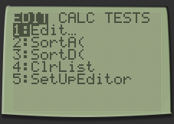 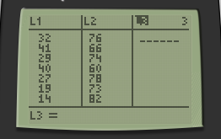

2: 2nd > Quit > STAT > CALC > 4(LinReg ax+b) > L1, L2 > ENTER

(Enter L1, L2 by using the 2nd key and the functions above the 1 and 2 number keys, which read L1 and L2. Use the comma in between. Depending on the updates on the calculators, students may see L1 and L2 already indicated after they choose option 4.)

Note that students may select 8(LinReg a + bx) instead of option 4(LinReg ax + b). Either will work, but students should understand the difference.



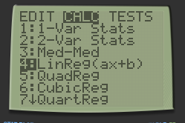 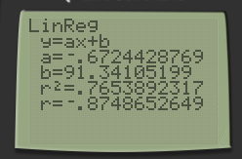

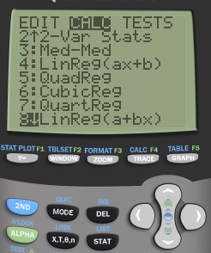 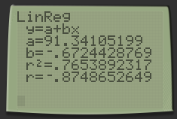

*Teacher Note: If students have not selected “DiagnosticOn” from the catalog, they will not see the r2 and r values.*

**Part B: Explain what the slope means in the context of this data.**

*Sample answer: The slope means that for every 1% increase in the percentage of students in poverty, there is approximately a 0.672% decrease in the percentage of students who participate in extracurricular activities.*

**Part C: Explain what the y-intercept means in the context of this data.**

*Sample answer: The y-intercept means that a school that had 0% of its students experiencing poverty would be predicted to have 91.341% of its students participating in extracurricular activities.*

Rubric:

3 points: The student provides correct answers for all three parts of the question.

2 points: The student provides correct answers for two parts of the question OR the equation is incorrect in Part A, but the answers in Part B and Part C are correct based on the slope and y-intercept in the equation the student wrote for Part A OR the equation for Part A is correct, but the answers for Part B and Part C are incomplete or are expressed only in general rather than contextual terms.

1 point: The student provides a correct answer for Part A but the answers for Parts B and C are incorrect or missing OR the student gives an incorrect answer for Part A, but the answer for Part B or Part C (but not both) correctly explains the slope or y-intercept given in Part A OR the student gives an incorrect answer for Part A, and parts B and C are partially correct but are incomplete or are expressed only in general rather than contextual terms.

0 points: The student’s answer for Part A is incorrect, and the answers for Parts B and C do not correspond to Part A and are too general or incomplete to indicate understanding.

**Item #6:** Alignment to ACT PLD.NQ.**4**

**Based on the data in Item #5, if 100% of a school’s students were experiencing poverty, what would be the predicted percentage of students participating in extracurricular activities? Justify your answer.**

*Sample answer: Based on the trend in the data, if 100% of a school’s students were experiencing poverty, we would predict that about 24% of the students would participate in extracurricular activities. This can be predicted by substituting 100 for x in the equation for the line of best fit:*

y = -0.672(100) + 91.341 = 24.141

Rubric:

2 points: The student provides a correct answer and a well-reasoned justification.

*Teacher note: If the student’s equation in Part A of Item #5 was incorrect, but this question is correctly answered using the equation given in Part A, the student should receive full credit for this question.*

1 point: The student provides a correct answer but the justification is missing or unclear.

0 points: The student’s answer is incorrect and the justification is missing, unclear, or incorrect.