Virginia’s 2009 Revised Mathematics
Standards of Learning

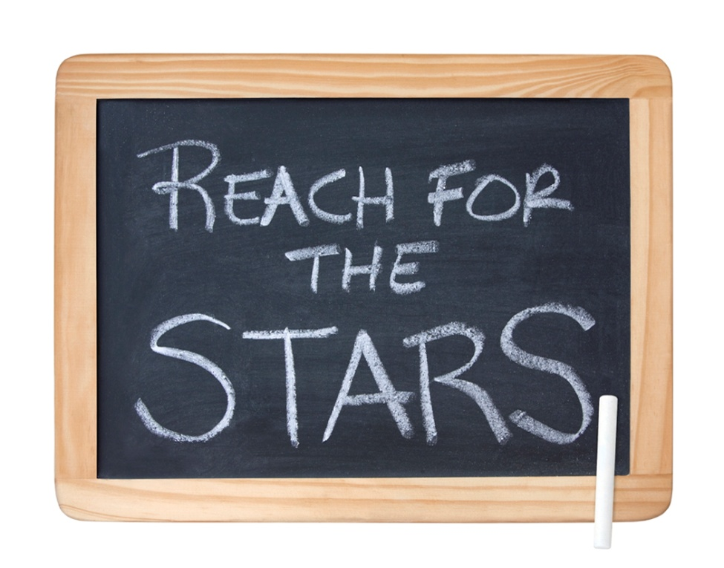
A Vertical Articulation by Strand
Grade 3 through Grade 8

Prepared by
Dan Mulligan, Ed. D.
flexiblecreativity.com
Number and Number Sense
Grade 3 | Grade 4 | Grade 5
Focus: Place Value and Fractions  3.1 The student will  a) read and write six-digit numerals and identify the place value for each digit.;  b) round a whole number, 9,999 or less, to the nearest ten, hundred, and thousand; and  c) compare two whole numbers between 0 and 9,999, using symbols (>, <, or = ) and words (greater than, less than, or equal to).  3.2 The student will recognize and use the inverse relationships between addition/subtraction and multiplication/division to complete basic fact sentences. Students will use these relationships to solve problems such as 5 + 3 = 8 and 8 – 3 = ____.  3.3 The student will  a) name and write fractions (including mixed numbers) represented by a model;  b) model fractions (including mixed numbers) and write the fractions’ names; and  c) compare fractions having like and unlike  denominators, using words and symbols for <, >, and =. | Focus: Place Value, Fractions, and Decimals  4.1 The student will  a) identify (orally and in writing) the place value for each digit in a whole number  expressed through millions;  b) compare two whole numbers expressed through millions, using symbols ( >, <, or = ); and  c) round whole numbers expressed through millions to the nearest thousand, ten thousand, and hundred thousand.  4.2 The student will  a) compare and order fractions and mixed numbers; using concrete objects and pictures  b) represent equivalent fractions; and  c) identify the division statement that represents a fraction.  4.3 The student will  a) read, write, represent, and identify decimals expressed through thousandths;  b) round decimals to the nearest whole number, tenth, and hundredth;  c) compare and order decimals, using symbols (<, >, or =), concrete materials, drawings, and calculators.; and  d) given a model, write the decimal and fraction equivalents. | Focus: Factors and Multiples, Fractions, Decimals  5.1 The student, given a decimal through thousandths, will round to the nearest whole number, tenth, or hundredth.  5.2 The student will  a) recognize and name fractions (halves, fourths, fifths, eighths, and tenths) in their equivalent decimal form and vice versa; and  b) compare and order a given set of fractions and decimals from least to greatest.  Fractions will include like and unlike denominators limited to 12 or less, and  mixed numbers.  5.3 The student will  a) identify and describe prime and composite numbers; and  b) identify and describe even and odd numbers.

Number and Number Sense
Grade 6 | Grade 7 | Grade 8
Focus: Relationships among Fractions, Decimals and Percents  6.1 The student will describe and compare data, using ratios, and will use appropriate notations, such as a/b, a to b, and a:b.  6.2 The student will  a) investigate and describe fractions, decimals and percents as ratios;  b) identify a given fraction, decimal, or percent from a representation;  c) demonstrate equivalent relationships among fractions, decimals, and percents; and  d) compare and order fractions, decimals, and percents.  6.3 The student will  a) identify, and represent integers, ;  b) order, and compare integers.; and  c) identify and describe absolute value of integers.  6.4 The student will demonstrate multiple representations of multiplication and division of fractions.  6.5 The student will investigate and describe concepts of positive exponents and perfect squares. | Focus: Scientific Notation and Square Roots  7.1 The student will  a) investigate and describe the concept of negative exponents for powers of ten;  b) determine scientific notation for numbers greater than zero;  c) compare and order fractions, decimals, percents and numbers written in scientific notation;  d) determine square roots; and  e) identify and describe absolute value for rational numbers.  7.2 The student will describe and represent arithmetic and geometric sequences using variable expressions. | Focus: Relationships within the Real Number System  8.1 The student will  a) simplify numerical expressions involving positive exponents, using rational numbers, order of operations, and properties of operations with real  numbers; and  b) compare and order decimals, fractions, percents, and numbers written in scientific notation.  8.2 The student will describe orally and in writing the relationship between the subsets of the real number system.

Computation and Estimation
Grade 3 | Grade 4 | Grade 5
Focus: Computation and Fraction Operations  3.4 The student will estimate solutions and solve single-step and multistep problems involving the sum or  difference of two whole numbers, each 9,999 or less, with or without  regrouping using various computational methods, including calculators, paper  and pencil, mental computation, and estimation.  3.5 The student will  a) recall the multiplication facts through the twelves table; and  b) the corresponding division facts.  3.6 The student will represent multiplication and division, using area set, and number line models; and create and solve problems that involve multiplication of two whole numbers, one factor 99 or less and the second factor 5 or less.  3.7 The student will add and subtract with proper fractions having like denominators of 12 or less, using concrete materials and pictorial models representing areas/regions, lengths/measurements, and sets. | Focus: Whole Number, Fraction, and Decimal Operations, and Estimation  4.4 The student will  a) estimate sums, differences, products, and quotients for whole numbers;  b) add, subtract, and multiply whole numbers;  c) divide whole numbers, finding quotients with and without remainders; and  d) solve single and multistep addition, subtraction, and multiplication problems with whole numbers.  4.5 The student will  a) determine common multiples and factors, including least common multiple and greatest common factor;  b) add and subtract with fractions having like and unlike denominators that are limited to 2, 3, 4, 5, 6, 8, 10, and 12, and simplify the resulting fractions, using common multiples and factors;  c) add and subtract with decimals; and  d) solve single-step practical problems involving addition and subtraction with fractions and with decimals. | Focus: Computation Operations and Estimations  5.4 The student will create and solve single and multistep practical problems involving addition, subtraction, multiplication, and division with and without remainders of whole numbers, using paper and pencil, estimation, mental computation, and  Calculators.  5.5 The student will  a) find the sum, difference, and quotient, of two numbers expressed as decimals through thousands (divisors with only one nonzero digit); and  create and solve single-step and multistep practical problems involving decimals.  5.6 The student will solve single-step and multistep practical problems involving addition and subtraction with fractions and mixed numbers and express answers in simplest form.  5.7 The student will evaluate whole number numerical expressions, using the order of operations limited to parentheses, addition, subtraction, multiplication, and division.

Computation and Estimation
Grade 6 | Grade 7 | Grade 8
Focus: Applications of Operations with Rational Numbers  6.6 The student will  a) multiply and divide with fractions and mixed numbers; and  b) estimate solutions and then solve single and multistep practical problems that involve addition, subtraction, multiplication and division of fractions.  6.7 The student will use solve single and multistep practical problems involving addition, subtraction, multiplication and division of decimals.  .  6.8 The student will evaluate whole number expressions, using the order of operations. | Focus: Application of Rational Number Operations and Proportional Reasoning  7.3 The student will  a) model addition, subtraction, multiplication and division of integers; and  b) add, subtract, multiply, and divide integers.  7.4 The student will solve single and multistep practical problems using proportional reasoning. | Focus: Practical Applications of Operations with Real Numbers  8.3 The student will  a) solve practical problems involving rational numbers, percents, ratios, and proportions; and  b) determine the percent increase or decrease for a given situation.  8.4 The student will apply the order of operations to evaluate algebraic expressions for given replacement values of the variables. Problems will be limited to positive exponents.  8.5 The student, will  a) identify a given whole number as a perfect square; and  b) find the two consecutive whole numbers between which a square root lies.

Measurement
Grade 3 | Grade 4 | Grade 5
Focus: U.S. Customary and Metric Units, Area and Perimeter, Time  3.8 The student will determine by counting the value of a collection of bills and coins whose total value is $5.00 or less, compare the value of the coins or bills, and make change.  3.9 The student will estimate and use U.S. Customary and metric units to measure:  a) length — to the nearest ½ inch), inches, feet, yards, centimeters, and meters;  b) liquid volume — cups, pints, quarts, gallons, and liters;  c) weight/mass — ounces, pounds, grams, and kilograms.; and  d) area and perimeter.  3.10 The student will  a) measure the distance around a polygon in order to determine perimeter; and  b) count the number of square units needed to cover a given surface in order to determine area.  3.11 The student will  a) tell time to the nearest minute, using analog and digital clocks.; and  b) determine elapsed time in one-hour increments over a 12-hour period.  3.12 The student will identify equivalent periods of time, including relationships among days, months, and years, as well as minutes and hours.  3.13 The student will read temperature to the nearest degree from a Celsius thermometer and a Fahrenheit thermometer. Real thermometers and physical models of thermometers will be used. | Focus: Equivalence between U.S. Customary and Metric Units  4.6 The student will  a) estimate and measure weight/mass, using actual measuring devices and describe the results in U.S. Customary/metric units as appropriate, including ounces, pounds, tons, grams, and kilograms and  b) identify equivalent measurements between units within the U.S. Customary system (ounces, pounds, and tons, and between units within the metric system (grams and kilograms).  4.7 The student will  a) estimate and measure length and determine the result in both metric and U.S. Customary units including part of an inch (1/2, 1/4, and 1/8), inches, feet, yards, miles, millimeters, centimeters, and meters; and  b) identify equivalent measurements between units within the U.S. Customary system (inches and feet; feet and yards; inches and yards; yards and miles) and between units within the metric system (millimeters and centimeters; centimeters and meters; and millimeters and meters). ; and  4.8 The student will  a) estimate and measure liquid volume, using actual measuring devices and describe the results in U.S. Customary; and b) identify equivalent measurements between units within the U.S. Customary system (cups, pints, quarts, and gallons).  4.9 The student will determine elapsed time in hours and minutes within a 12-hour period. | Focus: Perimeter, Area, volume, and Equivalent Measures  5.8 The student will  a) find perimeter, area, and volume in standard units of measure;  b) differentiate between perimeter, area, and volume and identify whether the application of the concept of perimeter, area, or volume is appropriate for a given situation;  c) identify equivalent measurements within the metric system;  d) estimate and then measure to solve problems using U.S. Customary and metric units; and  e) choose an appropriate unit of measure for a given situation involving measurement using U.S. Customary and metric units.  5.9 The student will identify and describe the diameter, radius, chord, and circumference of a circle.  5.10 The student will determine an amount of elapsed time in hours and minutes within a 24-hour period.  5.11 The student will measure and draw right, acute, and obtuse, and straight angles.

Measurement
Grade 6 | Grade 7 | Grade 8
Focus: Problem Solving with Area, Perimeter, Volume, and Surface Area  6.9 The student will make ballpark comparisons between U.S. Customary System of measurement and metric system; compare and convert units of measure for length, area, weight/mass, and volume within the U.S. Customary system and the metric system.  6.10 The student will  a) define pi (π) as the ratio of the circumference of a circle to its diameter;  b) solve practical problems involving circumference and area of a circle;  c) solve practical problems involving area and perimeter; and  d) describe and determine the volume and surface area of a rectangular prism. | Focus: Volume and Surface Area  7.5 The student will  a) describe volume and surface area of cylinders; and  b) solve practical problems involving the volume and surface area of cylinders, using concrete materials and practical situations to develop formulas;  c) describe how changing one measured attribute of a rectangular prism affects its volume and surface area.  7.6 The student will determine if plane figures – quadrilaterals and triangles – are similar and write proportions to express the relationships between corresponding sides of similar figures. | Focus: Problem Solving  8.6 The student will  a) verify by measuring and describe the relationships among vertical angles,  adjacent angles, supplementary angles, and complementary angles; and  b) measure angles of less than 360°.  8.7 The student will  a) investigate and solve practical problems involving volume and surface area of prisms, cylinders, cones, and pyramids; and  b) describe how changing one measured attribute of the figure affects the volume and surface area.

Geometry
Grade 3 | Grade 4 | Grade 5
Focus: Properties and Congruence  3.14 The student will identify, describe, compare, and contrast characteristics of plane and solid geometric figures (circle, square, rectangle, triangle, cube, rectangular prism, square pyramid, sphere, cone, and cylinder) by identifying relevant characteristics, including the number of angles, vertices, and edges, and the number and shape of faces, using concrete models..  3.15 The student will identify and draw representations of points, line segments,  rays, angles, and lines  3.16 The student, given appropriate drawings or models will identify and describe congruent and noncongruent, plane figures, using tracing procedures. | Focus: Representations and Polygons  4.10 The student will  a) identify and describe representations of points, lines, line segments, rays, and angles, including endpoints and vertices;  b) identify representations of lines that illustrate intersection, parallelism, and  perpendicularity; and  4.11 The student will  a) investigate congruence of plane figures after geometric transformations such as reflection, translation and rotation, using mirrors, paper folding, and tracing.  b) recognize the images of figures resulting from geometric transformations such as translation (slide), reflection (flip), or rotation (turn).  4.12 The student will  a) define polygon; and  b) identify polygons with 10 or fewer sides. | Focus: Classification and Subdividing  5.12 The student will classify  a) angles as right, acute, or obtuse, or straight; and  b) triangles as right, acute, obtuse, equilateral, scalene, or isosceles.  5.13 The student, using plane figures, (square, rectangle, triangle, parallelogram, rhombus, and trapezoid) will  a) develop definitions of these plane figures; and  b) investigate and describe the results of combining and subdividing plane figures.

Geometry
Grade 6 | Grade 7 | Grade 8
Focus: Properties and Relationships  6.11 The student will  a) identify the coordinates of a point in a coordinate plane; and  b) graph ordered pairs in a coordinate plane.  6.12 The student will determine congruence of segments, angles, and polygons  .  6.13 The student will describe and identify properties of quadrilaterals. | Focus: Relationships Between Figures  7.7 The student will compare and contrast the following quadrilaterals based on  properties: parallelogram, rectangle, square, rhombus, and trapezoid. Deductive reasoning and inference will be used to classify quadrilaterals.  7.8 The student, given a polygon in the coordinate plane, will represent transformations  — reflections, dilations, rotations, and translations — by graphing the coordinates of the vertices of the transformed polygon and sketching the resulting figure. | Focus: Problem Solving with 2- and 3- Dimensional Figures  8.8 The student will  a) apply transformations to plane figures;  b) identify applications of transformations.  8.9 The student will construct a three-dimensional model, given the top or bottom, side and front views.  8.10 The student will  a) verify the Pythagorean Theorem, using diagrams, concrete materials, and  measurement; and  b) apply the Pythagorean Theorem and its converse to find the missing length of a side of a right triangle when given the lengths of the other two sides.  8.11 The student will solve practical area and perimeter problems involving  composite, plane figures.

Probability and Statistics
Grade 3 | Grade 4 | Grade 5
Focus: Applications of Data and Chance  3.17 The student will  a) collect and organize data on a given topic of his/her choice, using observations,  measurements, surveys, or experiments;  b) construct a line plot, a picture graph, or a bar graph to represent the data. Each graph will include an appropriate title and key; and  c) read and interpret the data represented in line plots, bar graphs, and picture graphs and write a sentence analyzing the data.  3.18 The student will investigate and describe the concept of probability as chance and list possible results of a given situation. | Focus: Outcomes  4.13 The student will  a) predict the likelihood of an outcome of a simple event, using the terms certain, likely, equally likely, unlikely, impossible  b) represent probability as a number between 0 and 1.  4.14 The student will collect, organize, and display data from a variety of graphs, including bar graphs and line graphs. | Focus: outcomes and Measures of Centers  5.14 The student will  a) make predictions and determine the probability of an outcome by constructing a sample space.  5.15 The student will, given a problem situation, collect, organize, and display a set of numerical data in a variety of forms, using bar graphs, stem-and-leaf plots, and line graphs, to draw conclusions and make predictions.  5.16 The student will  a) describe mean, median, and mode as measures of center;  b) describe mean as fair share;  b) find the mean, median, mode, and range of a set of data; and  c) describe the range of a set of data as a measure of variation.

Probability and Statistics
Grade 6 | Grade 7 | Grade 8
Focus: Practical Applications of Statistics  6.14 The student, given a problem situation, will  a) construct circle graphs;  b) draw conclusions and make  predictions using circle graphs; and  c) compare and contrast graphs which present the same information from the same set of data.  6.15 The student will  a) describe the mean as balance point;  b) decide which measure of center is appropriate for a given purpose.  6.16 The student will  a) compare and contrast dependent and independent events; and  b) determine probabilities for dependent and independent events. | Focus: Applications of Statistics and Probability  7.9 The student will investigate and describe the difference between the experimental and theoretical probability of an event.  7.10 The student will determine the probability of compound events using the Fundamental (Basic) Counting Principle.  7.11 The student, given data in a practical situation, will  a) construct and analyze histograms; and  b) compare and contrast histograms with other types of graphs presenting information from the same data set. | Focus: Statistical Analysis of Graphs and Problem Situations  8.12 The student will determine the probability of independent and dependent events with and without replacement.  8.13 The student will  a) make comparisons, predictions, and inferences, using information displayed in  graphs; and  b) construct and analyze scatterplots.

Patterns, Functions, and Algebra
Grade 3 | Grade 4 | Grade 5
Focus: Patterns and Property Concepts  3.19 The student will recognize and describe a variety of patterns formed using numbers, tables, and pictures, and extend the pattern, using the same or different forms.  3.20 The student will  a) investigate the identity and the commutative properties for addition and multiplication; and  b) identify examples of the identity and commutative properties for addition and multiplication; and  c) demonstrate an understanding of equality by recognizing that the equals sign (=) in an equation links equivalent quantities, such as 4 • 3 = 14 – 2. | Focus: Geometric Patterns, Equality, Properties  4.15 The student will recognize, create, and extend numerical and geometric patterns, using concrete materials, number lines, symbols, tables, and words.  4.16 The student will  a) recognize and demonstrate the meaning of equality in an equation, using  symbols representing numbers, operations, and relations [e.g., 3 + 5 = 5 + 3 and 15 + (35 + 16) = (15 + 35) + 16; and  b) investigate and describe the associative property for addition and  multiplication. | Focus: Equations and Properties  5.17 The student will describe the  relationship found in a number patterns and express the relationship, using words, tables, and symbols to describe the relationship. Concrete materials and calculators will be used.  5.18 The student will  a) investigate and describe the concept of variable;  b) write an open sentence to represent a given mathematical relationship, using a variable.;  c) model one-step linear equations in one variable using addition and subtraction;  and  d) create a problem situation based on a given open sentence using a single variable.  5.19 The student will investigate and recognize the distributive property of multiplication over addition.

Patterns, Functions, and Algebra
Grade 6 | Grade 7 | Grade 8
Focus: Variable Equations and Properties  6.17 The student will identify and extend geometric and arithmetic sequences.  6.18 The student will solve one-step linear equations in one variable, involving whole number coefficients and positive rational solutions.  6.19 The student will investigate and recognize:  a) the identity properties for addition and multiplication;  b) the multiplicative property of zero; and  c) the inverse property for multiplication.  6.20 The student will graph inequalities on a number line. | Focus: Linear Equations  7.12 The student will represent relationships with tables, graphs, rules, and words.  7.13 The student will  a) write verbal expressions as algebraic expressions and sentences as equations and vice versa; and  b) evaluate algebraic expressions for given replacement values of the variable.  7.14 The student will  a) solve one- and two-step linear equations in one variable with strategies involving inverse operations and integers, using concrete materials, pictorial representations, and paper and pencil; and  b) solve practical problems requiring the solution of a one- or two-step linear equations.  7.15 The student will  a) solve one-step inequalities in one variable; and  b) graph solutions to inequalities on the number line.  7.16 The student will apply the following properties of operations with real numbers:  a) the commutative and associative properties for addition and multiplication;  b) the distributive property;  c) the additive and multiplicative identity properties;  d) the additive and multiplicative inverse properties; and  e) the multiplicative property of zero. | Focus: Linear Relationships  8.14 The student will  a) represent a given relationship in tables, graphs, word, and rules form; and  b) make connections between any two forms.  8.15 The student will  a) solve multistep linear equations in one variable on one and two sides of the equation;  b) solve two-step inequalities and graph the results on a number line; and  c) identify properties of operations used to solve an equation.  8.16 The student will graph a linear equation in two variables using a table of ordered pairs  8.17 The student will identify the domain, range, independent variable or dependent variable in a given situation.

