My Appointment Schedule | 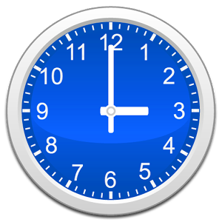

Time | Partner
1:00
2:00
3:00
4:00
5:00
6:00
7:00
8:00
9:00
10:00
11:00
12:00

