Newspaper Skeletons

Focus:
Each team will build a newspaper frame of one of the three-dimensional solids illustrated below. The frames will be used to solve “life size” spatial probes.
Materials:
- Newspaper
- Masking tape
Choosing the Frames:
To make the choice random, each team will select an envelope containing one of the three-dimensional solids illustrated below. Solids with curved surfaces will not be used here. The possible shapes included are:
The frame to be built must match the shapes of the faces on the model. For example, if the small triangular prism is drawn, the frame must have triangles and rectangles. If the large triangular prism is drawn, the frame must have triangles and squares.
Building the Frames:
- To make longer poles of the frame, use an entire sheet and roll the newspaper using the longer side. Roll fairly lightly and tape the final corners to keep the pole from unraveling.
- To make shorter poles, use the entire sheet and roll the newspaper using the shorter side.
- The poles are sturdy through the middle but weaker at the ends. Fold or crunch the ends and join them to each other with masking tape.
Maximum Vocabulary Brainstorming

Team Goal:
- To apply as many of our essential vocabulary words to your newspaper skeleton. Each team member must be able to justify the use of the word with your team’s newspaper skeleton.
Steps:
- With your team members, identify the words that can be applied to your newspaper skeleton.
- Write the word of phrase on a Post-It Note and attach it in the vicinity of where the word can be applied to your skeleton.
- Take turns explaining how the words apply.
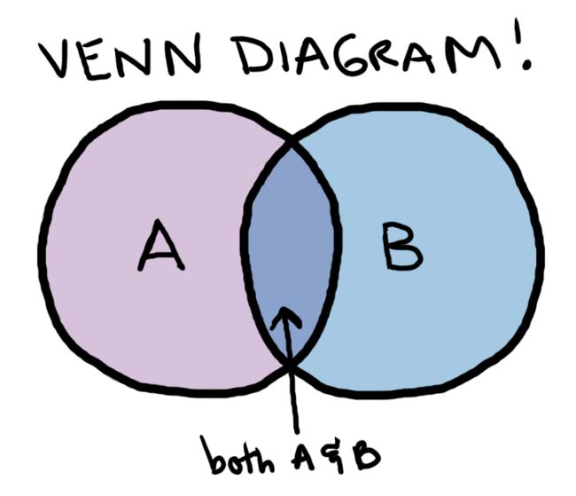

VENN My Skeleton

Team(s) Goal:
- Create an overlapping, two-circle Venn Diagram.
- Label each circle with the name of your skeleton.
- Compare the Post-It Notes used to label each team’s skeleton to find similarities and differences.
- Place the Post-it Notes in the Venn Diagram to accurately reflect your comparison from step 3. Note: if each team has a word in common, only place one Post-It Note or the word in the Venn Diagram.
- Make sure that each team member can justify your final Venn Diagram.

