Virginia Science Checkpoint Assessment
Science 3.4 SAMPLE
Reporting Category: Life Processes and Living Systems
Standards of Learning Blueprint Summary
Reporting Category | Grade 2 SOL | Grade 3 SOL | Number of Items
Assessed with other SOL | 2.1(m) | 3.1(m)
Scientific Investigation, Reasoning, and Logic | 2.1(a-l) | 3.1(a-l) | 10
Force, Motion, Energy, and Matter | 2.2(a-b), 2.3(a-c) | 3.2(a-d), 3.3(a-c) | 8
Life Processes and Living Systems | 2.4(a-b), 2.5(a-d), 2.7(a), 2.8(a-d) | 3.4(a-b), 3.5(a-c), 3.6(a-d), 3.10(a) | 11
Earth/Space Systems and Cycles | 2.6(a-c), 2.7(b) | 3.7(a-d), 3.8(a-c), 3.9(a-e), 3.10(b-d), 3.11(a-c) | 11
Excluded from Testing | None
Subsumed Content | Content in Kindergarten and Grade 1 SOL
Number of Operational Items |  |  | 40
Number of Field-Test Items |  |  | 10
Total Number of Items on Test |  |  | 50

Virginia Science SOL Test Cut Scores (2010)
Test | Failing Scores |  | Passing Scores
 | Basic |  | Proficient |  | Advanced
 | # correct | % correct | Minimum  # correct | Minimum  % correct | Minimum  # correct | Minimum  % correct
Science 3 | n/a | n/a | 27 of 40 | 68% | 36 of 40 | 90%
Science 5 | n/a | n/a | 26 of 40 | 65% | 37 of 40 | 93%
Science 8 | n/a | n/a | 27 of 50 | 54% | 44 of 50 | 88%
Earth Science | n/a | n/a | 25 of 50 | 50% | 45 of 50 | 90%
Biology | n/a | n/a | 27 of 50 | 54% | 45 of 50 | 90%
Chemistry | n/a | n/a | 25 of 50 | 50% | 44 of 50 | 88%

Checkpoint Items

- Directions: Circle the picture you want to select.

Which animal does not care for its young after birth?

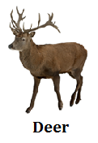
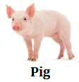
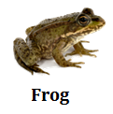
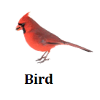

- Directions: Circle the box you want to select.

Soon after they hatch from their eggs sea turtles begin to move toward the ocean.

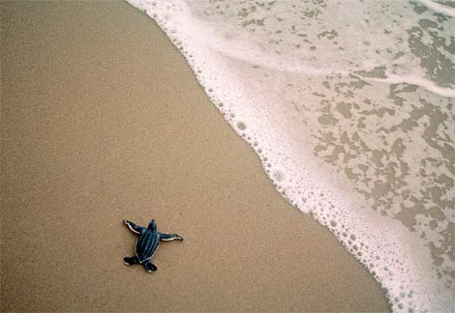

This action describes –

an environment
a learned behavior

a physical adaptation
an instinct

- Directions: Circle the box you want to select.

Which is an example of a physical adaptation?

A spider knows how to spin its own web
Rabbits use deep burrows for shelter
Monarch butterflies migrate as the seasons change

A porcupine has sharp quills for defending itself

- Directions: Circle the picture you want to select. You must select all correct answers.
Which animals are best adapted to catching fish out of the water?

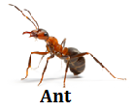
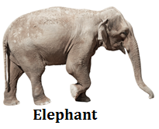
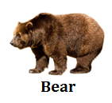
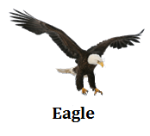

- Directions: Circle the box you want to select.

Look at the environment shown in the picture below.

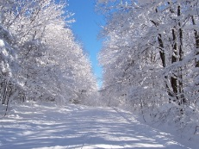

Which physical adaptations would best help an animal survive in a cold and snowy forest?

Feathers, wings and a beak
Scales, gills and fins
Thick fur, fat and claws

Six legs and an exoskeleton

- Directions: Write your answer in the box. You may use the possible answer choices provided.

This lion blends into his surroundings.

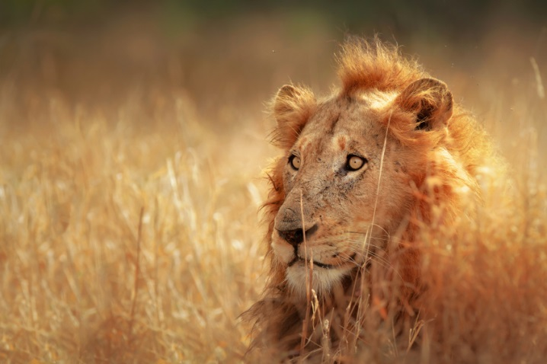

This is a type of .

Possible Answer Choices
hibernation
mimicry
camouflage
migration

- Directions: Circle the box you want to select.

Which is not an instinct?

A wolf learns to catch its prey
A bee gathers nectar from a flower
A fish swims through the water

An earthworm tunnels through the soil

- Directions: Circle the picture you want to select. You must select all correct answers.
Which animals migrate?

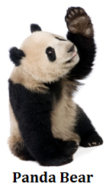
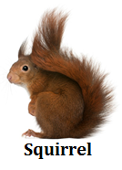
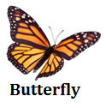
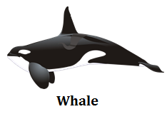

- Directions: Circle the box you want to select.

Why might a skunk put off a very bad smell?

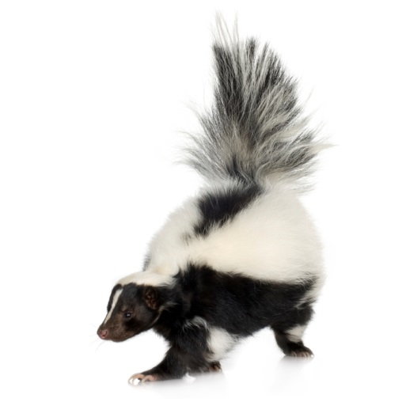

To help care for its young after birth
To defend itself from predators
To hunt for food

To camouflage itself with its surroundings

Checkpoint Solutions
SOL 3.4 The student will investigate and understand that adaptations allow animals to satisfy life needs and respond to the environment. Key concepts include
a) behavioral adaptations; and
b) physical adaptations.

Essential Knowledge, Skills and Processes
a. Give examples of methods that animals use to gather and store food, find shelter, defend themselves, and rear young
b. Describe and explain the terms camouflage, mimicry, hibernation, migration, dormancy, instinct, and learned behavior
c. Explain how an animal’s behavioral adaptations help it live in its specific habitat
d. Distinguish between physical and behavioral adaptations of animals
e. Compare the physical characteristics of animals, and explain how the animals are adapted to a certain environment
f. Compare and contrast instinct and learned behavior
g. Create (model) a camouflage pattern for an animal living in a specific dry-land or water-related environment (relates to 3.6)
h. Design and construct a model of a habitat for an animal with a specific adaptation

- Directions: Circle the picture you want to select.

Which animal does not care for its young after birth?

3.4aa Give examples of methods that animals use to gather and store food, find shelter, defend themselves, and rear young

- Directions: Circle the box you want to select.

Soon after they hatch from their eggs sea turtles begin to move toward the ocean.

This action describes –

an environment
a learned behavior

a physical adaptation
an instinct

3.4ab Describe and explain the terms camouflage, mimicry, hibernation, migration, dormancy, instinct, and learned behavior

- Directions: Circle the box you want to select.

Which is an example of a physical adaptation?

A spider knows how to spin its own web
Rabbits use deep burrows for shelter
Monarch butterflies migrate as the seasons change

A porcupine has sharp quills for defending itself

3.4bf Compare and contrast instinct and learned behavior

- Directions: Circle the picture you want to select. You must select all correct answers.
Which animals are best adapted to catching fish out of the water?

3.4be Compare the physical characteristics of animals, and explain how the animals are adapted to a certain environment

- Directions: Circle the box you want to select.

Look at the environment shown in the picture below.

Which physical adaptations would best help an animal survive in a cold and snowy forest?

Feathers, wings and a beak
Scales, gills and fins
Thick fur, fat and claws

Six legs and an exoskeleton

3.4be Compare the physical characteristics of animals, and explain how the animals are adapted to a certain environment

- Directions: Write your answer in the box. You may use the possible answer choices provided.

This lion blends into his surroundings.

camouflage
This is a type of .

Possible Answer Choices
hibernation
mimicry
camouflage
migration

3.4bb Describe and explain the terms camouflage, mimicry, hibernation, migration, dormancy, instinct, and learned behavior

- Directions: Circle the box you want to select.

Which is not an instinct?

A wolf learns to catch its prey
A bee gathers nectar from a flower
A fish swims through the water

An earthworm tunnels through the soil

3.4af Compare and contrast instinct and learned behavior

- Directions: Circle the picture you want to select. You must select all correct answers.
Which animals migrate?

3.4ab Describe and explain the terms camouflage, mimicry, hibernation, migration, dormancy, instinct, and learned behavior

- Directions: Circle the box you want to select.

Why might a skunk put off a very bad smell?

To help care for its young after birth
To defend itself from predators
To hunt for food

To camouflage itself with its surroundings

3.4aa Give examples of methods that animals use to gather and store food, find shelter, defend themselves, and rear young

