SPOTLIGHT
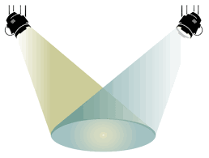
MOMENT
(Differentiation Pays Off)

My School | Research School
What was the reason for the action? | What was the reason for the action?
What did you do? Why? | What did they do? Why?
What happened? In hindsight, would you change anything? Why? | What happened? In hindsight, would you/they change anything? Why?
Why did it work? | Why did it work?
My additional notes/comments:

End of Day Planning Brainstorming Guide:
What have we learned? Why is it important to us?

How will we know if it worked? What evidence will we collect? How?

What will we do? When? Who will do it? What are the steps of implementation?

Brainstorming Zone:

