Suggested Diamond Board

I will justify my solutions to practical problems involving volume of a cylinder.

I will justify my solutions to practical problems involving volume of a sphere and cylinder.

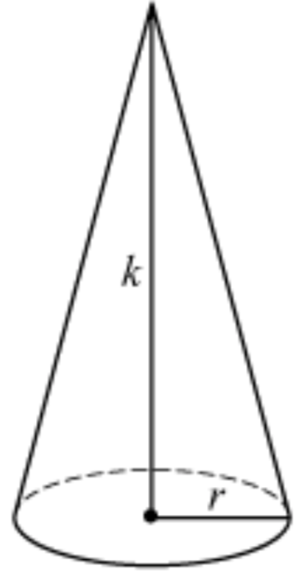 

I will explore how changes in one dimension affect the volume of a cone, sphere, or cylinder.

Geometric Solid, Square Root, Volume, Cylinder, Radius, Diameter, Height of Solid, Literal Equation, Sphere, Cube Root, Perfect Cubes, Cone



Driving Question: How do changes in the radius, diameter, and height of cylinders, cones, and spheres affect the volume of each shape?

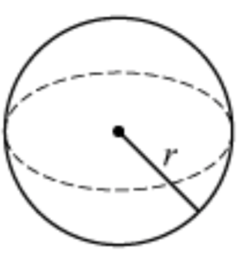

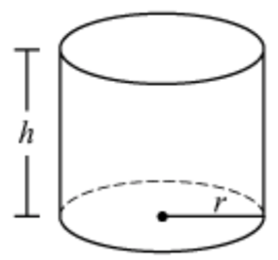

I will justify my solutions to practical problems involving volume of a cone, sphere, and cylinder.