Toolkit of Resources for Educators to Engage Each Student in Thinking and Wonder During Virtual Learning, Face-to Face, and (non-virtual) Distance Learning



Dan Mulligan, flexiblecreativity.com
2021 – 2022

Research that Grounds the Digital Learning Templates


Allen, D, et.al. (2020, August). Project Zero, Harvard University School of Education. Retrieved from: http://www.pz.harvard.edu

Dean, B., Hubbell, E., Pitler, H, & Stone, B. (2012). Classroom Instruction That Works, 2nd Edition. Denver, CO: McREL

Fisher, D., Frey, N., & Hattie, J. (2020). The Distance Learning Playbook, Grades K-12, Thousand Oaks, CA: Corwin Press

Hattie, J. (2020, August). Visible Learning Meta^{x}. Retrieved from http://www.visiblelearningmetax.com

Jensen, E. (2019) Poor Students Rich Teaching (revised Edition), Bloomington, IN: Solution Tree

Rose, D. (2020, August). Universal Design for Learning. Retrieved from udlguidelines.cast.org

Thinking Routine Matrix

Routines for Activating, Setting a Purpose, and Checking for Readiness
Routine | Key Thinking Moves | Notes
My Personal Goals | Focusing attention, charting progress, reflection | Clarifies purpose; celebrates/recognizes progress along the way
Diamond Board | Focusing attention, wondering, reflection | Each student participates in the evolution of a unit essential knowledge and essential vocabulary.
Y-Chart: See-Think-Wonder | Describing, interpreting, and wondering | Good with ambiguous or complex stimuli
Chatter Drawing | Uncovering prior knowledge, wondering, reflecting | Good at the beginning of a unit to direct personal or group inquiry and foster summarizing to reveal understandings as well as misconceptions.
Zoom In | Describing, interpreting, and inferring | Variation of See-Think-Wonder involving using only portions of an image.
These are… These are not… | Focusing attention, analyzing, hypothesizing, creating | Guides student use of similarities and differences to develop understanding rather than being ‘told’.
Think-Puzzle-Explore | Activating prior knowledge, wondering, planning | Good at the beginning of a unit to direct personal or group inquiry and uncover current understandings as well as misconceptions.
Alpha Blocks Sort | Identifying key concepts, recall | Activates background vocabulary; checks for misunderstandings; summarizes essential academic terminology
Whiteboard Talk | Uncovering prior knowledge and ideas, questioning | Open-ended discussion on paper, ensures all voices are heard, provides thinking time.
3-2-1 Bridge | Activating prior knowledge and ideas, questions | Works well when students have prior knowledge, but instruction will move it in another direction; can be done over extended time through a unit.
What I Know About | Hypothesize, uncovering prior knowledge with choice, generating questions, | Good to follow-up a group discussion on what we think is the meaning of a concept.
Compass Points | Decision making and planning, uncovers personal reactions | Solicits the group’s ideas and reactions to a proposal, plan, or possible decision.
Explanation Game | Observing details and building explanations | Variations of See-Think-Wonder that focuses on identifying parts and explaining them in order to build up an understanding of the whole from its parts and their purposes.
Word Splash | Focusing attention, previewing content and identifying key vocabulary | Simple technique to open an activity, provide exposure to key terms or serve as a means to review after a lesson

Routines for Synthesizing and Organizing Ideas
Routine | Key Thinking Moves | Notes
Headlines | Summarizing, capturing the heart | Quick summaries of the big ideas or what stands out
Frayer Model (v1,v2,v3) | Connection making, discovering key concepts | Student & teacher collaboratively discover the meaning of essential vocabulary
CSI: Color, Symbol, Image | Capturing the heart through metaphors | Nonverbal routine that fosters visual connections
Generate, Sort, Connect, Elaborate: Concept Maps | Uncovering the heart through metaphors | Highlights the thinking steps of making an effective concept map that both organizes and revels one’s thinking and reflecting
The 4 C’s | Connection making, identifying key concept, raising questions, and considering implications | A text-based routine that helps identify key points of complex text for discussion; demands a rich text or book
Cube it! | Analyzing, creating | A random thinking routine
Micro Lab | Focusing attention, analyzing, and reflecting | Can be combined with other routines and used to prompt reflection and discussion
Think Pad | Perspective taking, justifying, summarizing | Fosters effective communicating (explaining, listening)
Reporter’s Notebook | Analyzing, reflecting and metacognition | A routine for separating fact from feelings.
Interactive Notetaking | Reflecting, analyzing, raising questions, making connections | A method of organizing concepts and building knowledge

Routines for Digging Deeper into Ideas
Routine | Key Thinking Moves | Notes
Where do I Belong | Analyzing, creating, sorting | Good for character analysis; identifying similarities and differences
Dinner Menu | Choice, decision-making, applying | Good for providing choice; differentiation
What’s My Rule? | Reasoning with evidence; identifying key concepts | When provided with clues, students try to identify and defend their thinking about a rule.
Think-Tac-Toe | Decision-making, reasoning with evidence (if responses are challenged) | Can be used as a before-learning or end-of-learning check for understanding
Walk a Mile in My Shoes | Perspective taking | Stepping into a position and talking or writing from that perspective to gain a deeper understanding
RAFT | Decision-making, reflecting with evidence, creating | RAFT (Role, Audience, Format, Topic) is a writing strategy
Red Light, Yellow Light | Monitoring, identifying a bias, raising questions | Used to identify errors in reasoning, over-reaching by authors, or areas that need to be questioned
Tug of War | Perspective taking, reasoning, identifying complexities | Identifying and building both sides of an argument or tension/dilemma
Genius Hour | Creating, choice, decision-making | Genius hour is an approach to learning where students are guided by their own interests, background knowledge, and curiosity to learn.
Fan & Pick | Reasoning with evidence, analyzing, reflecting | Good for summarizing informational text, fiction and biography (can be adapted to all content areas

Learning Contract | Decision-making, wonder, creativity | A teaching strategy and an assessment tool that encourages self-directed learning
Thinking Explosion | Decision-making, exploring hidden options, brainstorming | A method to assist learner to brainstorm decision-making and uncover hidden options
Jigsaw | Perspective, reasoning with evidence, analyzing, reflecting | Excellent strategy for groupwork so that each member has a valuable role toward the group task

Foundational Thinking Routines
Routine | Key Thinking Moves | Notes
Y-Chart: See-Think-Wonder | Describing, interpreting, and wondering | Good with ambiguous or complex stimuli
Claim, Support, Question | Reasoning with evidence, analyzing, identifying generalizations | Good for guiding reasoning with evidence.
I Used to Think…I Now Think… | Reflecting, monitoring, capturing the heart | A routine for reflecting on how and why our thinking has changed.
Two-Word Strategy | Contextual analysis, describing, interpreting | A routine to guide students in identifying key concepts and justifying their choice.
Circle of Viewpoints | Perspective taking | A routine for exploring perspectives.
Connect, Extend, Challenge | Uncovering prior knowledge, wondering, reflecting | A routine for drawing connections between new ideas and prior knowledge.
Compass Points | Wondering, analyzing, perspective taking | A routine for examining propositions
Think, Pair, Share | Identifying generalizations and theories, reasoning with evidence, making counter arguments | Think, Pair, Share involves posing a question to students, asking them to take a few minutes of thinking time and then turning to a nearby student to share their thoughts.
Think, Puzzle, Explore | Describing, interpreting, and wondering | A routine that sets the stage for deeper inquiry.
What Makes You Say That? | Analyze, justify | Interpretation with Justification Routine.

My Personal Goals Click here to return to Matrix

Purpose: What kind of thinking does this routine encourage?  This routine encourages each student to be clear of their goals, chart their progress, reflect on where they are compared to the standard.  Application: When and where can I use it?  Use this routine when you want students to remember the big picture and celebrate their individual achievement along the way rather than only when they are there.  Launch: What are some tips for starting and using this routine?  Celebrate with each child…. explicitly and often. | 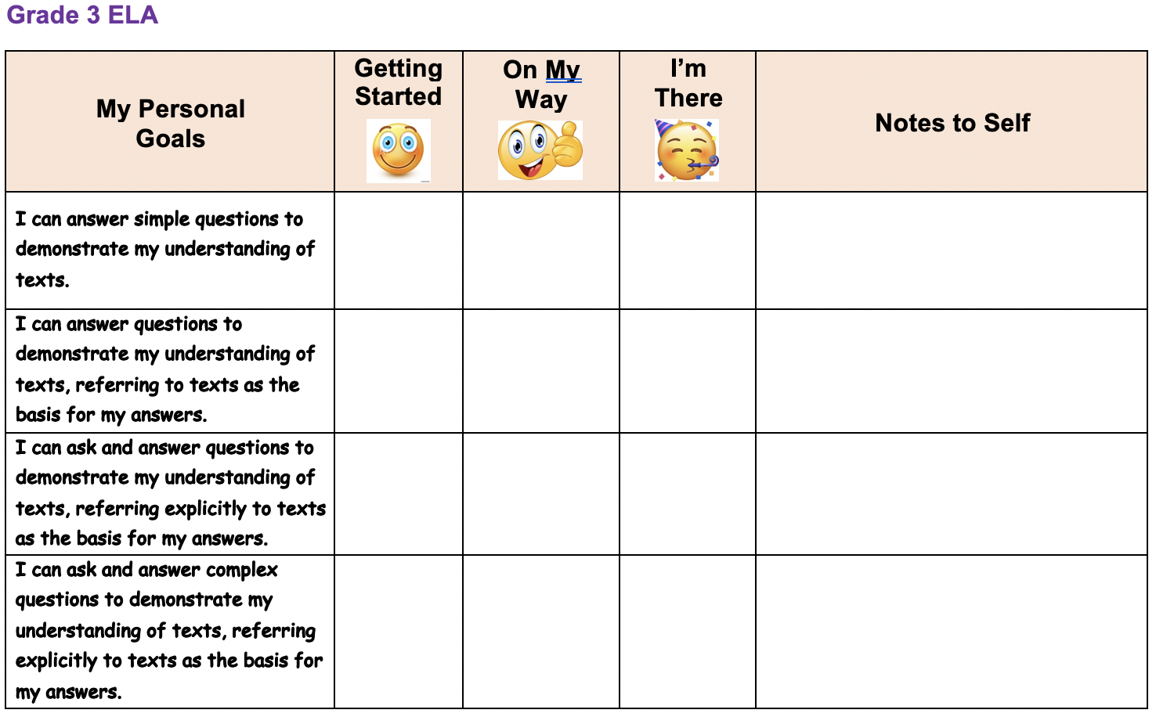
 | 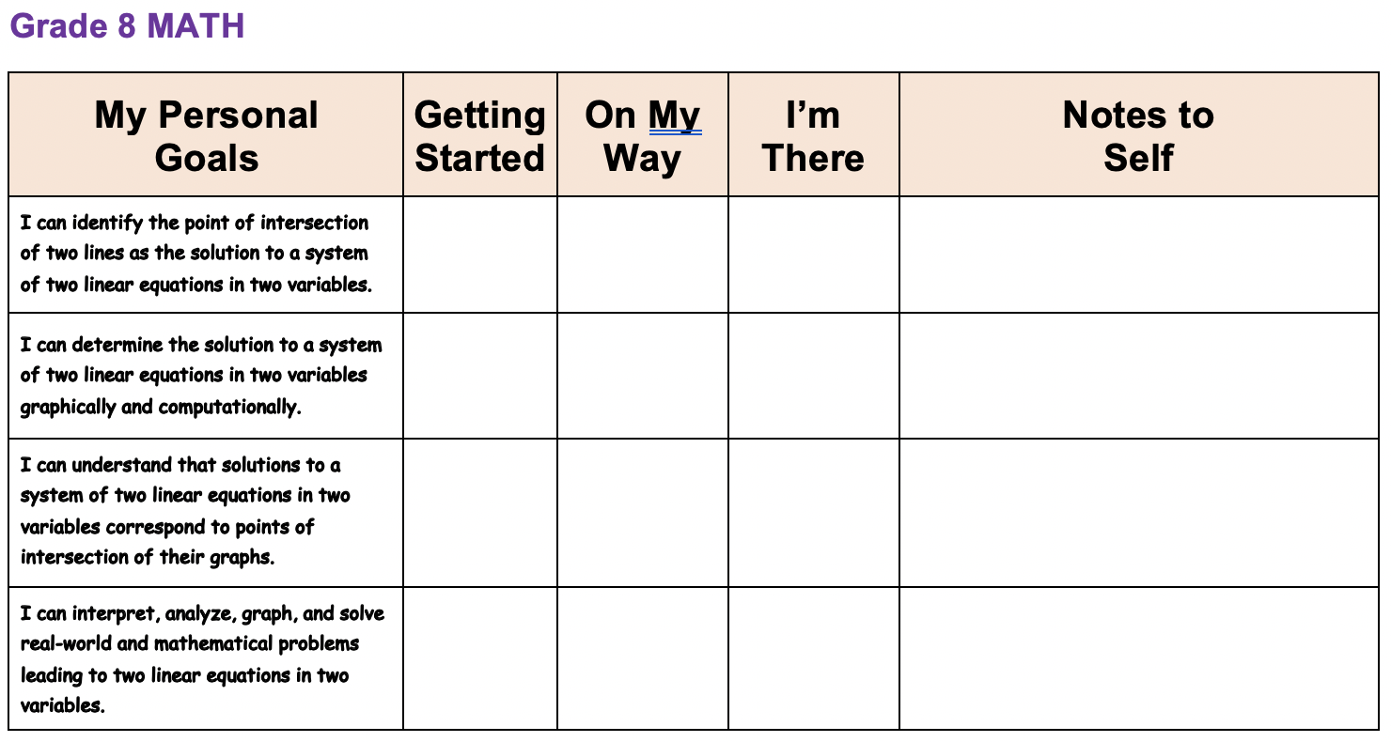

My Personal Goals

My Personal  Goals | Getting  Started | On My  Way | I’m  There | Notes to  Self

Diamond Board Click here to return to Matrix

Purpose: What kind of thinking does this routine encourage?  This routine encourages teachers and students to spiral earlier aspects of a unit. The essential (driving) question is used to focus students on the BIG IDEA.  NOTE the use of nonlinguistic representations to present the objective in a differentiated manner.  Application: When and where can I use it?  Each day of a unit to spiral and introduce new concepts that form a unit of learning. Objectives can be unpacked with students.  Launch: What are some tips for starting and using this routine?  Essential vocabulary is constructed as the unit progresses. Students can be provided a blank diamond board to actively participate in owning the objectives of the unit.  Diamond Boards work well with My Personal Goal Chart. | 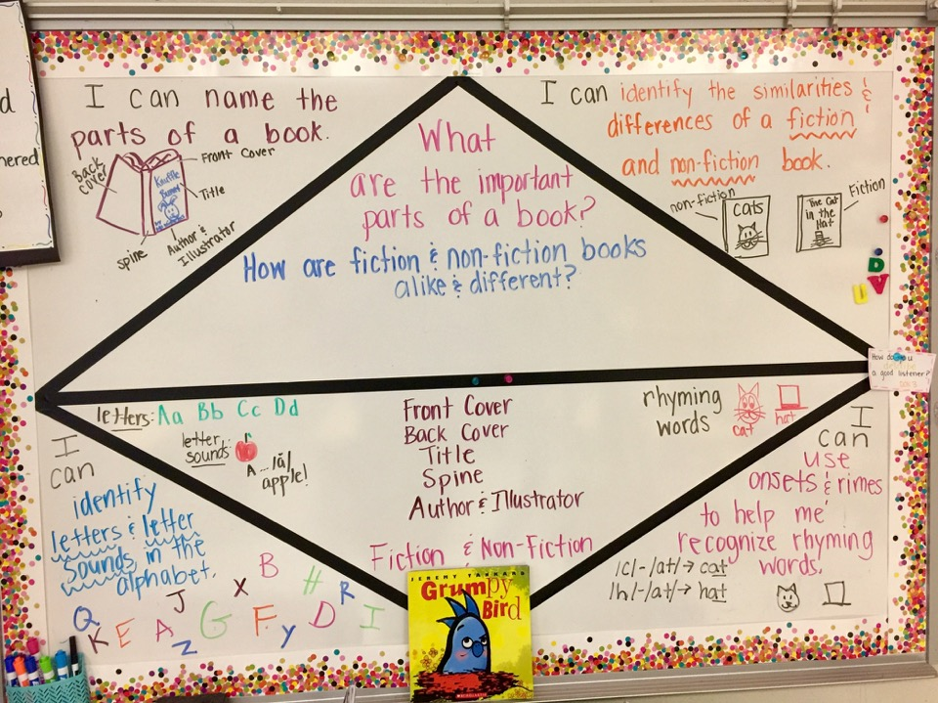
 | 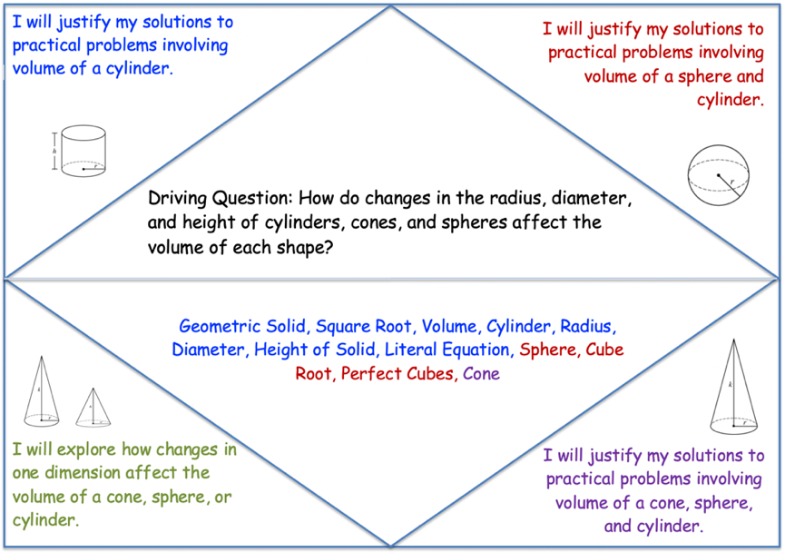

Diamond Board Template
I will
I will.
image
I will
Vocabulary
image
Driving Question:
image
image
I will

Chatter Drawing Click here to return to Matrix


Purpose: What kind of thinking does this routine encourage?
This routine guides each student to activate and evaluate their depth of understanding of a topic.

Application: When and where can I use it?
In this activity, students will activate prior knowledge by creating a graphic representation of a topic before the lesson. After engaging in learning about that topic, students will re-evaluate their prior knowledge by drawing a second depiction of their topic. They will then summarize what the different drawing say to them about what they learned.
Launch: What are some tips for starting and using this routine?
- Ask students to close their eyes and think about topic X. Using the Chatter Drawing worksheet, have students draw a picture what they saw while they were thinking about topic X.
- Teach cognitive portion of your lesson.
- At the end of the lesson, ask students to elaborate upon their initial drawing by creating a new drawing that incorporates what they learned about topic X during the lesson.
- Have students share their ideas before and after drawings with a partner. Students should discuss the differences between the two depictions of topic X.
- Finally, have students respond in writing at the bottom of their Chatter Drawing worksheet. What do the two drawings tell them about what they learned during the lesson?

Current: Close your eyes and think about ______________________________ . Now, open your eyes and draw what you saw.
Variation: Close your eyes and think about ______________________________ . Now, open your eyes and either write a short story, draw a picture, or author a poem to capture what you saw.

Chatter Drawing
- Close your eyes and think about ______________________________ . Now, open your eyes and draw what you saw.

- Now that you have learned more about ________________________ , draw a second picture to show what you learned.

- In the space below, tell what you have changed about your before and after pictures. Explain why you made those changes.

Zoom IN Click here to return to Matrix

Purpose: This routine asks learners to observe a portion of an image closely and develop a hypothesis.

Prep:
- Select an image to share with students. Remember that only sections of the image will be visible till the end.
- Once you have selected the image, consider what information will be conveyed by each section of the image.
- Take note that each new part revealed should add significantly to the meaning of the section of the image originally displayed and challenge students to think in new ways.

Teacher Instructions:
- Have students look closely at the small bit of image that is revealed.
  - Ask:
    - What do you see or notice?
    - What is your hypothesis or interpretation of what this might be based on what you are seeing?
- Reveal more of the image.
  - Ask:
    - What new things do you see?
    - How does this change your hypothesis or interpretation? Has the new information answered any of your wonders or changed your previous ideas?
    - What new things are you wondering about?
- Repeat the Reveal and Questioning Until the Whole Image Has Been Revealed.
- Invite learners to state any lingering questions they have.
- Share the thinking: Whole group or with partners
  - Ask questions such as:
    - How did your interpretations shift and change over time?
    - How did seeing more of the image influence your thinking?
    - What parts were particularly rich in information and had a dramatic effect?
    - What would the effect have been if the reveals had happened in a different order?

Tips:
- Walk yourself through your proposed sequence of reveals to question what you are seeing and how much and what type of information is revealed each time.
- Ask yourself, will it challenge students’ thinking?
- Encourage students to make connections to other situations when their thinking has changed as they learned more about a situation.
*This routine is adapted from Project Zero, Harvard Graduate School of Education.
Zoom In | 

Look closely at the small portion of the image that is revealed?
What do you see or notice?
What is your hypothesis or interpretation of what this might be based on what you are seeing?
Reveal more of the image
What new things do you see?
How does this change your hypothesis or interpretation?
Has the new information answered any of the wonders or changed your previous ideas?
What new things are you wondering about?
Repeat the reveal and question until whole image is revealed.
What beginning questions remain for you about this image?

These are… These are not… Click here to return to Matrix

Purpose: What kind of thinking does this routine encourage?  Rather than telling students the meaning of a concept, this routine asks students to take ownership of determining meaning.  Application: When and where can I use it?  This routine can be used as a warm-up to set a purpose, capture student interest, check along the way, and as an effective exit ticket.  Launch: What are some tips for starting and using this routine?  - Begin the learning by asking students to look for similarities and differences in the ‘These are…’ and ‘These are not…’ descriptors.  - Students can apply what they observe to determine ‘Which of these are’ that meet the patterns.  - Conclude with asking each student to create their own examples. | 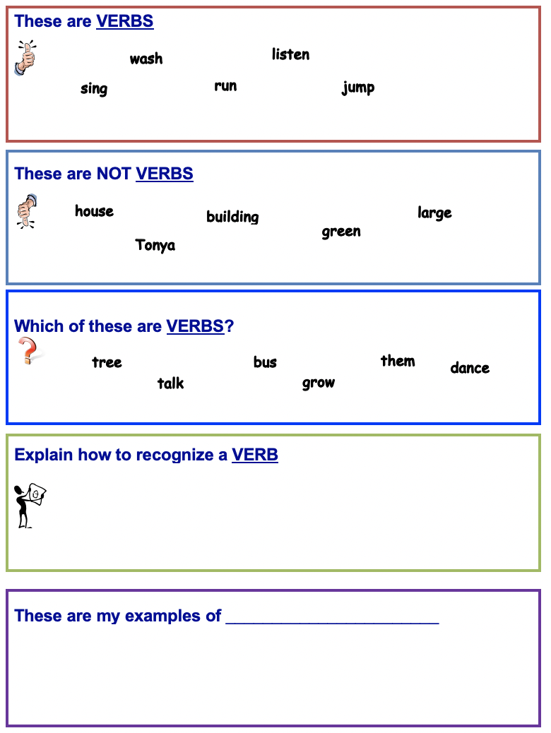

These are _______________________________

These are NOT __________________________

Which of these are _______________________?



Explain how to recognize a ____________________________?

These are my examples of _______________________

Think, Puzzle, Explore Click here to return to Matrix
Purpose: What kind of thinking does this routine encourage?
This routine activates prior knowledge, generates ideas and curiosity, and sets the stage for deeper inquiry.
Application: When and where can I use it?
This routine works especially well when introducing a new topic, concept, or theme in the classroom. It helps students take stock of what they already know and then pushes students to identify puzzling questions or areas of interest to pursue. Teachers can get a good sense of where students are on a conceptual level and, by returning to the routine over the course of study, they can identify development and progress. The third question is useful in helping students lay the ground work for independent inquiry.
Launch: What are some tips for starting and using this routine?
With the introduction of a new topic—for example, earth, leaves, fractions, Buddhism—the class can engage in the routine together to create a group list of ideas. Between each phase of the routine, that is with each question, adequate time needs to be given for individuals to think and identify their ideas. You may even want to have students write down their individual ideas before sharing them out as a class. In some cases, you may want to have students carry out the routine individually on paper or in their heads before working on a new area.
Keep a visible record of students’ ideas. If you are working in a group, ask students to share some of their thoughts and collect a broad list of ideas about the topic on chart paper. Or students can write their individual responses on post-it notes and later add them to a class list of ideas.
Note that it is common for students to have misconceptions at this point—include them on the list so all ideas are available for consideration after further study. Students may at first list seemingly simplistic ideas and questions. Include these on the whole class list but push students to think about things that are truly puzzling or interesting to them.
1. What do you think you know about this topic?
2. What questions or puzzles do you have?
3. What does the topic make you want to explore?
*This routine is adapted from Project Zero, Harvard Graduate School of Education.

Think Puzzle Explore

 | What do you think you know about this topic?
 | What questions or puzzles do you have about this topic?
 | How might you explore the puzzles we have around this topic?
This routine activates prior knowledge, generates ideas, and curiosity. It sets the stage for deeper inquiry.

Alpha Blocks Sort Click here to return to Matrix

Purpose: What kind of thinking does this routine encourage?

To check for and build academic vocabulary.

Application: When and where can I use it?

This routine asks students to recall what they already know about a concept as an activating strategy.

It can be revisited at the conclusion of a lesson or unit to:
- allow students to review terms that were identified before the lesson to check for validity;
- add additional terminology that has been acquired during the learning process
The completed Alpha Sort can be used by students to scaffold their writing to a prompt.

Launch: What are some tips for starting and using this routine?

Check student entries throughout the process to inform instruction and learning.

ALPHA BLOCKS SORT

Topic: ________________________________________

ABC |  | DEF |  | GHI
JKL |  | MN |  | OPQ
RST |  | UVW |  | XYZ

Write a summary of this topic. In the summary, use the most important words from the list that appears in your alpha blocks.

Whiteboard Talk Click here to return to Matrix
Purpose: What kind of thinking does this routine encourage?
This routine asks learners to consider ideas, questions, or problems by silently responding in writing both to the prompt and the thoughts of others. This “silent conversation” provides learners with time to follow through thoughts without interruption by choosing when they are ready to consider other points of view and make comments.
Application: When and where can I use it?
This routine highlights the notion of building understanding in a collaborative way through putting forward ideas, questioning one another, and developing the ideas further. Since individuals are asked to sign their comments, there is a degree of an anonymity that will free up some learners to take more risk and offer ideas. This activity can also be used for reflection.
Launch: What are some tips for starting and using this routine?
- Set up. Write (below) prompt on a large sheet of chart paper and place on tables around room. Have markers available. Decide if you wish to assign students to groups or allow them to move freely around the room.
- Present the Whiteboard Talk prompt. Invite learners to think about their reactions to the prompt and record the ideas and questions. Encourage learners to read and to add to each other’s responses with additional comments and questions.
- Circulate. Provide time for learners to circulate around the Whiteboard Talk paper, reading and adding to the prompts and responses as they build. If working in groups you may want them to stay with one recording sheet for 5 min. to allow conversation to develop. Groups can then rotate to another group’s paper, silently reading what is written there, and adding their reactions and questions to the paper.
- Facilitate. May need to prompt the group about the types of responses they can make as they read: connecting ideas, elaborating on others’ ideas, commenting on what others have written, asking others to respond with more detail, and so on.
- Share the thinking. If people have rotated as a group, allow them to return to their original starting places to read what others have written on “their” Whiteboard Talk paper. Ask the group what themes they noticed emerging. What did they see as common issues and reactions? What questions surprise them? Debrief the process itself, asking the group how their thinking developed during the Whiteboard Talk process.
- What ideas come to mind when you consider this idea, question, or problem?
- What connections can you make to the others’ responses?
- What questions arise as you think about the ideas and consider the responses and comments of others?
*This routine is adapted from Project Zero, Harvard Graduate School of Education.
Whiteboard Talk | 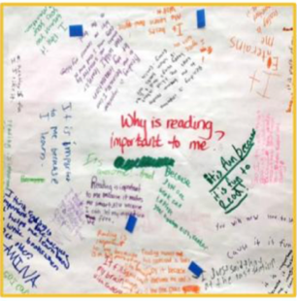

Look at the topic:
What ideas come to mind? | What questions come to mind? | What issues might arise?
What connections can you make to other posted responses?
What questions arise as you think about the ideas and consider the responses and comments of others?

3-2-1 Bridge Click here to return to Matrix
Purpose: What kind of thinking does this routine encourage?
This routine asks students to uncover their initial thoughts, ideas, questions and understandings about a topic and then to connect these to new thinking about the topic after they have received some instruction.
Application: When and where can I use it?
This routine can be used when students are developing understanding of a concept over time. It may be a concept that they know a lot about in one context, but instruction will focus their learning in a new direction, or it may be a concept about which students have only informal knowledge. Whenever new information is gained, bridges can be built between new ideas and prior understanding. The focus is on understanding and connecting one’s thinking, rather than pushing it toward a specific outcome.
Launch: What are some tips for starting and using this routine?
This routine can be introduced by having students do an initially 3, 2, 1 individually on paper. For instance, if the topic is “democracy,” then students would write down 3 thoughts, 2 questions, and 1 metaphor. Students might then read an article, watch a video, or engage in an activity having to do with democracy. Provocative experiences that push students thinking in new directions are best. After the experience, students complete another 3,2,1. Students then share their initially and new thinking, explaining to their partners how and why their thinking shifted. Make it clear to students that their initial thinking is not right or wrong, it is just a starting point. New experiences take our thinking in new directions.
Your initial response to the topic  3 Thoughts / Ideas  2 Questions  1 Metaphor / Simile | Your new response to the topic  3 Thoughts / Ideas  2 Questions  1 Metaphor / Simile
Bridge:
Explain how your new responses connect to your initial responses

3 – 2 – 1 Bridge | 

Initial Response | New Response
3 Words | 3 Words
2 Questions | 2 Questions
1 Metaphor / Simile | 1 Metaphor / Simile

Bridge

What I know about Click here to return to Matrix
Purpose: Why use this routine?  This routine helps students flesh out an idea or proposition and eventually evaluate it.  Application: When and where can I use it?  This routine works well to explore various sides and facets of a proposition or idea prior to taking a stand or expressing an opinion on it. For instance, what is the meaning of a word or a concept.  Launch: What are some tips for starting and using this routine?  A teacher-led discussion (to build background knowledge) might precede individual student use of this strategy. | 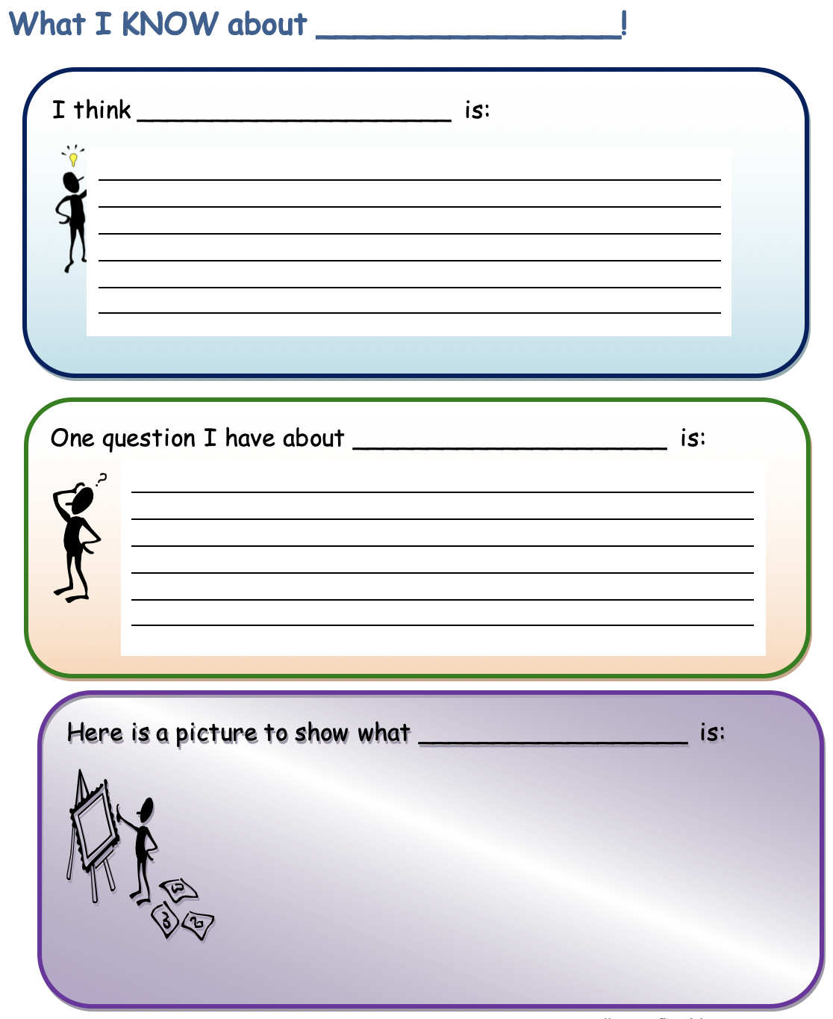
What I KNOW about ________________!
I think _____________________ is:

One question I have about _____________________ is:

Here is a picture to show what __________________ is:

The Explanation Game Click here to return to Matrix
Purpose: What kind of thinking does this routine encourage?
This is a routine for understanding why something is the way it is. This routine can get at either causal explanation or explanation in terms of purposes or both.
Application: When and where can I use it?
You can apply it to almost anything: a pencil, cell phones, forms of government, historical documents, or events. Students can work in pairs or groups of larger size, even as a whole class. The explanation game can also be used solo. The first time the routine is used, the teacher may need to take an active role in scaffolding the conversation and modeling how to ask questions of explanation and clarification of others. Over time, students can begin to emulate the conversational moves and questioning they have seen modeled.
Launch: What are some tips for starting and using this routine?
Begin with something “on the table”—an object like a cup or a compass; a document like a poem, or a picture; a historical event; a scientific theory, etc. The first person (this might be the teacher initially) points out an interesting feature of the object: “I notice that.... That’s interesting. Why is it that way?” or “Why did it happen that way?” (or some similar why question). The other people in the group try to answer the question or at least to propose possible explanations and reasons. As these students share their ideas, the person asking the original question follows up by asking, “What makes you think so?” The group works together to build explanations rather than merely deferring to an outside source, the teacher, or a textbook to provide an answer.
Student questions and explanations become visible to the class as they are shared. Responses to the routine can also be written down and recorded so that there is a class list of evolving ideas. A few key issues or puzzles might then be chosen for further investigations. A conversation could also be recorded as a chart with four columns representing the key structures of the conversation: 1) the Observation that is initially made, 2) the Question that comes out of that observation, 3) the various Explanations/Hypotheses that the rest of group puts forth, 4) the Reasons/Justifications that are given in support of the explanations.
The routine focuses first on identifying something interesting about an object or idea:
I notice that...
And then following that observation with the question:
Why is it that way? or Why did it happen that way?

The Explanation Game

Take a close look at the object you are trying to understand.

 | My/Our Initial Thinking | My/Our Updated thinking
Name it. Name a feature or aspect of the object that you notice.
Explain it. What could it be? What role or function might it serve? Why might it be there?
Give reasons. What makes you say that? Or why do you think it happened that way?
Generate alternatives. What else could it be? And what makes you say that?

Explain why and how your thinking evolved.

Headlines Click here to return to Matrix
Purpose: What kind of thinking does this routine encourage?
This routine helps students capture the core or heart of the matter being studied or discussed. It also can involve them in summing things up and coming to some tentative conclusions.
Application: When and where can I use it?
This routine works especially well at the end of a class discussion or session in which students have explored a topic and gathered a fair amount of information or opinions about it.
Launch: What are some tips for starting and using this routine?
The routine can be used quite effectively with think-pair-share. For example, at the end of a class the teachers can ask the class, “Think about all that we have been talking about today in class. If you were to write a headline for this topic or issue right now that captured the most important aspect that should be remembered, what would that headline be?” Next, the teacher tells students, “Share your headline with your neighbor.” The teacher might close the class by asking, “Who heard a headline from someone else that they thought was particularly good at getting to the core of things?”
Student responses to the routine can be written down and recorded so that a class list of headlines is created. These could be reviewed and updated from time to time as the class learns more about the topic. The follow- up question, “How has your headline changed or how does it differ from what you would have said?” can be used to help students reflect on changes in their thinking.
This routine draws on the idea of newspaper-type headlines as a vehicle for summing up and capturing the essence of an event, idea, concept, topic, etc. The routine asks a core question:
1. If you were to write a headline for this topic or issue right now that captured the most important aspect that should be remembered, what would that headline be?
A second question involves probing how students’ ideas of what is most important and central to the topic being explored have changed over time:
- How has your headline changed based on today’s discussion? How does it differ from what you would have said yesterday?

Headlines | 

Topic:

If you were to write a headline for this topic or issue right now that captured the most important aspect that should be remembered, what would that headline be?

Explain why you selected this headline.

How has your headline changed based on today’s discussion?

How does it differ from what you would have said yesterday? If you chose to keep your headline, explain your thinking.

Frayer Model Click here to return to Matrix

Purpose: What kind of thinking does this routine encourage?  This strategy is a graphic organizer for building student vocabulary.  Application: When and where can I use it?  A Frayer Model draws on a student's prior knowledge to build connections among new concepts and creates a visual reference by which students learn to compare attributes and examples.  Launch: What are some tips for starting and using this routine?  This routine works with the entire class, small groups, or for individual work. | 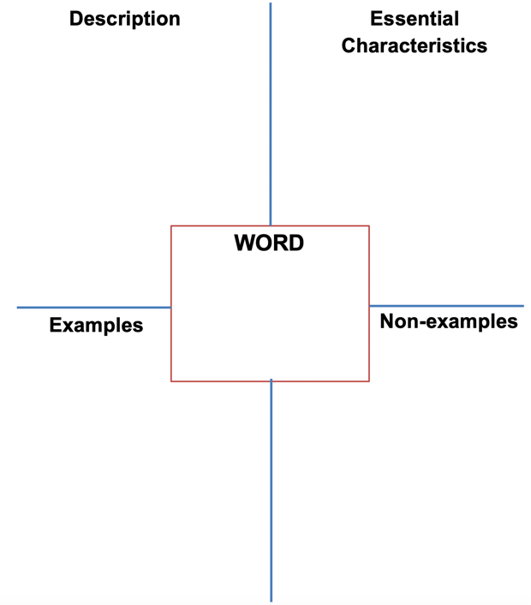
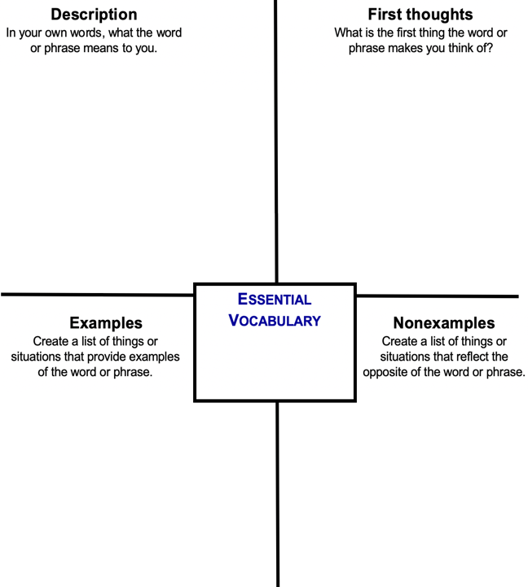 | 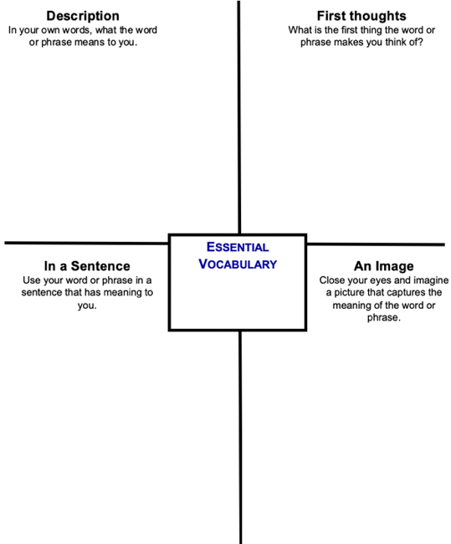

Frayer Model
Essential Characteristics
s
Description
Dan Mulligan, Frayer Model, 2011

WORD

Examples
Non-examples

CSI: Color, Symbol, Image Click here to return to Matrix

Purpose: What kind of thinking does this routine encourage?
This routine asks students to identify and distill the essence of ideas from reading, watching, or listening in non-verbal ways by using a color, symbol, or image to represent the ideas.

Application: When and where can I use it?
This routine can be used to enhance comprehension of reading, watching, or listening. It can also be used as a reflection on previous events or learnings. It is helpful if students have had some previous experience with highlighting texts for important ideas, connections, or events. The synthesis happens as students select a color, symbol, and image to represent three important ideas. This routine also facilitates the discussion of a text or event as students share their colors, symbols, and images.

Launch: What are some tips for starting and using this routine?
After the class has read a text, you might ask the class to identify some of the interesting, important, or insightful ideas from the text and list these on the board. Write CSI: Color, Symbol, Image on the board. Select one of the ideas the class has identified. Ask students, what color might they use to represent the essence of that idea. What color captures something about that idea, maybe it is the mood or tone. Select another idea and ask the class what symbol they could use to represent that idea. You might define a symbol as a simple line representation or uncomplicated drawing, such as two crossed lines to denote an intersection of ideas, or a circle to represent wholeness or completeness. Then pick another idea from the list and ask students what image they might use to represent that idea. You might define an image as a visual image or metaphor that is more complex and fully developed than just a symbol.
As you are reading, listening, or watching, make note of things that you find interesting, import- ant, or insightful. When you finish:
- Choose a color that you feel best represents or captures the essence of a key idea.
- Choose a symbol that you feel best represents or captures the essence of a key idea.
- Choose an image that you feel best represents or captures the essence of a key idea.
With a partner or group, first share your color and then share the item from your reading that it represents. Tell why you chose that color as a representation of that idea. Repeat the sharing process until every member of the group has shared his or her Color, Symbol, and Image.

Color  Symbol  Image 

Color  What color best represents this? | Symbol  What symbols best represent this? | Image  What image best represents this?
Why did you choose this color? | Why did you choose this symbol? | Why did you choose this image?

Generate-Sort-Connect-Elaborate Click here to return to Matrix
Purpose: What kind of thinking does this routine encourage?
This routine activates prior knowledge and helps to generate ideas about a topic. It also facilitates making connections among ideas. Concept maps help to uncover students’ mental models of a topic in a non-linear way.
Application: When and where can I use it?
This routine can be useful as a pre-assessment before the beginning of a unit of study if students already have a lot of background information about the topic. Conversely, it can also be useful as a post or ongoing assessment to see what students are remembering and how they are connecting ideas. Individual maps can be used as the basis for construction of a whole classroom map. Maps can also be done progressively, with students adding to their maps each week of the unit.
Launch: What are some tips for starting and using this routine?
Depending on how much familiarity students have with concept maps, you may need to demonstrate making a concept map using this routine with the whole class. However, if students are relatively familiar with the idea of concept maps, you can launch right into the routine explaining that students will be making concept maps but in a structured way. Give time for students to complete each step of the routine before moving
on to the next step. It isn’t necessary that students generate an exhaustive list of all their ideas initially, but make sure they have time to generate a rich and varied list before moving on. Tell students that at any point they can add new ideas to their list and incorporate them into their map. If you are adding to a map over time, you might want to have students use a different color pencil each time they make additions. Explaining and discussing maps with partners helps students to consolidate their thinking and gain other perspectives.
Select a topic, concept, or issue for which you want to map your understanding.
- Generate a list of ideas and initial thoughts that come to mind when you think about this particular topic/issue.
- Sort your ideas according to how central or tangential they are. Place central ideas near the center and more tangential ideas toward the outside of the page.
- Connect your ideas by drawing connecting lines between ideas that have something in common. Explain and write in a short sentence how the ideas are connected.
- Elaborate on any of the ideas/thoughts you have written so far by adding new ideas that expand, extend, or add to your initial ideas.
Continue generating, connecting, and elaborating new ideas until you feel you have a good representation of your understanding.

Generate Sort Connect Elaborate

Generate a list of ideas and initial thoughts that come to mind when you think about this topic or issue.

Sort your ideas according to how important or unimportant they are. Place central ideas near the middle and more unimportant ideas toward the outside.

Connect your ideas by drawing connecting lines between ideas that have something in common. Explain and write in a short sentence how the ideas are connected.

Elaborate on any of the ideas/thoughts you have written so far by adding new ideas that expand, extend, or add to your initial ideas.

The 4 C’s Click here to return to Matrix
Purpose: What kind of thinking does this routine encourage?
The routine provides learners with a structure for a text-based discussion built around making connections, asking questions, identifying key ideas, and considering application.
Application: When and where can I use it?
After reading a text, or even several different but related texts, small groups can use this rou-tine to discuss the text and explore the application of ideas. The individual questions for each of the C’s may be adjusted to fit the needs of the group and the text being read. Sometimes you may want to focus on a just 2 or 3 C’s rather than all 4.
Launch: What are some tips for starting and using this routine?
This routine works best with small groups. Before beginning discussion, give group members time to identify passages from the text that correspond to each of the C’s. These should be underlined or in some way identified so that they can later be shared with the group. In the group, discussion begins by one person sharing a connection that he or she made, reading the text passage and explaining the connection. Members of the group may add their comments on the offered passage. The next member of the group then shares his or her passage and the discussion continues in the matter until each member has shared a “connection.” The group then moves on to the next “C,” always making sure that the chosen text passage is first shared and then discussed. You may have groups record the text passages to document the discussions.
Connections: Challenge: Concepts: Changes:
- What connections do you draw between the text and your own life or your other learning?
- What ideas, positions, or assumptions do you want to challenge or argue with in the text?
- What key concepts or ideas do you think are important and worth holding on to from the text?
- What changes in attitudes, thinking, or action are suggested by the text, either for you or others?

The 4 C’s | Connections Challenge  Concepts Changes

What connections do you draw between the text and your own life or your other learning? | What ideas, positions, or assumptions do you want to challenge or argue with in the text?
What key concepts or ideas do you think are important and worth holding on to from the text? | What changes in attitudes, thinking, or action are suggested by the text, either for you or others?

Cube it Click here to return to Matrix

Purpose: What kind of thinking does this routine encourage?

Cubing is a versatile, easy-to-use instructional strategy that adds a bit of randomness and chance to your lessons. It’s easy to differentiate and works well with both individuals and small groups of students

Application: When and where can I use it?
What the Cube Sides Might Say:
1. Describe | 1. Characters | 1. Who
2. Compare | 2. Plot | 2. What
3. Contrast | 3. Conflict | 3. When
4. Analyze | 4. Rising Action | 4. Where
5. Evaluate | 5. Climax | 5. Why
6. Imagine | 6. Resolution | 6. How

Launch: What are some tips for starting and using this routine?
Basically, students are given (or make) a cube with different directions/questions/prompts on each of the six sides. Students then roll the cube and respond to the directions/question/prompt that they get.

CUBE It!
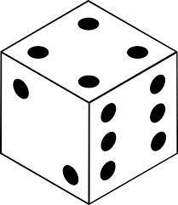
Topic: __________________________

Words… | Image…
- Describe it: What is it?

- Explain it: How would you make it clearer for someone to understand it?
Words… | Images…

- Apply it: What does it make you think of? What can you do with it?
Words… | Images…

- Analyze it: What are its essential parts? How is it made? What is it composed of?
Words… | Images…

- Judge it: Argue for or against it. Support your thinking.
Words… | Images…

- Create with it: What is something you can do with it?
Words… | Images…

Micro Lab Click here to return to Matrix

Purpose: What kind of thinking does this routine encourage?

This routine is designed to ensure equal participation and make sure everyone contributes during class discussion. It also helps to build active listening skills and the ability to build on and connect with other’s ideas.

Application: When and where can I use it?
It is suggested that this routine is most effective when used to:
- To discuss and explore perspectives on current events, to reflect-on and share what one has learned so far, to explore and process, and to discuss possible problem-solving strategies.
NOTE: Content matters…meaningful discussions depend on meaningful topics.

Launch: What are some tips for starting and using this routine?
- Set up: Inform the learners of what you want to discuss and what you hope they will get out of these discussions. Give students 5 – 10 minutes to write their initial thoughts.
- Share: Learner 1 begins sharing for set time (1 – 2 minutes). No one speaks except the speaker.
- Pause: Allow 20 – 30 seconds of silence for everyone to process what was heard. In the beginning you may ask students just to mentally review what they heard.
- Repeat: Repeat steps 2 and 3 above until each member of the group has shared their thinking.
- Discuss: Groups can now engage in an open discussion for a predetermined time (5 – 10 minutes). Encourage groups to begin by making connections between what others said or asking questions for clarification.
- Share the thinking: As a whole group, ask, students to reflect on the process and how it helped their thinking.

Micro Lab*

Reflect individually on the issue or topic being examined, then work in pairs or triads.
*Works well with a Think Pad.

 |  | The first person in the group shares for a set time (1 – 2 minutes). The other members listen attentively without comment or interruption.
 |  | Pause for 20 – 30 seconds of silence to take in what was said.
 |  | Repeat for persons 2 and 3 pausing for a moment of silence after each round.
 |  | Discuss as a group (5 – 10 minutes), referencing the comments that have been made and making connections between the responses of the group.
 |  | The purpose of this routine is to ensure equal participation and make sure everyone contributes during class discussion. It also helps to build active listening skills and the ability to build on and connect to others’ ideas.

Think Pad Click here to return to Matrix

Purpose: What kind of thinking does this routine encourage?  This routine encourages each student think before responding.  Application: When and where can I use it?  Use this routine when checking for understanding or perspective gathering is the goal.  Launch: What are some tips for starting and using this routine?  Throughout the learning process. | 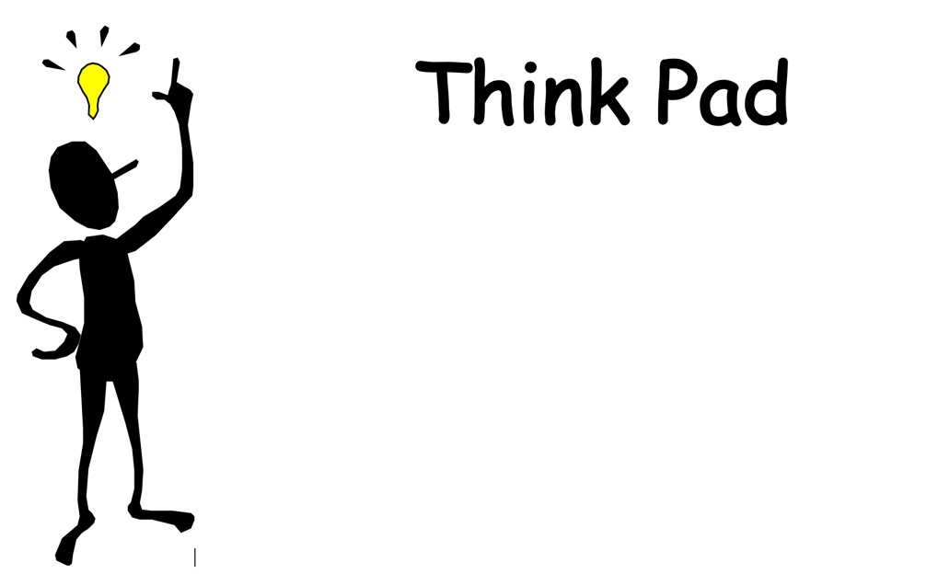
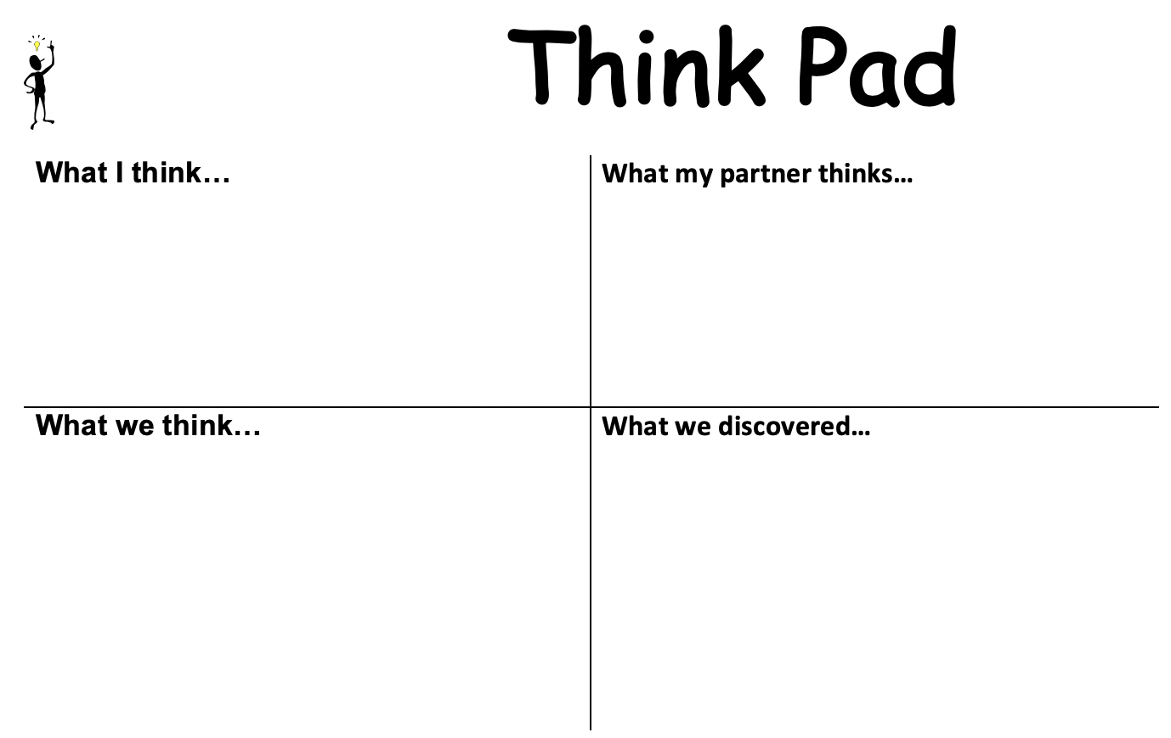 | 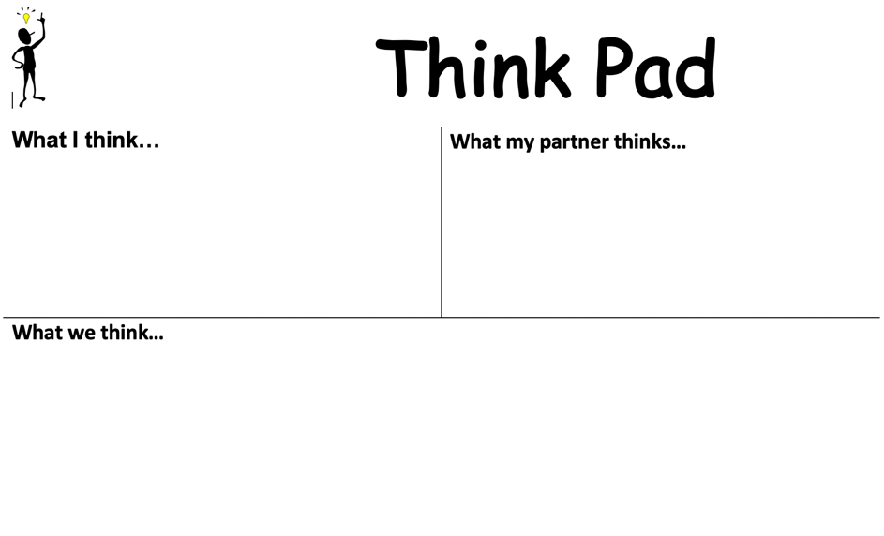

Think Pad

What I think… | What my partner thinks…
What we think… | What we discovered…

Reporter’s Notebook Click here to return to Matrix

Purpose: What kind of thinking does this routine encourage?
This routine is about distinguishing facts from thoughts and judgments. It helps organize ideas and feelings in order to consider a situation where fairness may be at stake. It promotes the fine discernment of information and perspective taking in order to clarify and make a tentative judgment.
Application: When and where can I use it?
Students can use the reporter’s notebook in any number of situations. These could include when discussing imagined or real moral dilemmas or topics from history, literature, or science; after reading a chapter, or watching a video or performance; or when thinking about actual events from their own life, etc. This routine is most useful “mid-investigation,” after some information about a given situation has already been put on the table. Maybe things are getting convoluted or there are disagreements. Perhaps opinions are taken as facts or things are getting “messy.” Use the routine to go deeper into an issue to clarify thoughts about it OR to even clarify what the issue is.
Launch: What are some tips for starting and using this routine?
This routine is best introduced with the whole class. Later students can work independently or in small groups using the recording sheet on the following page. Students are asked to imagine they are a newspaper reporter in order to differentiate the facts of a given event or topic from involved characters’ thoughts and feelings. The stance of a reporter helps students clarify issues and points of agreement and disagreement by getting distance from their own perspective or initial understanding of a given situation. Draw a 4x4 grid. Along the top write “Clear” and “Need to Check.” Down the side write “Facts & Events” and “Thoughts & Feelings.” List responses in the appropriate portion of the grid. Make sure kids talk about the characters, not their own thoughts or feelings. Once the notebook is completed, the routine asks the students to make an informed judgment.

Reporter’s Notebook
 | Clear | Need to Check
Facts and Events
Thoughts and Feelings

Where do I Belong Click here to return to Matrix

Purpose: What kind of thinking does this routine encourage?  This strategy simulates a drag-and-drop question. Students must identify categories and then sort attributes to describe each category. Good to challenge their thinking to justify their choices.  Application: When and where can I use it?  This is great for technology-enhanced thinking that involves reflecting on similarities and differences.  Launch: What are some tips for starting and using this routine?  This routine works well with students creating their own categories and attributes for others to try.  NOTE: The template for a three column and four column version can be found at flexiblecreativity.com. | 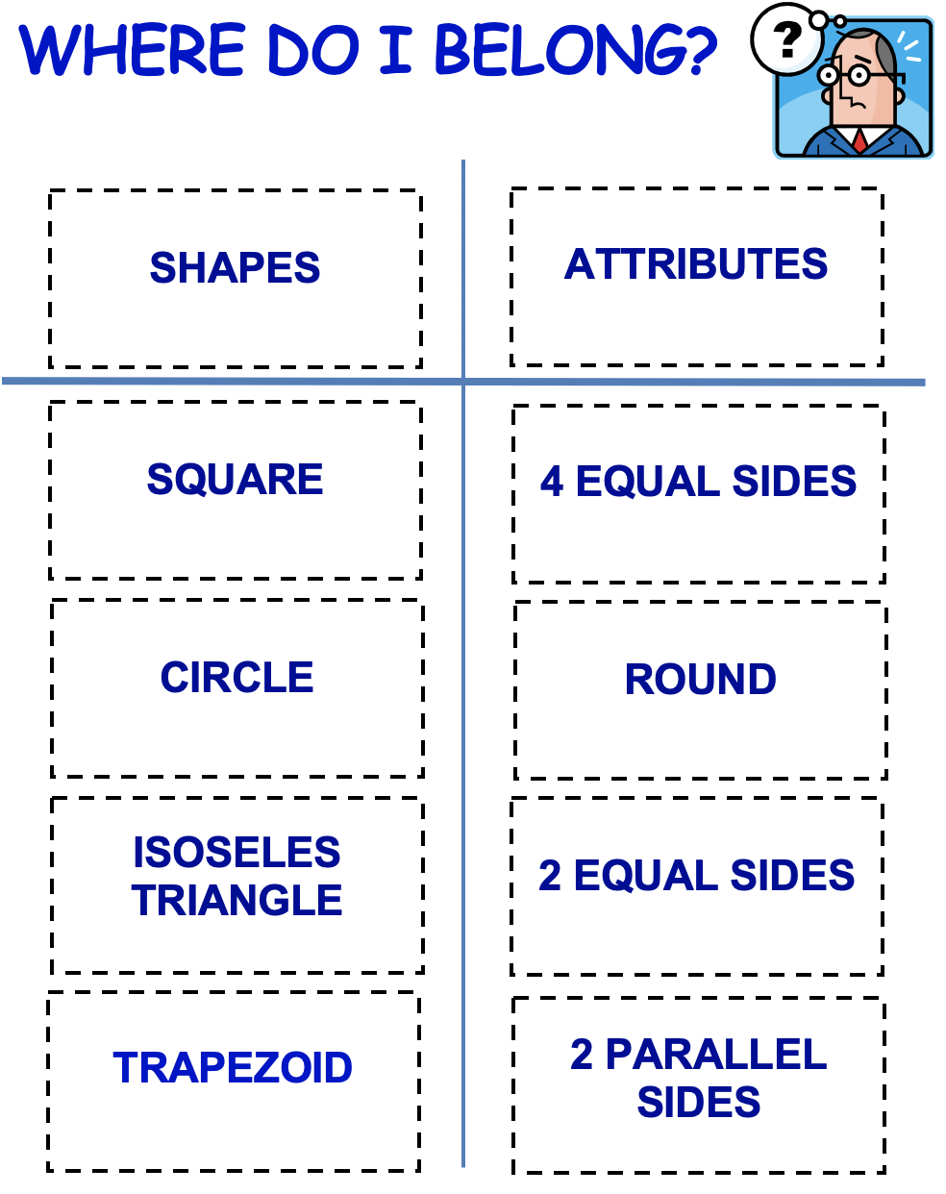

WHERE DO I BELONG?
Main Idea

Main Idea

Detail

Detail

Detail

Detail

Detail

Detail

Detail

Detail

Dinner Menu Click here to return to Matrix

Purpose: What kind of thinking does this routine encourage?  The menu strategy is a strategy for differentiation in which students are given a menu of activities to complete that meet learning objectives and standards.  Application: When and where can I use it?  By designing varied activities that align with objectives, teachers can create a menu that targets different learning styles and instructional needs.  Launch: What are some tips for starting and using this routine?  - Making choices on a menu, is a skill that needs to be taught.  - Provide appropriate number of choices for the students.  - When introducing your choices, be equally excited about each choice to avoid "pleasing the teacher". | 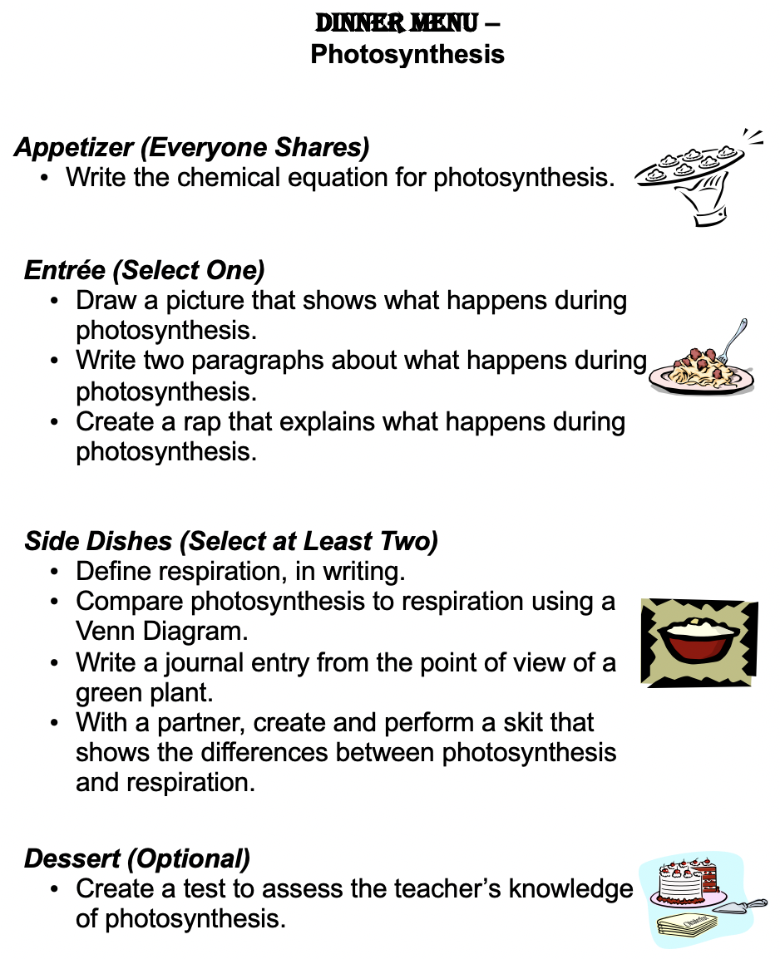

Dinner Menu – ___________________________________________
Appetizer (________________)

Entrée (Select _____)

Side Dishes (Select at Least____)

Dessert (______________)

What’s My Rule? Click here to return to Matrix

Purpose: What kind of thinking does this routine encourage?  This strategy encourages reasoning with evidence; identifying key concepts; captures student wonder.  Application: When and where can I use it?  This is great for summarizing strategy that guides students to think deeper (depending on the strategic placement of clues.  Launch: What are some tips for starting and using this routine?  This routine works well with students creating their own clues and rule for others to try. | 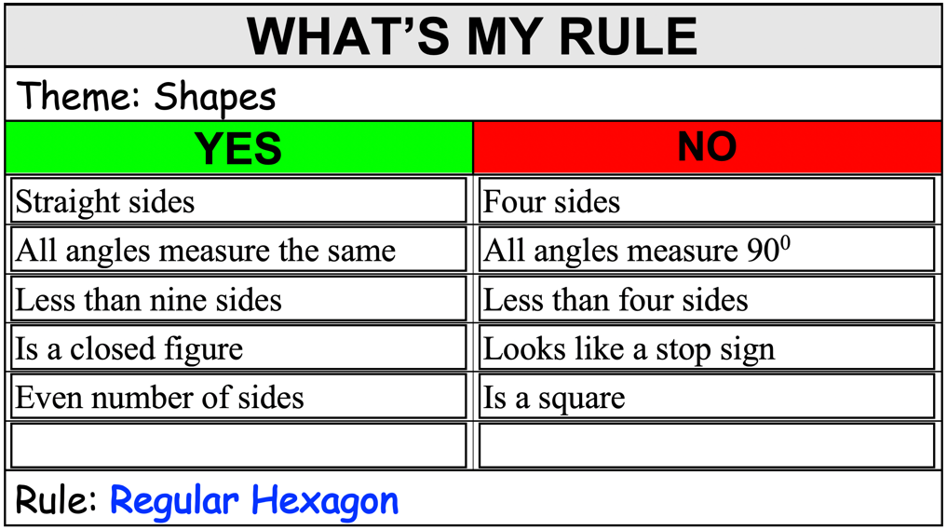
Creates great excitement if the clues are gradually revealed rather than all at once.

WONDER is a POWERFUL MOTIVATIONAL TOOL!

What’s My Rule?

WHAT’S MY RULE
Theme:
YES | NO
Rule:

Think-Tac-Toe Click here to return to Matrix

Purpose: What kind of thinking does this routine encourage?  This strategy is designed to engage each student in thinking and answering a variety of DOK questions to achieve three in a row.  Application: When and where can I use it?  This is great as a summarizing strategy that guides students to think deeper in a game format. Can be used with pairs to students or teams of students.  Launch: What are some tips for starting and using this routine?  This routine works well with students creating their own clues and rule for others to try.  *Ask students to justify/explain their responses. | 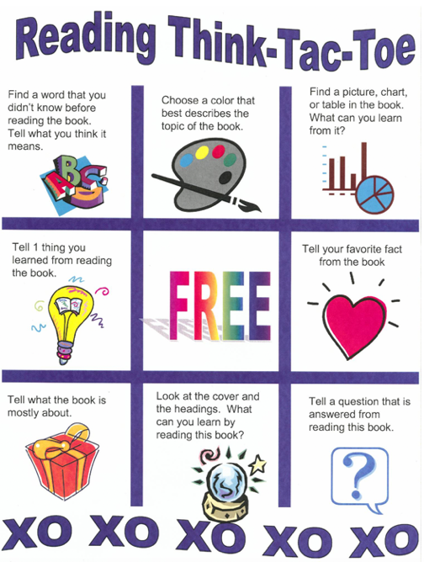
 | 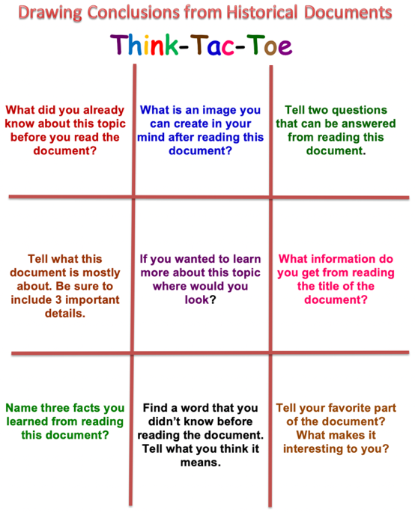

Think-Tac-Toe
Think-Tac-Toe
DOK 2 or 3 | DOK 1 | DOK 2 or 3
DOK 1 | DOK 2 or higher  (e.g., Create a question for.the team to answer and explain) | DOK 1
DOK 2 or 3 | DOK 1 | DOK 2 or 3

Walk a Mile in My Shoes Click here to return to Matrix
Purpose: What kind of thinking does this routine encourage?
This routine helps students to explore different perspectives and viewpoints as they try to imagine things, events, problems, or issues differently. In some cases, this can lead to a more creative understanding of what is being studied. For instance, imagining oneself as the numerator in a fraction. In other settings, exploring different viewpoints can open up possibilities for further creative exploration. For example, following this activity, a student might write a poem from the perspective of a soldier’s sword left on the battlefield.
Application: When and where can I use it?
This routine asks students to step inside the role of a character or object—from a picture they are looking at, a story they have read, an element in a work of art, a historical event being discussed, and so on—and to imagine themselves inside that point of view. Students are asked to then speak or write from that chosen point of view. This routine works well when you want students to open up their thinking and look at things differently.
Launch: What are some tips for starting and using this routine?
In getting started with the routine, the teacher might invite students to look at an image and ask them to generate a list of the various perspectives or points of view embodied in that picture. Students then choose a particular point of view to embody or talk from, saying what they perceive, know about, and care about. Sometimes students might state their perspective before talking. Other times, they may not and then the class could guess from which perspective they are speaking.
In their speaking and writing, students may well go beyond these starter questions. Encourage them to take on the character of the thing they have chosen and talk about what they are experiencing.
Three core questions guide students in this routine:
- What can the person or thing perceive?
- What might the person or thing know about or believe?
- What might the person or thing care about?

Walk a Mile in My Shoes
Topic/Person: ____________________________________________________

What can the person or thing perceive? | What might the person or thing know about or believe? | What might the person or thing care about?

RAFT Click here to return to Matrix
Purpose: What kind of thinking does this routine encourage?
The RAFT strategy can be used across subject areas to help students to understand and focus on four critical aspects of writing
Application: When and where can I use it?
The writer’s Role (Are you a journalist? A solider? A witness? A castle? An engineer? An endangered species? The human heart? - Can be people, objects, etc.); the Audience to whom the writer is speaking (Are you writing to a friend? Readers of a newspaper? A local TD? Your dog? A scientist? A museum? - Can be people, objects, etc.); the varied Formats for writing (Is it a letter? A speech? An obituary? A Blog? An Infographic? A top 10 list?); and the Topic addressed in the writing (What's the subject or the point of this piece). Asking students to write from another point of view requires a deeper understanding of the topic. Rafts can also be differentiated by learner readiness, interest and/or learning profile.
Launch: What are some tips for starting and using this routine?
Step 1
Explain that all writers need to consider four key components: the role of writer, the audience, the format and topic. Explain to students that they are going to structure their writing around these elements using the RAFT strategy. Identify important ideas or information.
Step 2
Demonstrate, model and "think aloud" another sample RAFT exercise with the help of the class (thinking aloud allows students to see what you think by narrating how you think as you use a strategy). Brainstorm RAFT ideas about a topic.
Step 3
Divide students into pairs or small groups of three or four to write about a chosen topic from the brainstormed list. Provide assistance to students as needed. Then have the groups share their completed RAFTs with the class. (* RAFTs can also be created where one column is consistent while the other columns in the RAFT grid vary. Also use strong verbs – for example instead of ‘write’ use verbs such as ‘plead’ or ‘convince’ – as this can help focus the writing and sets the tone of the response).
Step 4
After students become more proficient with the strategy have them create their own RAFTS based on topics studied in class.

___________________ Unit
Role – Audience – Format – Topic

Your RAFT must show that you understand the following concepts:

Choose one of the following RAFT options:
Role | Audience | Format | Topic

Other Ideas?
Submit a proposal below:

Red Light, Yellow Light Click here to return to Matrix
Purpose: What kind of thinking does this routine encourage?
In the general clutter of everyday life, moments that need deeper thinking tend to be invisible. Students have to learn to see them. This routine focuses students on signs of puzzles of truth, and also on typical red zones and yellow zones where such puzzles are common. To build up this sensitivity, use the routine often in deliberately different ways.
Application: When and where can I use it?
Wherever there might be interesting puzzles of truth: a text that might have questionable claims, the daily paper,
TV news, political speeches, a mystery story, a math proof that might have weaknesses, playground activities and conversations, home life, pop science, potentially risky behaviors, self-critique of something one has written, etc. For settings outside of school, students can keep logs over a day to a week. Typical red zones are the editorial pages of newspapers, political speeches, playground arguments, because so many red lights occur within them.
The source should be large enough to take some time, like a chapter or keeping track of rumors for a few days. That way, students have to keep alert in a sustained way, which practices their skills of noticing puzzles of truth.
Launch: What are some tips for starting and using this routine?
Explain that “red lights” are specific moments with signs of a possible puzzle of truth, signs like sweeping statements, one-sided arguments, obvious self-interest, etc. See the sample chart for others. Yellow lights are milder versions of the same thing.
Naturally students may disagree on what’s red vs. yellow vs. green in particular cases. Have students explain the signs and their judgments briefly, but mainly the routine is for detecting potential puzzles of truth. The real way to investigate a couple of the more important red or yellow lights is to dig further into the issue with another truth routine.

Red Light, Yellow Light | 

What are the red lights be here? What things stop you in your tracks because you doubt their truth or accuracy?
What are the yellow lights be here?
What things slow you down a bit, give you pause, and make you wonder if they are true and accurate or not?

Tug of War Click here to return to Matrix
Purpose: What kind of thinking does this routine encourage?
This routine builds on children’s familiarity with the game of tug of war to help them understand the complex forces that “tug” at either side of a fairness dilemma. It encourages students to reason carefully about the “pull” of various factors that are relevant to a dilemma of fairness. It also helps them appreciate the deeper complexity of fairness situations that can appear black and white on the surface.
Application: When and where can I use it?
This routine can be used in any situation where the fairness dilemma seems to have two obvious and contrasting ways of being resolved. Dilemmas can come from school subjects or everyday life: testing of medicine on animals, adding people to a game once it has started, censoring a book in a library, and so on.
Launch: What are some tips for starting and using this routine?
The routine works well as a whole class activity. Present the dilemma to the class. Draw or place a rope with the two ends representing the opposing sides of the dilemma and ask students to think about what side of the dilemma they would be on and why. Students can write their justifications on post-it notes. Encourage students to think of other reasons or “tugs” for both sides of the dilemma, and then have students add their post-it notes to the rope. Stand back and ask students to generate “What if’s:” questions, issues, factors or concerns that might need to be explored further to resolve the issue. Write and post these above the rope. Finish the lesson by asking students to reflect on the activity. What new ideas they have about the dilemma? Do they still feel the same way about it? Have they made up minds or changed their minds?
The display of the tugs and What if’s? on the rope helps to make students’ thinking visible. Most importantly, their ideas are displayed in a way that shows their interconnectedness. The collaborative thinking process of the group as a whole is represented through the “action” of the tug of war. This is a key point about making thinking visible: It shows the dynamic interaction of people’s thoughts in a context of a shared inquiry. Documenting thinking and making it visible in the classroom can facilitate this interaction in order to make the inquiry richer.

Tug of War

- Identify and frame the 2 opposite sides.
- Generate as many tugs (reasons) that pull you towards one end or the other end
- Determine the strength of each tug – placing the strongest reasons at the farthest ends
- Capture any ‘What if’ questions that arise and place the above the tug line rope.



Genius Hour Click here to return to Matrix
Purpose: What kind of thinking does this routine encourage?
This routine is inquiry-based, student-directed learning. It gives students an opportunity to look at the big wide world around them and explore their own unique interests in a loosely structured, but supported, way.
Application: When and where can I use it?
Genius Hour simply allows teachers to provide students a choice in what they learn and how they learn it during a set period of time within a school day or week. Some teachers allot one class period or one hour per week. Others aim for the 80/20 rule, in which 80 percent of the time is traditional standards-based teaching and learning and 20 percent is student directed
Launch: What are some tips for starting and using this routine?

Pick a topic.
Brainstorming ideas and narrowing down options can sometimes be the trickiest part of the process for students. Guide them to choose a topic that they are truly passionate about and is just the right size.

Develop a driving question.
Once your students pick a topic, they will need a driving question to guide their research. This is the what, why, and how that allows them to go deeper into their subject. If the question they are asking can be answered with a simple Google search, it is not specific enough.
Do the research.
In addition to reading books and articles, students can access websites, watch videos, and connect with experts in the community. Have your students use note catchers, write in their journals, or blog to stay organized and be accountable for their research. However, don’t get bogged down on this step.

Bring it all together.
Creating something original is the core purpose of Genius Hour. Whether students publish, design, act, make, or do, there should always be a tangible takeaway from the process. How your students choose to present what they have learned is limited only by their imagination. Some ideas? Create a blog, shoot a video, write and perform a play, or paint a mural. Put on a puppet show, set up a gallery walk or wax museum. Make it a big deal by inviting families and community members to presentation day.

Reflect.
After the presentation, bring the process full circle and “cement the learning” by asking your students to reflect. What went well? What did you learn? What would you do differently? Where do you want to go from here?

My GENIUS HOUR Proposal
STAMP of Approval
- Congratulations! Your project idea has been approved!
- Your project idea still needs some work. Let’s discuss.
My topic is ___________________________________

The inquiry question that I have come up with is:

- What I hope to learn is –

- Why I think this important to learn–

- How I plan to share my project with the class –

- How I will incorporate technology into the learning –

- The materials I will need include –

- My teacher can support me by -

Fan and Pick Click here to return to Matrix
Purpose: What kind of thinking does this routine encourage?  This strategy provides an engaging way for students to collaboratively ‘go deeper’ with their understanding of a text or content essential understandings.  Application: When and where can I use it?  This is an effective summarizing strategy.  Launch: What are some tips for starting and using this routine?  This works well with a heterogeneous group. To give each student as opportunity to think divergently, rotate roles. | 
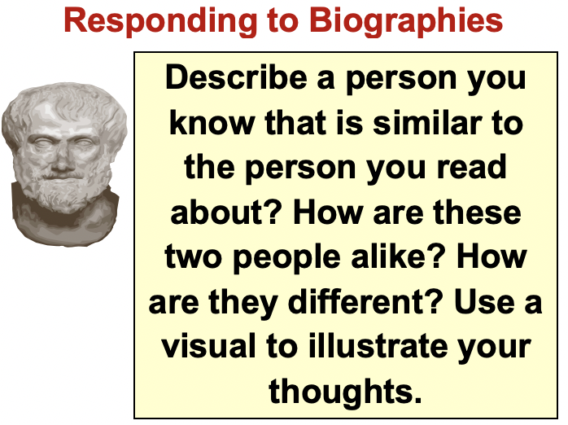 | 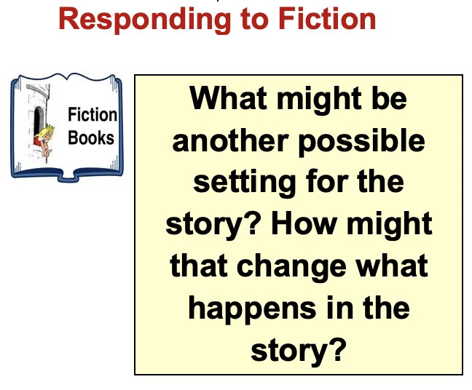

Fan and Pick

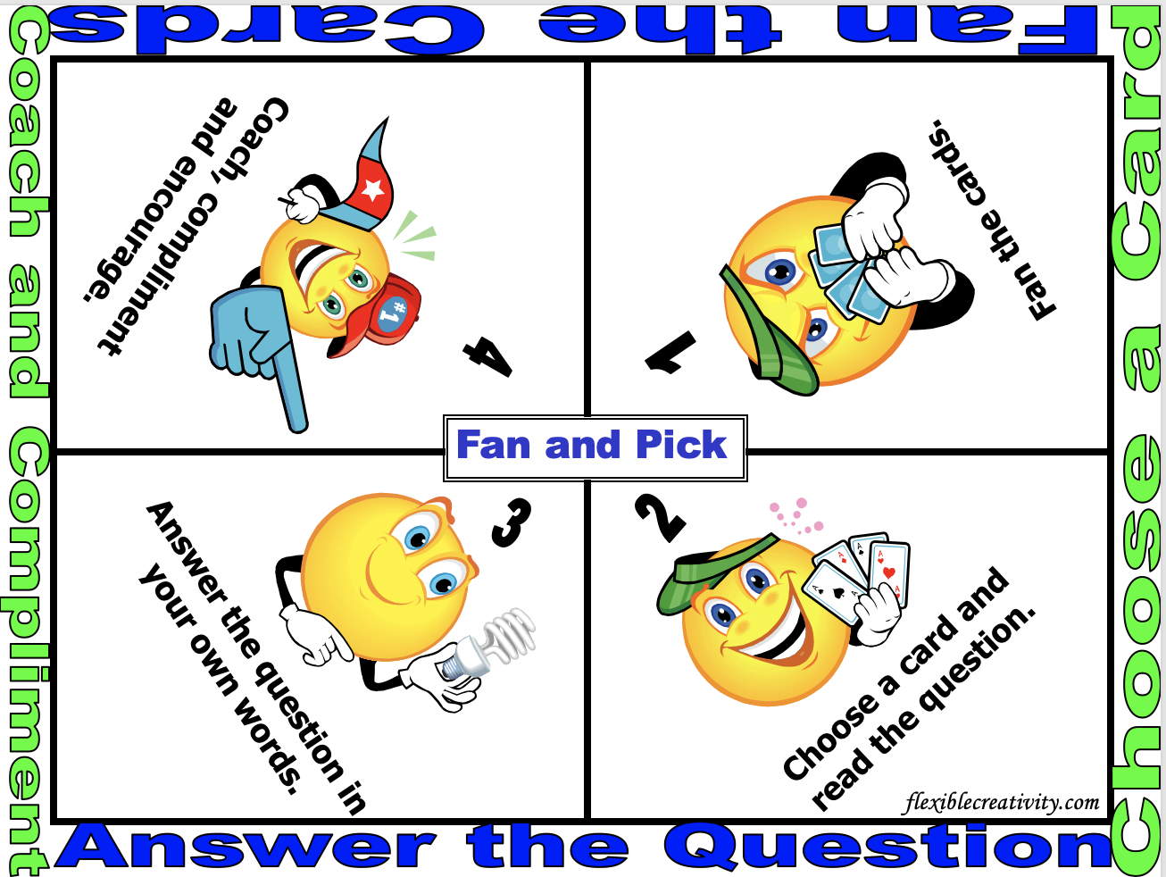

Learning Contract Click here to return to Matrix
Purpose: What kind of thinking does this routine encourage?
A learning contract is an agreement between the student and the teacher that showcases the importance of specific learning outcomes that the student is expected to reach throughout the year. Learning contracts are considered both a teaching strategy and an assessment tool that will encourage self-directed learning.
Application: When and where can I use it?
Use this routine when you want students’ ownership over their learning at the outset of a project or class, they prompt students to reflect on how they learn, and they establish clear goals and project timelines. For instructors, learning contracts serve as an outline for independent study units and as tools to aid evaluation.
Launch: What are some tips for starting and using this routine?

Student responsibilities
- Propose a written learning contract of what you want to learn and how you plan to learn it.
- Develop a detailed schedule that has you working on contract activities each week.
- Take the initiative to contact your advising instructor immediately to get the assistance you need (with, for example, motivation, resources, feedback, problems).
- Meet with your advising instructor regularly to review progress and discuss material

Instructor responsibilities
- Assist in developing learning contract and ensure its completion and good quality.
- Recommend learning resources, such as books, journals, people, agencies, library materials.
- Be available as a resource for information but allow the student to take initiative in asking for assistance with learning.
- Meet regularly with the student to review progress, share ideas, and encourage learning.
- Evaluate the student’s work as described in the learning contract.

Individual Learning Contract Project #: ____

To demonstrate what I have learned about: __________________________

I want to: ______________________________________________
___ Author a report | ___ Produce a movie (podcast)
___ Conduct a demonstration | ___ Generate graphic organizer
___ Design an experiment | ___ Build a model
___ Create a multimedia presentation | ___ Construct a model
___ Invent a mural | ___ Other:  _________________________________________________

This is a valid way to demonstrate understanding of this concept because:

To do this task, I will need:

My action plan is:

The criteria/rubric which will be used to assess my final product is:

My project will be completed by this date: _______________

Student signature: ______________________________ Date: ___/___/____

Teacher signature: _____________________________ Date: ___/___/____

Y-Chart: See-Think-Wonder Click here to return to Matrix
Purpose: What kind of thinking does this routine encourage?
This routine encourages students to make careful observations and thoughtful interpretations. It helps stimulate curiosity and sets the stage for inquiry.
Application: When and where can I use it?
Use this routine when you want students to think carefully about why something looks the way it does or
is the way it is. Use the routine at the beginning of a new unit to motivate student interest or try it with an object that connects to a topic during the unit of study. Consider using the routine with an interesting object near the end of a unit to encourage students to further apply their knowledge and ideas.
Launch: What are some tips for starting and using this routine?
Ask students to make an observation about an object—it could be an artwork, image, artifact, or topic—and follow up with what they think might be going on. Encourage students to back up their interpretation with reasons. Ask students to think about what this makes them wonder about the object or topic.
The routine works best when a student responds by using the three stems together at the same time, i.e., “I see..., I think..., I wonder... .” However, you may find that students begin using one stem at a time, and that you need to scaffold each response with a follow-up question for the next stem. The routine works well in a group discussion but in some cases, you may want to ask students to try the routine individually on paper or in their heads before sharing out as a class. Student responses to the routine can be written down and recorded so that a class chart of observations, interpretations, and wonderings are listed for all to see and return to during the course of study.

Y-Chart

I see…

I think…
I wonder…

Claim, Support, Question Click here to return to Matrix
Purpose: What kind of thinking does this routine encourage?
This routine reveals and encourages the process of reasoning by asking students to formulate an interpretation of something and support it with evidence. By pushing students to ask questions about their interpretation, it helps students see that reasoning is an ongoing process that is as valuable for raising questions as it is for providing answers.
Application: When and where can I use it?
Use the routine with works of art, pieces of text, poems, and with topics in the curriculum that invite explanation or are open to interpretation.
Launch: What are some tips for starting and using this routine?
The routine can work well for individuals, in small groups and for whole group discussions. Begin by modeling the routine: Identify a claim and explore support and questions in a whole group discussion. On the board make one column for SUPPORT and one column for QUESTIONS. Ask the class for evidence that either supports a claim or questions the claim and write it in the appropriate column. Take turns using the routine so that each student makes a claim, identifies support and asks a question.
Following each person’s report, take a moment as a group to discuss the topic in relation to the claim before moving on to the next person. Be patient as students take a few moments to think. You may need to probe further by asking: What are some other questions you might want to ask about this statement? or Can you think of reasons why this
may be true? Encourage friendly disagreement -- once a student comes up with an alternative perspective about a claim, encourage other students to follow. The questions can challenge the plausibility of the claim, and often lead to
a deeper understanding of the reasoning process. Let students know it is fine to disagree with one another’s reasons and encourage them to come up with creative suggestions for support and questioning. After everyone has had a turn, reflect on the activity. What new thoughts do students have about the topic?

Claim Support Question

 | ?

Claim: Tina thinks the next term in this illustration follows an increasing pattern and should result in 15 circles.

Support: What evidence is there to support Tina’s claim?

Question: What questions or puzzles are raised for you? What isn’t fully explained?

I Used to Think … Now I Think Click here to return to Matrix
Purpose: What kind of thinking does this routine encourage?
This routine helps students to reflect on their thinking about a topic or issue and explore how and why
that thinking has changed. It can be useful in consolidating new learning as students identify their new understandings, opinions, and beliefs. By examining and explaining how and why their thinking has changed, students are developing their reasoning abilities and recognizing causal relationships.
Application: When and where can I use it?
This routine can be used whenever students’ initial thoughts, opinions, or beliefs are likely to have changed as a result of instruction or experience. For instance, after reading new information, watching a film, listening to a speaker, experiencing something new, having a class discussion, at the end of a unit of study, and so on.
Launch: What are some tips for starting and using this routine?
Explain to students that the purpose of this activity is to help them reflect on their thinking about the topic and to identify how their ideas have changed over time. For instance:
When we began this study of ________, you all had some initial ideas about it and what it was all about. In just a few sentences, I want to write what it is that you used to think about _________. Take a minute to think back and then write down your response to “ I used to think...”
Now, I want you to think about how your ideas about __________ have changed as a result of what we’ve been studying/doing/discussing. Again in just a few sentences write down what you now think about ___________. Start your sentences with, “Now, I think...”
Have students share and explain their shifts in thinking. Initially it is good to do this as a whole group so that you can probe students’ thinking and push them to explain. Once students become accustomed to explaining their thinking, students can share with one another in small groups or pairs.

I Used to Think…  I Now Think… | 

Directions: Reflect on your current understanding of this topic, and respond to each of these sentence stems:
- I used to think…
- I now think…
I used to think… | I now think…
I still wonder…

Two-Word Strategy Click here to return to Matrix
Purpose: What kind of thinking does this routine encourage?
This routine helps students see and explore key concepts from a passage or essential components of a lesson.
Application: When and where can I use it?
The routine works well as a summarizing activity.
Launch: What are some tips for starting and using this routine?
      - Brainstorm a list of important words/phrases from a passage, lesson, or unit.

      - Students then word independently or in pairs to analyze the brainstormed words to identify the most important words /concepts.

      - Each student then explains why they consider their selected words as the most important concepts for getting to the ‘big idea’.

Two-Word Strategy

Concept: _____________________________________
Brainstorm here
:

Word 2
Word 1

I chose word 1 because | I chose word 2 because

Circle of Viewpoints Click here to return to Matrix
Purpose: What kind of thinking does this routine encourage?
This routine helps students see and explore multiple perspectives. It helps them understand that different people can have different kinds of connections to the same thing, and that these different connections influence what people see and think.
Application: When and where can I use it?
The routine works well with topics and artworks that deal with complex issues. It also works well when students are having a hard time seeing other perspectives or when things seem like there are only two sides to an issue. The routine can be used to open discussions about dilemmas and other controversial issues.
Launch: What are some tips for starting and using this routine?
1. Brainstorm a list of difference perspectives.
2. Choose one perspective to explore, using these sentence-starters:
- I am thinking of ... the topic ... from the viewpoint of ... the viewpoint you’ve chosen
- I think ... describe the topic from your viewpoint. Be an actor—take on the character of your viewpoint
- A question I have from this viewpoint is ... ask a question from this viewpoint

This routine focuses on perspective taking. It helps learners to identify and consider these different and diverse perspectives involved in and around a topic, issue, or event.

Circle of Viewpoints
- I am thinking of … (name the event/issue… from the point of view of…
2. I think… (describe the topic from your viewpoint) … Because… (explain your reasoning)

3. I A question or concern I have from this viewpoint is …

Connect, Extend, Challenge Click here to return to Matrix
Purpose: What kind of thinking does this routine encourage?
The routine helps students make connections between new ideas and prior knowledge. It also encourages them to take stock of ongoing questions, puzzles and difficulties as they reflect on what they are learning.
Application: When and where can I use it?
A natural place to use this routine is after students have experienced something new. The routine is broadly applicable: Use it after students have explored a work of art, or anything else newly introduced in he curriculum. Try it as a reflection during a lesson, after a longer project, or when completing a unit of study. Try using it after another routine!
Launch: What are some tips for starting and using this routine?
This routine works well with the whole class, in small groups or individually. Keep a visible record of students’ ideas. If you are working in a group, ask students to share some of their thoughts and collect a list of ideas in each of the three categories Or have students write their individual responses on post-it notes and add them to a class chart. Keep students’ visible thinking alive over time: Continually add new ideas to the lists and revisit the ideas and questions on the chart as students’ understanding around a topic develops.
- How is the artwork or object connected to something you know about?
- What new ideas or impressions do you have that extended your thinking in new directions?
- What is challenging or confusing? What do you wonder about?

Connect, Extend, Challenge

 | How are the ideas and information presented connected to what you already knew?
 | What new ideas did you get that extended or broadened your thinking in new directions?
 | What challenges or puzzles have come up in your mind from the ideas and information presented?

Compass Points Click here to return to Matrix
Purpose: What kind of thinking does this routine encourage?
This routine helps students flesh out an idea or proposition and eventually evaluate it.
Application: When and where can I use it?
This routine works well to explore various sides and facets of a proposition or idea prior to taking a stand or expressing an opinion on it. For instance, the school may be considering the idea of a dress code, a teacher might present the class with idea of altering the room arrangement, a character in a book might be confronted with making a choice, a politician might be putting forth a new way of structuring taxes, and so on.
Launch: What are some tips for starting and using this routine?
The routine needs to be modeled with the whole group initially with responses recorded for the entire class to see. This enables students to build on each other’s ideas. You might record responses using the directions of a compass to provide a visual anchor. That is, draw a compass in the center of the board and then record responses corresponding the appropriate direction: E, W, N, or S. It is generally easiest for students to begin with what is exciting or positive about the idea or proposition and then move to worrisome and need to know. Students might be asked to write down their individual stance or suggestion for moving forward after the initial group discussion. You can also ask students to make an initial judgment or evaluation of the idea or proposition before doing the compass points and then ask them how their thinking has changed after discussion from compass points.
- E = Excited
What excites you about this idea or propositions? What’s the upside?
- W = Worrisome
What do you find worrisome about this idea or proposition? What’s the downside?
- N = Need to Know
What else do you need to know or find out about this idea or proposition? What additional information would help you to evaluate things?
- S = Stance or Suggestion for Moving Forward
What is your current stance or opinion on the idea or proposition? How might you move forward in your evaluation of this idea or proposition?

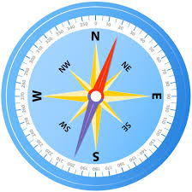 | Compass Points
Directions: There is no right or wrong responses.
Think before answering the question(s) at each compass point.

Compass Point | Question(s) | Your Thoughts
Excitements | What excites you about the topic? What is the upside?
Worries | What worries you about the topic? What is the downside?
Needs | What do you need to know or find out about this topic?
Stance, Steps, or Suggestions | What is your current stance on the topic? What should your next steps be to evaluate the topic? What suggestions do you have at this point?

Think, Pair, Share Click here to return to Matrix
Purpose: What kind of thinking does this routine encourage?
This routine encourages students to think about something, such as a problem, question or topic, and then articulate their thoughts. The Think, Pair, Share routine promotes understanding through active reasoning and explanation. Because students are listening to and sharing ideas, Think, Pair, Share encourages students to understand multiple perspectives.
Application: When and where can I use it?
Think, Pair, Share can be applied at any given moment in the classroom. For example, when approaching a solution, solving a math problem, before a science experiment, or after reading a passage or chapter of a book you may ask students to take a moment to think about a particular question or issue and then turn to their neighbor and share their thoughts. Sharing can also be done in small groups. Sometimes you will want to have pairs or groups summarize their ideas for the whole class.
Launch: What are some tips for starting and using this routine?
When first introducing the routine, teachers may want to scaffold students’ paired conversations by reminding them to take turns, listen carefully and ask questions of one another. One way to ensure that students listen to each other is to tell students that you will be calling on individuals to explain their partners thinking, as opposed to telling their own thoughts. Encourage students to make their thinking visible by asking them to write or draw their ideas before and/or after sharing. Journals can also be useful. Student pairs can report one another’s thoughts to the class and a list of ideas can be created in the classroom.
Think, Pair, Share involves posing a question to students, asking them to take a few minutes of thinking time and then turning to a nearby student to share their thoughts.

This routine is adapted from Frank Lyman: Lyman, F. T. (1981). The Responsive Classroom Discussion: The Inclusion of All Students. In A. Anderson (Ed.), Mainstreaming Digest (pp. 109-113). College Park: University of Maryland Press.

Think, Pair, Share (NOTE: Additional versions in the Think Pad files on flexiblecreativity.com)
Think Pad

What I think… | What my partner thinks…
What we think… | What we discovered…

Think, Puzzle, Explore Click here to return to Matrix
Purpose: What kind of thinking does this routine encourage?
This routine activates prior knowledge, generates ideas and curiosity, and sets the stage for deeper inquiry.
Application: When and where can I use it?
This routine works especially well when introducing a new topic, concept, or theme in the classroom. It helps students take stock of what they already know and then pushes students to identify puzzling questions or areas of interest to pursue. Teachers can get a good sense of where students are on a conceptual level and, by returning to the routine over the course of study, they can identify development and progress. The third question is useful in helping students lay the ground work for independent inquiry.
Launch: What are some tips for starting and using this routine?
With the introduction of a new topic—for example, earth, leaves, fractions, Buddhism—the class can engage in the routine together to create a group list of ideas. Between each phase of the routine, that is with each question, adequate time needs to be given for individuals to think and identify their ideas. You may even want to have students write down their individual ideas before sharing them out as a class. In some cases, you may want to have students carry out the routine individually on paper or in their heads before working on a new area.
Keep a visible record of students’ ideas. If you are working in a group, ask students to share some of their thoughts and collect a broad list of ideas about the topic on chart paper. Or students can write their individual responses on post-it notes and later add them to a class list of ideas.
Note that it is common for students to have misconceptions at this point—include them on the list so all ideas are available for consideration after further study. Students may at first list seemingly simplistic ideas and questions. Include these on the whole class list but push students to think about things that are truly puzzling or interesting to them
      - What do you think you know about this topic?
      - What questions or puzzles do you have?
      - What does the topic make you want to explore?

Think, Puzzle, Explore
What I think about this topic… | What questions or puzzles I have about this topic… | How I can explore this topic…

What Makes You Say That? Click here to return to Matrix
Purpose: What kind of thinking does this routine encourage?
This routine helps students describe what they see or know and asks them to build explanations. It promotes evidential reasoning (evidence-based reasoning) and because it invites students to share their interpretations, it encourages students to understand alternatives and multiple perspectives.
Application: When and where can I use it?
This is a thinking routine that asks students to describe something, such as an object or concept, and then support their interpretation with evidence. The routine can be adapted for use with almost any subject and may also be useful for gathering information on students’ general concepts when introducing a new topic.
Launch: What are some tips for starting and using this routine?
In most cases, the routine takes the shape of a whole class or group conversation around an object or topic, but it can also be used in small groups or by individuals. When first introducing the routine, the teacher may scaffold students
by continually asking follow-up questions after a student gives an interpretation.
The two core questions for this routine can be varied in a number of ways depending on the context: What do you know? What do you see or know that makes you say that?
When using this routine in a group conversation, it may be necessary to think of alternative forms of documentation that do not interfere with the flow of the discussion. One option is to record class discussions using video or audio. Listening and noting students’ use of language of thinking can help you see their development.
Another option is to make a chart or keep an ongoing list of explanations posted in the classroom. As interpretations develop, note changes and have further discussion about these new explanations. These lists can also invite further inquiry and searches for evidence. Other options for both group and individual work include students documenting their own interpretations through sketches, drawings, models and writing, all of which can be displayed and revisited in the classroom.
This routine is adapted from Visual Thinking Strategies (VTS), developed by Philip Yenowine and Abigail Housen. See: Yenawine, P. (2013). Visual thinking strategies. Cambridge, MA: Harvard University Press.

What Makes You Say That?
I predict… | Thinking Zone  (organize your thoughts here)
What makes you say that? | Thinking Zone  (organize your thoughts here)

Thinking Explosion Click here to return to Matrix
Purpose: What kind of thinking does this routine encourage?
This routine fosters creative thinking. It helps explore “hidden” options in a decision-making situation. Often people don’t make good decisions because they miss the hidden options. It is also relevant to understanding. It helps in building an understanding of decision-making situations even when you are not the real decision maker.
Application: When and where can I use it?
Students can use it for personal decision making or you and students can use it for classroom decision making. Also, you can use it with students as a way of exploring and understanding important decisions in the news or history or literature or science policy or medical policy, etc. You can ask students to make the decision personal by role playing, imagining that they were in the situation.
Launch: What are some tips for starting and using this routine?
Emphasize that maybe there are good hidden options, maybe not – we have to find out by looking. Put the ideas on the blackboard or have students write them on Post-its and stick them up. Use an explosion- like diagram with radiating lines instead of a list if you want to emphasize the spirit, but a list is okay too. Remember, crazy ideas are okay – they are just part of the mix and they may lead to something else by piggybacking. In many classroom situations the point is to use creative thinking to understand the situation better, as in step 3. You don’t need a final decision. You can decide whether it’s a good idea to go on to another routine for choosing among the options. Or you can just take a quick vote on some of the likely options. If you want, you can do this before step 3, to give students a little more to discuss in step 3.
List the obvious options. There would not be a decision unless there were at least two or three obvious options. |  | Now brainstorm all sorts of different options to find the “hidden” options. Often there are hidden options that are the real best choices. Be imaginative! Piggyback on ideas already up, combine ideas to get new ones, look for ideas of a very different kind, imagine you are in different roles and suggest ideas from the perspective of those roles, etc. |  | Ask: What have we learned about the situation from finding these options? This is a way of understanding the situation better.

Options
A process to guide creative decision making by considering both obvious options, as well as, hidden options.
Explosion

Write your situation/issue statement:

List the obvious choices. |  | Brainstorm different options  Think outside the box |  | What have we Learned about the situation and Our Options?
 |  |  |  | 

Word Splash Click here to return to Matrix
Purpose: What kind of thinking does this routine encourage?
Word Splash is one simple technique for previewing new content, and it can also be used as a closure activity.
Application: When and where can I use it?
A word splash is a collection of terms or concepts related to the target topic placed randomly around the topic heading. The teacher guides learners to consider the words and their relationship to the topic. At the end of the lesson or unit, the teacher might repeat the activity to guide students' reflections about their learning.
Launch: What are some tips for starting and using this routine?
- Brainstorm important words related to the target topic. Consider vocabulary words, important concepts, examples, and related ideas.
- Display the words "splashed" around the topic.
- Explain that each of the words displayed relates to their upcoming topic. Read the words aloud.
- Instruct students to think about how the words are related. They might consider how each word is related to the overall topic or how one word relates to another. Model an accurate example.
  - Determine how students will make their thinking visible. For example, you might guide them to connect two words with a complete sentence and record the sentences in their academic notebooks.
- Present the content, or have students read the selection. Encourage them to look for evidence to confirm or revise their predictions.
- After the lesson (or unit or reading), cause students to revisit their initial predictions. They should confirm and/or revise their initial connections with their new understanding and correct their written record (notes). Use a group discussion activity such as Interaction Sequence to help students publicly summarize their learning
Tips:
- Use Word Splash to preview academic vocabulary in assigned reading or for a unit of study.
- Consider how you will organize students effectively. For example, after students think independently about connections (step 4), use a strategy such as Partners A & B or Numbered Heads Together to provide students more engagement with the content.
- Use a world cloud generator such as http://www.wordle.net/, http://www.tagxedo.com/, or http://wordsift.com/ to create your word splash.
- After reading or learning about the topic, have students create their own word splash. (Be certain to have them make the connections as well!)

Sample Word Splash
wordsift.org Together, You Can Redeem the Soul of Our Nation, John Lewis, July 30, 2020 | tagxedo.com
 | 


Jigsaw Click here to return to Matrix
Purpose: What kind of thinking does this routine encourage?
Jigsaw is an efficient way to learn material in a limited amount of time. It also encourages listening, engagement, and empathy by giving each group member an essential part to play in the activity.
Application: When and where can I use it?
Jigsaw works well through the use of breakout rooms in zoom.
Launch: What are some tips for starting and using this routine?
- Divide students into 5-6-person Jigsaw groups. The groups should be diverse in terms of gender and ability.
- Divide the lesson (the reading) into 5-6 segments. For example, if you are doing a lesson on Eleanor Roosevelt, you might divide her biography into the following segments (1) childhood, (2) family life w/Franklin and kids, (3) Life after Franklin’s polio diagnosis, (4) First Lady, (5) Life after Franklin’s death.
- Assign each student in the Jigsaw group to learn one segment of the lesson (the reading). Give them time to read their assigned segment.
- Now divide the class into Expert groups. Each member of the Jigsaw group will go to a different Expert group based on their assigned segment. For example, all of the students who read about Eleanor Roosevelt’s childhood will gather together, etc.
- Give time for the Expert groups to discuss the main points of their segment.
- Students then return to their Jigsaw groups.
- Each member of the Jigsaw group then presents his/her assigned segment to the group. Encourage students to ask questions for clarification.
- Teacher should provide some type of closure (e.g., sum up discussions, present missed points, give a quiz, etc.)
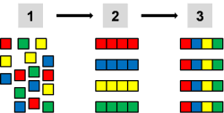

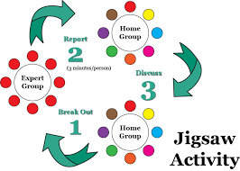
Jigsaw Expert

The Big Idea to Explore:

Area to Investigate for My Home Group:

What My Expect Group Discovered:

What I Learned from My Home Group Experts:

My Summary of All I Learned about the Big Idea:

Interactive Notetaking Click here to return to Matrix

Purpose: What kind of thinking does this routine encourage?  This routine encourages each student to own archiving essential concepts. It fosters higher order thinking (e.g., synthesizing).  Application: When and where can I use it?  Interactive notetaking is active learning because it helps students understand what is important in a text and allows them to represent what is important in their own way. It also helps students use BOTH parts of their brain!  Launch: What are some tips for starting and using this routine?  How to Organize Your Interactive Notebook:  - Make a cover.  - Number all pages both front and back.  - Start your Table of Contents. This will be a work in progress as you add content to your notebook. As you start new topics, you’ll add those to the Table of Contents (Columns: Date, Topic, Page #)  - Place a Glossary at the end of each unit (Columns: Word, Image/Example, Description)  - Add in any pertinent information like a Notebook Rubric. | 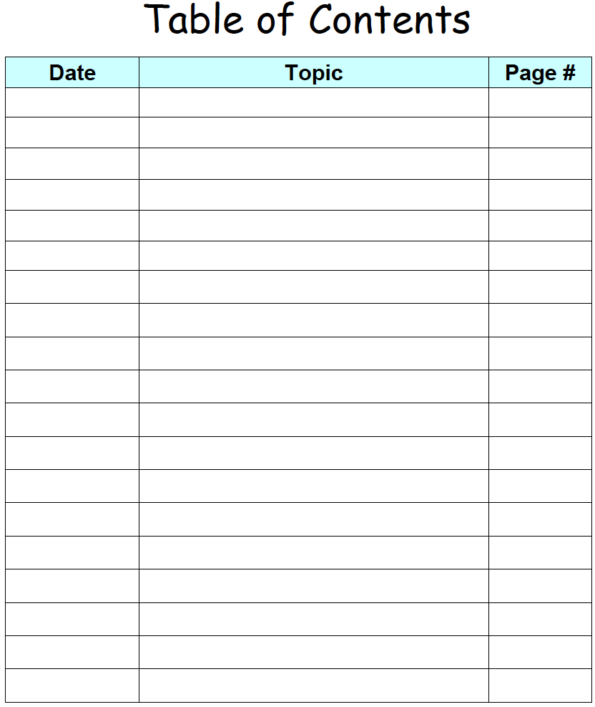
 | 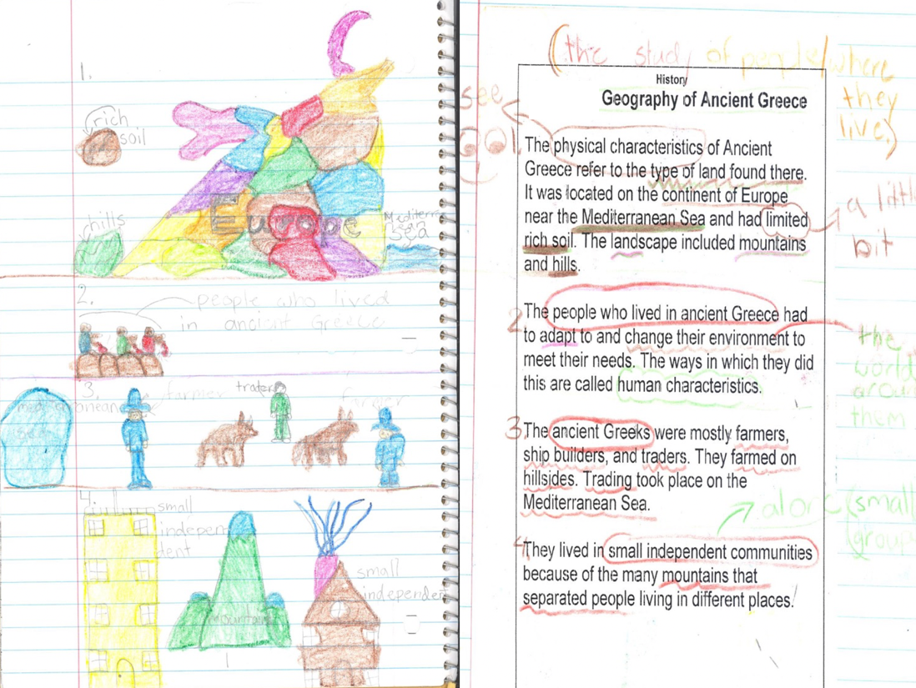

Interactive Notetaking

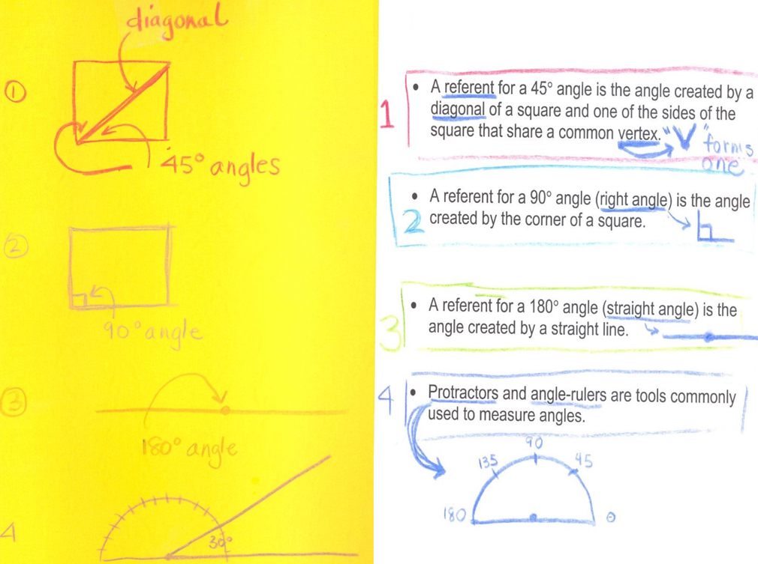 | 