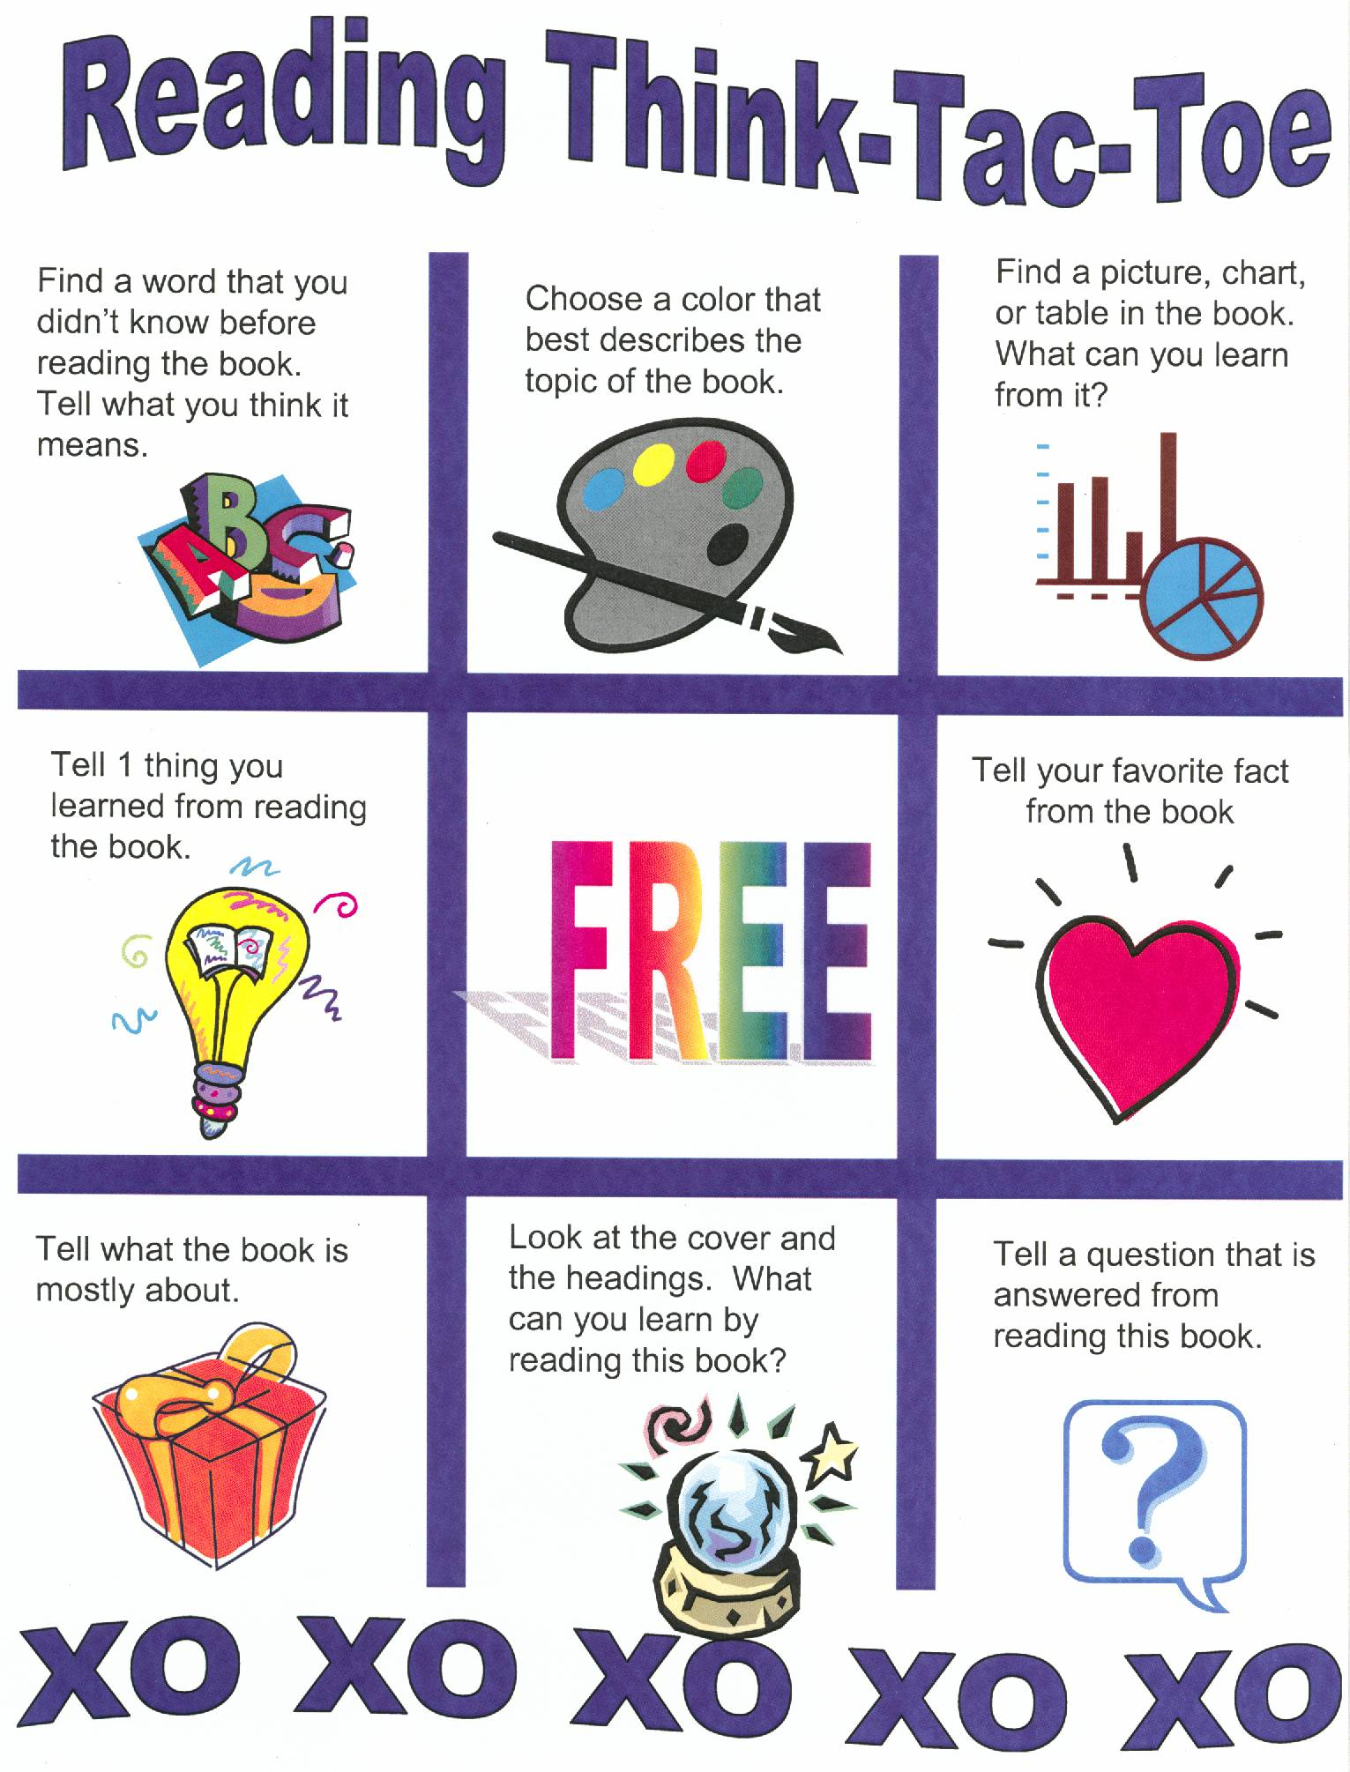
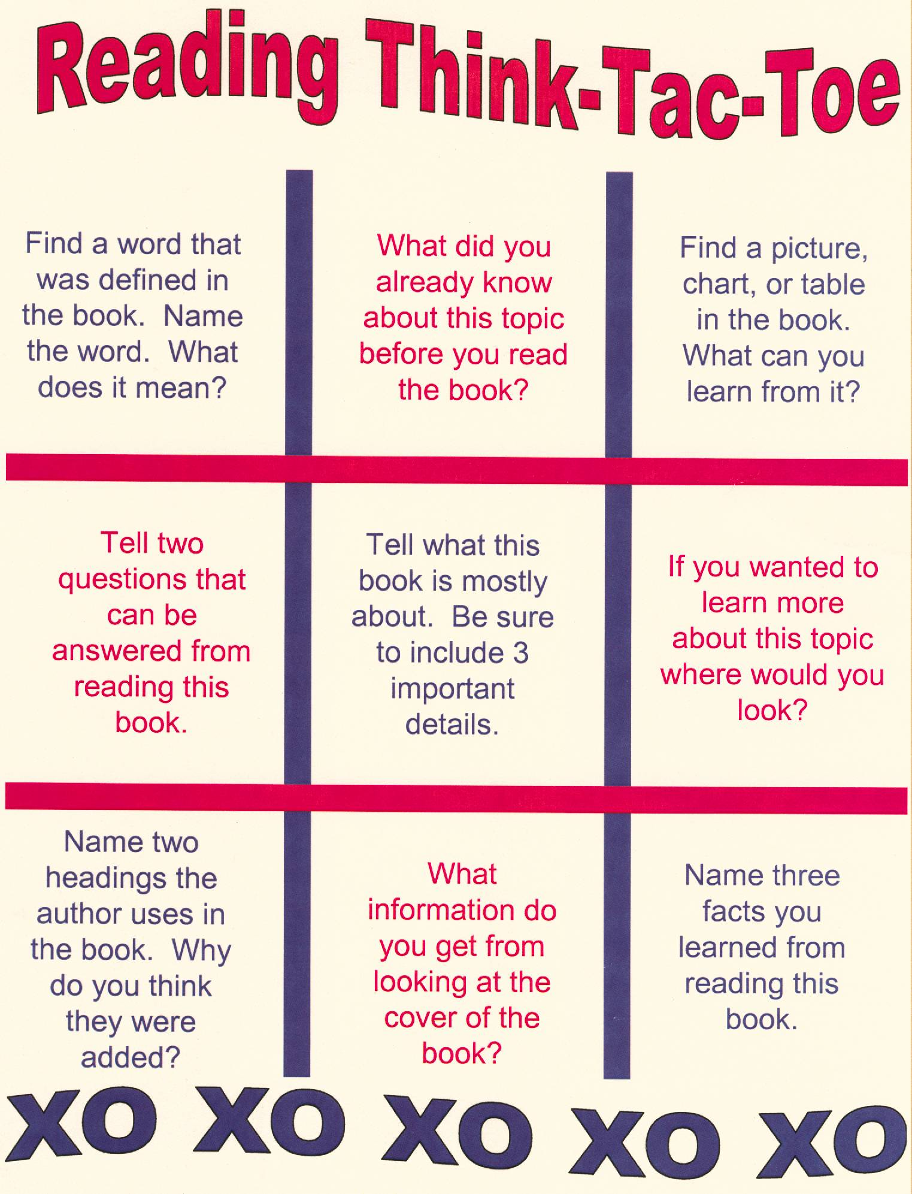

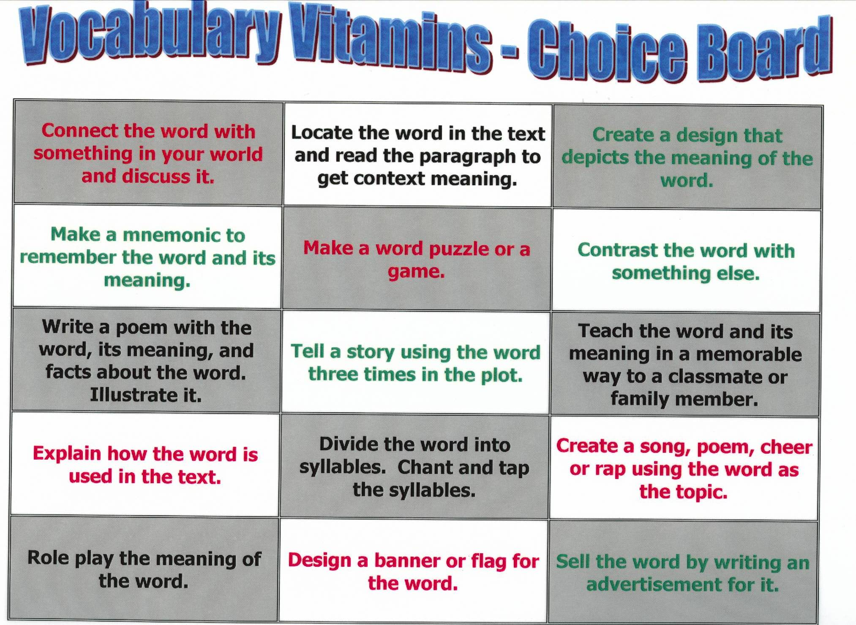
Drawing Conclusions from Historical Documents

Think-Tac-Toe
What did you already know about this topic before you read the document? | What is an image you can create in your mind after reading this document? | Tell two questions that can be answered from reading this document.
Tell what this document is mostly about. Be sure to include 3 important details. | If you wanted to learn more about this topic where would you look? | What information do you get from reading the title of the document?
Name three facts you learned from reading this document? | Find a word that you didn’t know before reading the document. Tell what you think it means. | Tell your favorite part of the document? What makes it interesting to you?
Analyzing a Graph

Think-Tac-Toe
You have decided to graph something daily. What is it and why is it important to see in a graph? | What is the relationship between a set of data and its graph? | What are some ways you would prepare to collect data from your classmates or neighbors? Explain why it is important.
What are some things common to all types of graphs? | Graphs are sometimes called ‘data pictures’ (glyphs). Do you agree or disagree with the statement? Explain. | What are some ways to determine the title of a set of data, a table, or a graph?
How are bar graphs and pictographs similar? How are they different? | What are the advantages of creating a graph out of a set of data? | What are some situations for which you would display data in a bar graph or pictograph

Your title goes here!

Think-Tac-Toe
DOK 2 or 3 | DOK 1 | DOK 2 or 3
DOK 1 | DOK 2 or higher  (e.g., Create a question for the team to answer and explain) | DOK 1
DOK 2 or 3 | DOK 1 | DOK 2 or 3

