Grade 1
Diagnostic Formative Assessment

Unwrap a Standard: What do students have to know and be able to do?

Strand: Number and Number Sense
Strand Weight: 23.5%

Standard 1.1a-d: I will
  - count forward orally by ones to 110, starting at any number between 0 and 110
  - write the numerals 0 to 110 in sequence and out-of-sequence
  - count backward orally by ones when given any number between 1 and 30; and
  - count forward orally by ones, twos, fives, and tens to determine the total number of objects to 110.

Emerging (1) | Developing (2) | Proficient (3) | Distinguished (4)
I can count forward orally, by ones, from 0 to 110 starting at any number between 0 and 110.  I can use the oral counting sequence to tell how many objects are in a set. | I can write numerals 0 – 110 in sequence and out of sequence. | I can count backward orally by ones when given any number between 1 and 30.  I can count forward orally by ones, twos, fives, and tens to determine the total number of objects to 110. | I can apply counting to 110 in real-world situations.
Virginia Performance Level Descriptors
Extending Knowledge and skills: Flashback Standard

SOL K.3 I will
- count forward orally by ones from 0 to 100;
- count backward orally by ones when given any number between 1 and 10
- identify the number after, without counting, when given any number between 0 and 100 and identify the number before, without counting, when given any number between 1 and 10; and
- count forward by tens to determine the total number of objects to 100.

Building Background Knowledge and skills: Preview Standard

SOL 2.2 I will
- count forward by twos, fives, and tens to 120, starting at various multiples of 2, 5, or 10
- count backward by tens from 120; and
- use objects to determine whether a number is even or odd.

Essential Knowledge/Concepts  What Do Students Need to Know/Understand?  List the underlined nouns.  Ones Counting Numerals  Sequence Out-of-Sequence Set  Forward Backward Total Number  Twos Fives Tens | Essential Skills  What Do Students Need to Be Able to Do?  List the circled (or italicized) verbs.  Count Write Determine  Use Tell Apply  FS Identify Count Determine  PS Count Use Determine
DOK Level
Level of content complexity rather than content difficulty.

DOK 1 DOK 2 DOK 3
Essential Questions  How can we capture student wonder?  *Including open-ended and ‘second’ questions  - What was the hardest part about counting backward from 30? What helped you? What was the easiest part? Why?  - What is one less than 24? How do you know?  - How can counting backward from 10 to 1 help you with counting backward starting at 30? | Essential Vocabulary  What Do Students Need to Comprehend?  List all key vocabulary  Ones Count Number  Order Sequence Forward  Backward Total Fives  Twos Tens Set
Learning Objectives aligned to the Standard
What ‘I can’ statement(s) will clarify the objective for students?

Evidence of Student Mastery?
How will we know when they know it?

Specific Instructional Framework?
What will we do to help them know/understand/can do it?
What will we do for students who still don’t know it?
What will we do for students who already know it?

Alignment to SOL 1.1a-d.0 (Flashback to SOL K.3c,d) (DOK 2)

- Task:
Materials: (S) 10 linking cubes (or other familiar classroom objects), brown construction paper mat to show the problem
T: Now, let’s pretend these cubes are bears! Show me this problem: There were four bears who were eating leaves here in the woods. (Pause.) Two more bears came over to snack on some leaves. How many bears were eating leaves in the woods?
T: Use your words to tell me how you figured out the problem.
T: Write the number that tells how many bears there are eating leaves.
T: Another bear came. Show me the bears now. How many bears is that? Write that number.

What did the student do? | What did the student say?

Alignment to SOL 1.1a-d.1 (DOK 1)

- Carol gathered all the triangle shapes from her bag of attribute blocks. How many triangles are in Carol’s collection of triangles?

Alignment to SOL 1.1a-d.2 (DOK 1)

- Dwayne is helping his teacher complete her number chart. Fill in the missing numbers on the charts below.

8 |  | 10 |  |  | 13
 | 22 |  |  | 25
 |  |  | 105

Alignment to SOL 1.1a-d.3 (DOK 3)

- Farmer Selena Gomez is guiding her animals into the barn for the night. She has 14 animals. She needs your help to make sure all the animals make it into the barn. She remembered her teacher taught her how to count backward as the animals enter the barn.

She begins counting as the animals enter the barn: (fill in the missing numbers).

14 13 12 ___ ___ ___ ___ ___ ___ ___ ___ ___ ___ ___

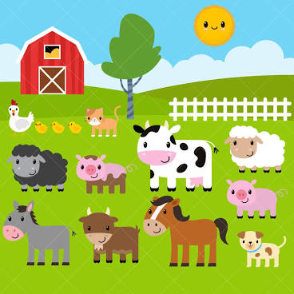

Alignment to SOL 1.1a-d.4 (DOK 3)
- Lisa has opened a package of cookies.

Part A. How many cookies are in the package?

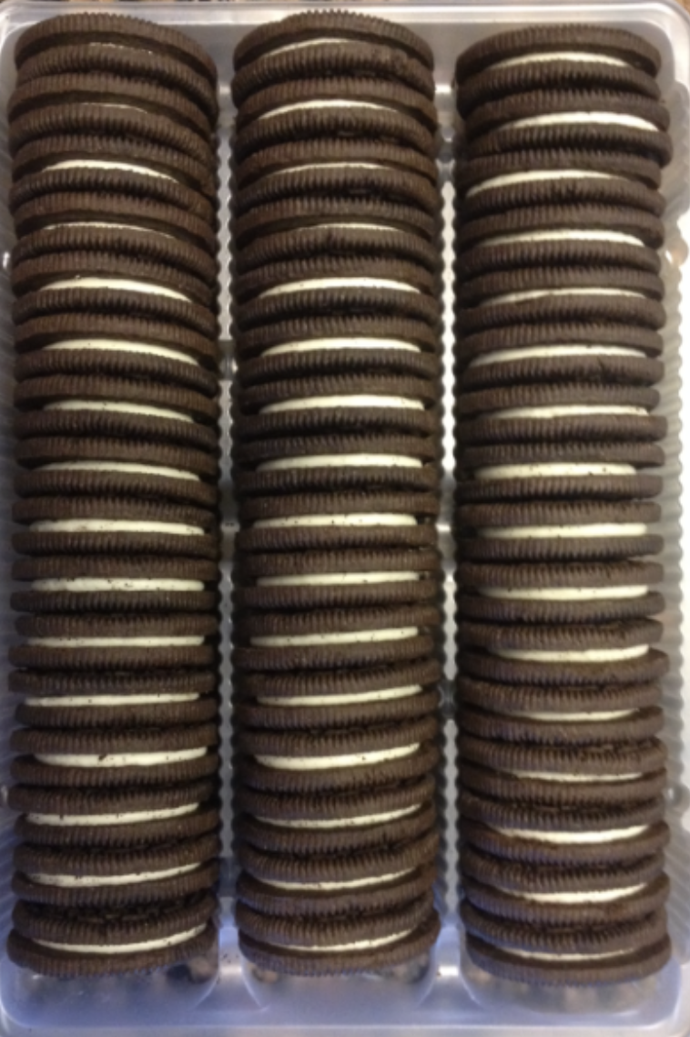

Part B. Lisa and her friends ate some cookies. How many cookies remain in the box?

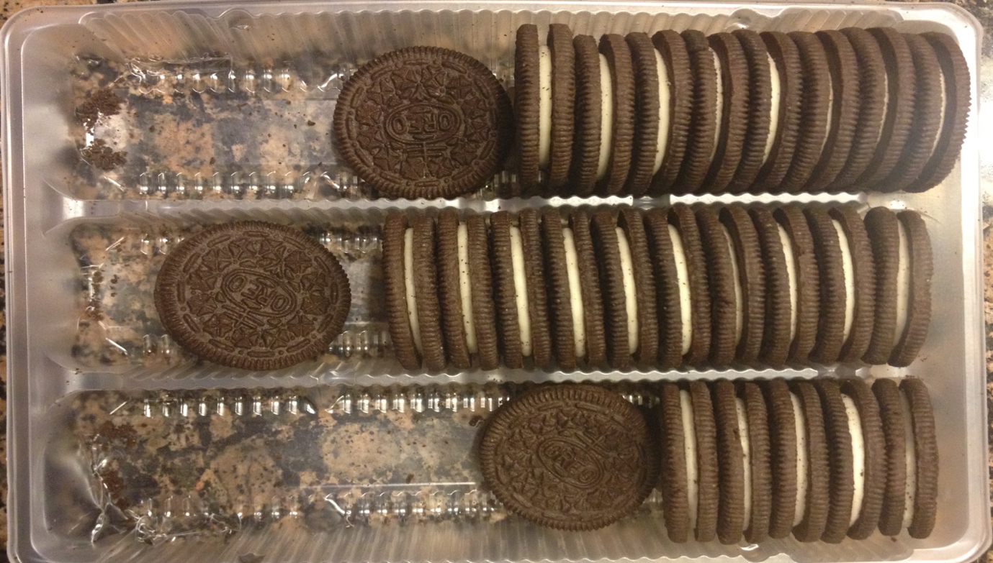

My Personal  Goals | Getting  Started | On My  Way | I’m  There | Notes to  Self
I can count forward orally, by ones, from 0 to 110 starting at any number between 0 and 110.
I can use the oral counting sequence to tell how many objects are in a set.
I can write numerals 0 – 110 in sequence and out of sequence.
I can count backward orally by ones when given any number between 1 and 30.
I can count forward orally by ones, twos, fives, and tens to determine the total number of objects to 110.
I can apply counting to 110 in real-world situations.

Guided Group Lesson
Standard: Date:

Group Members | Emerging | Developing | Proficient | Distinguished

Warm-Up:

Vocabulary

Emerging | Developing | Proficient | Distinguished
Lesson focus: | Lesson focus: | Lesson focus: | Lesson focus:

Observations: |  | Next Steps:
What you notice about your students during small group instruction. |  | What will you do with these students next? Change groups, repeat, etc.

