Grade 3
Diagnostic Formative Assessment

Unwrap a Standard: What do students have to know and be able to do?

Reporting Category: Measurement and Geometry
Reporting Category Weight: 28.6%

Standard 3.10: I will read temperature to the nearest degree.

Emerging (1) | Developing (2) | Proficient (3) | Distinguished (4)
I can read Celsius and Fahrenheit temperatures to the nearest degree using real thermometers. | I can read Celsius and Fahrenheit temperatures to the nearest degree using linear models. | I can read Celsius and Fahrenheit temperatures to the nearest degree using circular models. | I can predict a change in Celsius and Fahrenheit temperatures in real-world situations.
Virginia Performance Level Descriptors

Extending Knowledge and skills: Flashback Standard

SOL 2.11 I will read temperatures to the nearest ten degrees.

Building Background Knowledge and skills: Preview Standard

SOL 4.5c I will solve single-step and multistep practical problems involving addition and subtraction with fractions and mixed numbers.

Essential Knowledge/Concepts  What Do Students Need to Know/Understand?  List the underlined nouns.  Temperature Celsius Fahrenheit  Thermometer Linear Model Degree  Circular Model  PS Fraction Mixed Number | Essential Skills  What Do Students Need to Be Able to Do?  List the circled (or italicized) verbs.  Read Use Predict  PS Solve
DOK Level
Level of content complexity rather than content difficulty.

DOK 1 DOK 2 DOK 3
Essential Questions  How can we capture student wonder?  *Including open-ended and ‘second’ questions  - Cathy and her family are going to the beach to escape the very warm temperatures on a July day. What could be the temperature in Celsius? What could be the temperature in Fahrenheit? How do you know? | Essential Vocabulary  What Do Students Need to Comprehend?  List all key vocabulary  Temperature Celsius Fahrenheit  Thermometer Linear Model Degree  Circular Model
Learning Objectives aligned to the Standard
What ‘I can’ statement(s) will clarify the objective for students?

Evidence of Student Mastery?
How will we know when they know it?

Specific Instructional Framework?
What will we do to help them know/understand/can do it?
What will we do for students who still don’t know it?
What will we do for students who already know it?

Alignment to SOL 3.10.0 (Flashback to SOL 2.11) (DOK 1)

- Color the thermometer to show a temperature of 40 degrees Fahrenheit.

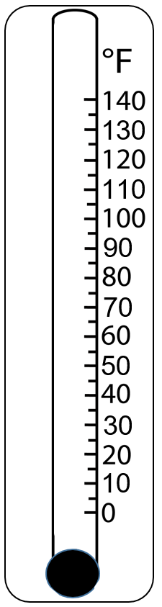

Alignment to SOL 3.10.1 (DOK 1)

- Wendy is playing a ‘Guess the Temperature’ game with her friend. Wendy showed her friend the thermometer below that measures temperature in Celsius. Circle the number of degrees that is closest to the temperature displayed on the thermometer?
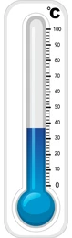

0 |  | 37 |  | 50 |  | 63 |  | 100

Alignment to SOL 3.10.2 (DOK 2)

- Wendy is using the thermometer shown below to model the lowest temperature in Henry County in November and the highest temperature in Henry County in May. The thermometer measures temperature in degrees Fahrenheit.
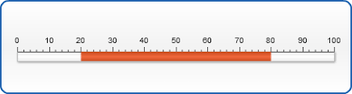
Part A. Use the thermometer to determine the lowest temperature in Henry County in November.
Part B. Use the thermometer to determine the highest temperature in Henry County in May.
Part C. What is the difference between the the lowest temperature in Henry County in November and the highest temperature in Henry County in May?

Alignment to SOL 3.10.3 (DOK 2)

- The circular thermometer measures the temperature in degrees Fahrenheit. Use the thermometer to determine the recorded temperature to the nearest ten degrees.
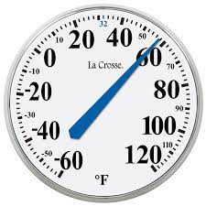

Alignment to SOL 3.10.4 (DOK 2)

- The thermometer below measures the temperature in both degrees Celsius (inside circle) and in degrees Fahrenheit (outside circle).
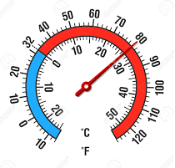
Tom understands that water freezes at 32 degrees Fahrenheit. According to the thermometer, what is the corresponding Celsius temperature that water will freeze?

My Personal  Goals | Getting  Started | On My  Way | I’m  There | Notes to  Self
I can read Celsius and Fahrenheit temperatures to the nearest degree using real thermometers.
I can read Celsius and Fahrenheit temperatures to the nearest degree using linear models.
I can read Celsius and Fahrenheit temperatures to the nearest degree using circular models.
I can predict a change in Celsius and Fahrenheit temperatures in real-world situations.

Guided Group Lesson
Standard: Date:

Group Members | Emerging | Developing | Proficient | Distinguished

Warm-Up:

Vocabulary

Emerging | Developing | Proficient | Distinguished
Lesson focus: | Lesson focus: | Lesson focus: | Lesson focus:

Observations: |  | Next Steps:
What you notice about your students during small group instruction. |  | What will you do with these students next? Change groups, repeat, etc.

