Waiting for the Train

A point on the graph represents each person shown below. Label each point on the graph with the name of the person it represents.
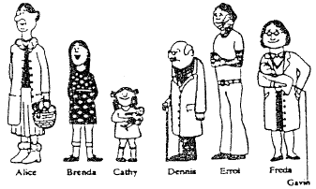

1.

2.

3.

4.

5.
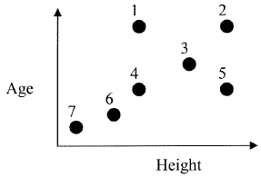

6

7.

Now, draw a graphical relationship that can be compared using two variables (like height and age). Provide a picture and a graph with locations represented with numbers or letters. Prepare to explain your scenario.

