Web Applications to Increase Student Engagement
- www.zopler.com (Zopler Collaborative Storytelling)
Zopler is a free web site that allows students to write collaboratively. Zopler considers itself a social network for writers where people can share stories and tap into the community of authors (students and teachers) to help wordsmith a piece or get over the writers block hurdle. Zopler is a neat concept that shows promise. This resource would be great for Middle and High School students.

- http://generator.acmi.net.au/storyboard (ACMA Storyboard Generator)
Storyboard Generator is a free tool from the Australian Centre for the Moving Image. Students can choose a script (or write their own) and create a storyboard. This is a great free tool for teachers to use with their students to help them learn storytelling, presentation skills, and so much more. Easy to use, this is a powerful tool for students of all ages

- www.convertfiles.com (Convert Files)
Convert Files is a wonderful free site that allows users to convert any file type to any other type. It works great for images, videos, music, and more. Quick and simple to use, this is a very powerful tool for students and teachers converting content that can be useful in many areas, including presentations and projects.

- www.classconnect.com (Class Connect)
Class Connect is a great free resource that allows teachers and students to build and share lessons. These lessons can include video content, Google Docs, and more. This is a great tool to organize and store the materials and also to share and collaborate with other teachers and colleagues. The site is free, well-organized, and does a great job or allowing teachers to share the best of their lessons with other passionate educators.

- http://www.101qs.com (Dan Meyer’s 101 Questions)
101 Questions is a wonderful site developed by Math teaching guru Dan Meyer that helps educators create engaging questions that allow students to truly get inquisitive about how to develop a great math questions. This website is a great concept that melds user generated content together in a unique way that not only poses some great questions, but also lets teachers test their own content before putting it in front of their students. This is a powerful site that has great implications for teaching math and will hopefully inspire other curricula to adopt similar methodologies.

- http://bigfuture/collegeboard.org (Big Future @ the College Board)
Big Future is a dynamic free website that allows students to learn all about preparing for, finding, and applying to colleges. Whether a student is interested in financial aid, what colleges are a good fit for them, or exploring career opportunities that they are interested in, this is an excellent site. Through dynamic videos, interactive modules, and an appealing interface, this site is the place to visit for kids interested in preparing and applying to college. There are a wealth of resources on the site that are also great for parents and counselors.
Dan Mulligan
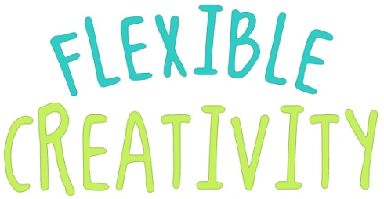
- http://ed.ted.com (TED)
TED-Ed is a site dedicated to lessons worth sharing. TED, which is known for their stunning video lecture series, has launched a new service that focuses on lessons and education. Teachers, other experts, and pretty much anyone can send an audio file which TED-Ed will animate and place on their site to share with the world. It is a stunning effort powered by real educators and volunteer animation experts. The results are fantastic and engaging. This is another strong entry for those teachers interested in sharing high quality video content with their students.

- http://tinkercad.com/home (Tinkercad)
Thinkcad is a free open source web-based tools that allows users to learn to design the products of their life. Students will be able to easily design in 3D what they have always dreamed of, but never thought possible. Until now. This is a fantastic tool to introduce real-world fabrication skills that teach student that that they can learn by doing. Tinkercad also has a growing community that helps users learn how to create their first real things in just a few minutes.

- http://owl.english.purdue.edu/ (The Purdue Online Writing Lab – OWL)
This website offers over 200 free resources including:
- Writing and Teaching Writing
- Research
- Grammar and Mechanics
- Style Guides
- ESL (English as a Second Language)
- Job Search and Professional Writing

- Tagxedo.com
Tagxedo is a free web site that turns words -- famous speeches, news articles, slogans and themes, even your love letters -- into a visually stunning word cloud, words individually sized appropriately to highlight the frequencies of occurrence within the body of text.

- http://schools.nyc.gov/Academics/CommonCoreLibrary/SeeStudentWork/default.htm
This web site provides educators with an excellent bank of resources for the common core math and common core literacy standards. These activities can be easily aligned to the Virginia Standards of Learning.

